10_gls_models

Jake Cavaiani

9/12/2022

#load libraries

### BY YEAR

Due to the fact that we dont have data for 3 of the sites for 2018 the gls structure does not like that…so we will try this analysis by year and see if concentrations vary significantly from each other within years

# CorAR1 structure

mean_daily_2018 <- subset(mean_daily, year == "2018")  
  
no3.mod.gls.2018 <- gls(dailyNO3 ~ site.ID,   
 na.action = na.omit,   
 data = mean_daily_2018,   
 correlation = corAR1(form = ~ julian|site.ID))

# diagnostic plots

plot(no3.mod.gls.2018, resid(., type = "p") ~ fitted(.), abline = 0)

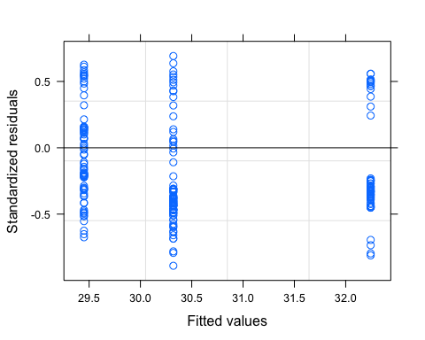

plot(no3.mod.gls.2018, dailyNO3 ~ fitted(.) | site.ID, abline = c(0,1))

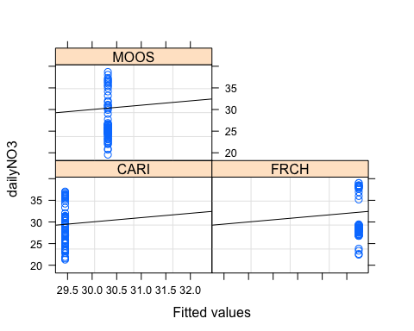

qqnorm(no3.mod.gls.2018, abline = c(0,1))

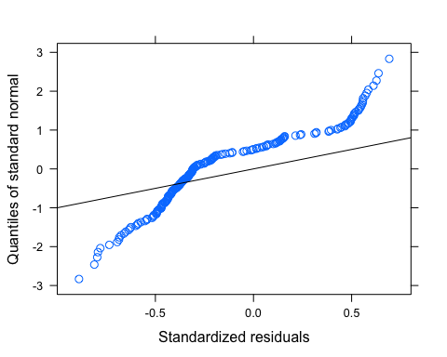

Our normality is not great…lets log transform

mean_daily_2018$logDailyNO3 <- log(abs(mean_daily_2018$dailyNO3))  
  
no3.mod.gls.2018.log <- gls(logDailyNO3 ~ site.ID,   
 na.action = na.omit,   
 data = mean_daily_2018,   
 correlation = corAR1(form = ~ julian|site.ID))

# diagnostic plots

plot(no3.mod.gls.2018.log, resid(., type = "p") ~ fitted(.), abline = 0)

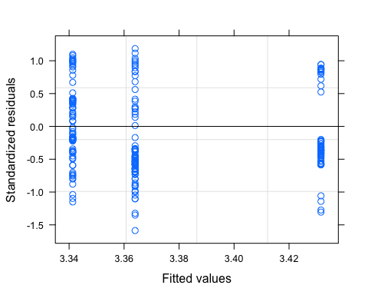

plot(no3.mod.gls.2018.log, logDailyNO3 ~ fitted(.) | site.ID, abline = c(0,1))

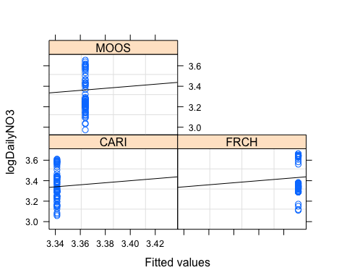

qqnorm(no3.mod.gls.2018.log, abline = c(0,1))

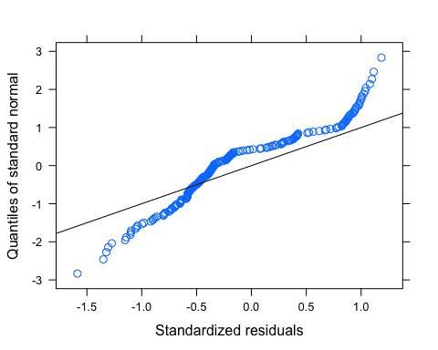

Still not good for normality…we have to transform further before preceding

### fDOM

ggplot(mean_daily_2018, aes(x = julian, y = dailyfDOM, color = site.ID)) +  
 geom_line() +  
 scale_color_manual(values=c("#3288BD","#FF7F00", "#A6761D")) +  
 facet_wrap(~site.ID, scales = "free") +  
 theme_classic()

## Warning: Removed 12 row(s) containing missing values (geom_path).

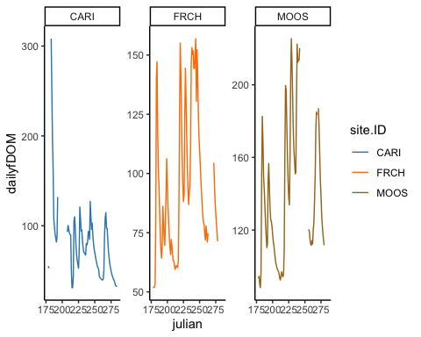

ggplot(mean_daily_2018, aes(x = site.ID, y = dailyfDOM, fill = site.ID)) +  
 geom_boxplot() +  
 scale_fill_manual(values=c("#3288BD","#FF7F00", "#A6761D"))

## Warning: Removed 39 rows containing non-finite values (stat_boxplot).

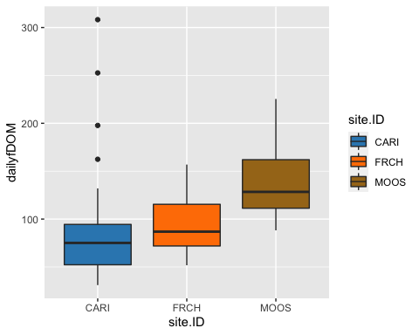

# corAR1 structure

fDOM.mod.ar1.2018 <- gls(dailyfDOM ~ site.ID,   
 na.action = na.omit,   
 data = mean_daily_2018,   
 correlation = corAR1(form = ~ julian|site.ID))

# diagnostic plots

plot(fDOM.mod.ar1.2018, resid(., type = "p") ~ fitted(.), abline = 0)

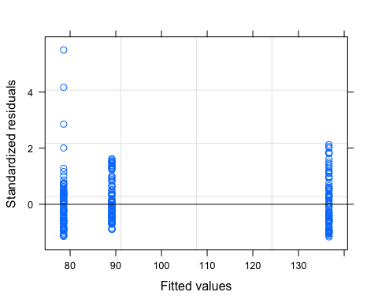

plot(fDOM.mod.ar1.2018, dailyfDOM ~ fitted(.) | site.ID, abline = c(0,1))

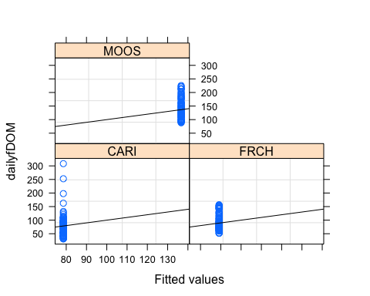

qqnorm(fDOM.mod.ar1.2018, abline = c(0,1))

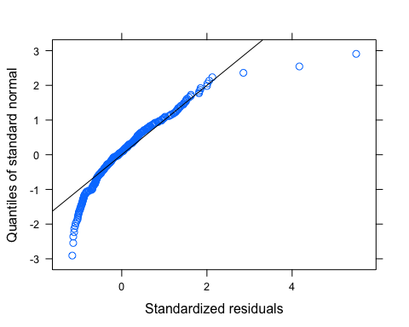

Let me log transform to see if its better

# log transformed

mean_daily_2018$logDailyfDOM <- log(mean_daily_2018$dailyfDOM)  
  
# removing clear outliers here   
which(mean_daily_2018$logDailyfDOM > 5.4)

## [1] 6 7 257 266

mean_daily_2018 <- mean_daily_2018 %>%  
 mutate(across(c(logDailyfDOM),   
 ~ifelse(logDailyfDOM > 5.4, NA, .)))  
  
  
varfixed <- varIdent(form = ~ 1 | site.ID)  
fDOM.mod.ar1.log <- gls(logDailyfDOM ~ site.ID,   
 na.action = na.omit,   
 data = mean_daily_2018,   
 weights = varfixed,   
 correlation = corAR1(form = ~ julian|site.ID))

# diagnostic plots

plot(fDOM.mod.ar1.log, resid(., type = "p") ~ fitted(.), abline = 0)

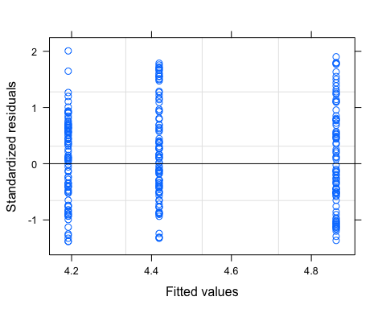

plot(fDOM.mod.ar1.log, logDailyfDOM ~ fitted(.) | site.ID, abline = c(0,1))

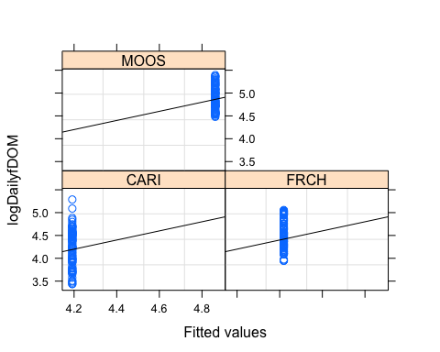

qqnorm(fDOM.mod.ar1.log, abline = c(0,1))

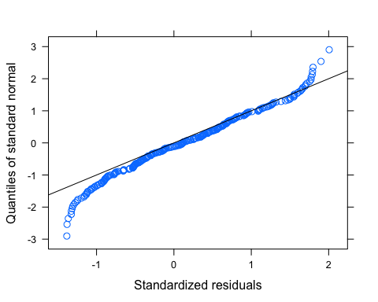 Normality checks out…variance looks pretty good after adjusting weights # ACF plot

Ear1<-residuals(fDOM.mod.ar1.log, type="normalized")  
I1<-!is.na(mean_daily_2018$logDailyfDOM)  
Efulla<-vector(length = length(mean_daily_2018$logDailyfDOM))  
Efulla<-NA  
Efulla[I1]<-Ear1  
acf(Efulla, na.action=na.pass)

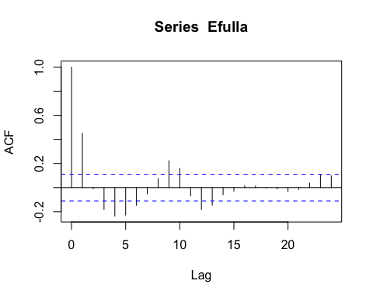

pacf(Efulla, na.action=na.pass)

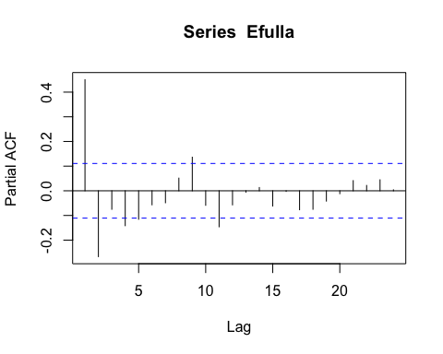 AR1 is not adequately handling the temporal autocorrelation

# corARMA structure

fDOM.mod.arma.1.1 <- gls(logDailyfDOM ~ site.ID,   
 na.action = na.omit,   
 data = mean_daily_2018,   
 weights = varfixed,  
 correlation = corARMA(form = ~ julian|site.ID, p = 1, q = 1))

# ACF plot

Ear1<-residuals(fDOM.mod.arma.1.1, type="normalized")  
I1<-!is.na(mean_daily_2018$logDailyfDOM)  
Efulla<-vector(length = length(mean_daily_2018$logDailyfDOM))  
Efulla<-NA  
Efulla[I1]<-Ear1  
acf(Efulla, na.action=na.pass)

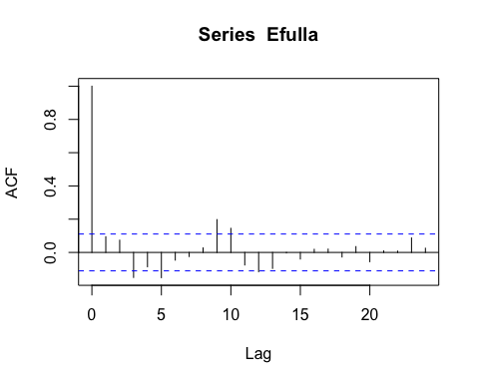

pacf(Efulla, na.action=na.pass)

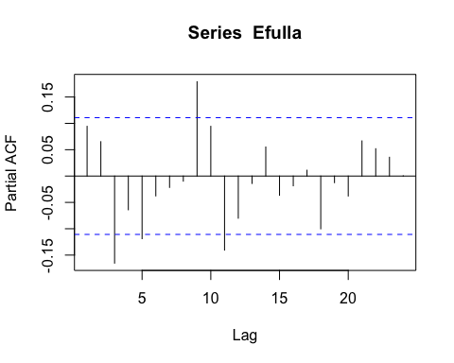 Still autocorrelation

# corARMA structure

fDOM.mod.arma.2.1 <- gls(logDailyfDOM ~ site.ID,   
 na.action = na.omit,   
 data = mean_daily_2018,   
 weights = varfixed,  
 correlation = corARMA(form = ~ julian|site.ID, p = 2, q = 1))

# ACF plot

Ear1<-residuals(fDOM.mod.arma.2.1, type="normalized")  
I1<-!is.na(mean_daily_2018$logDailyfDOM)  
Efulla<-vector(length = length(mean_daily_2018$logDailyfDOM))  
Efulla<-NA  
Efulla[I1]<-Ear1  
acf(Efulla, na.action=na.pass)

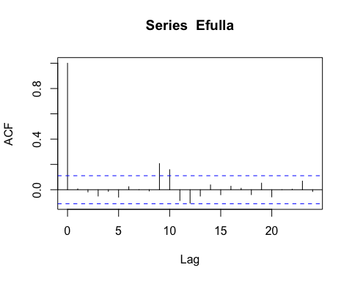

pacf(Efulla, na.action=na.pass)

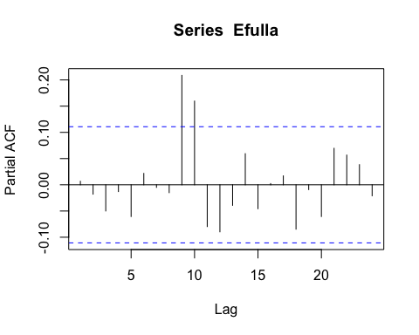 gets worse in the later lags

# corARMA structure

fDOM.mod.arma.1.2 <- gls(logDailyfDOM ~ site.ID,   
 na.action = na.omit,   
 data = mean_daily_2018,   
 weights = varfixed,  
 correlation = corARMA(form = ~ julian|site.ID, p = 1, q = 2))

# ACF plot

Ear1<-residuals(fDOM.mod.arma.1.2, type="normalized")  
I1<-!is.na(mean_daily_2018$logDailyfDOM)  
Efulla<-vector(length = length(mean_daily_2018$logDailyfDOM))  
Efulla<-NA  
Efulla[I1]<-Ear1  
acf(Efulla, na.action=na.pass)

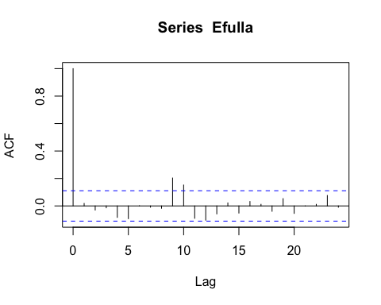

pacf(Efulla, na.action=na.pass)

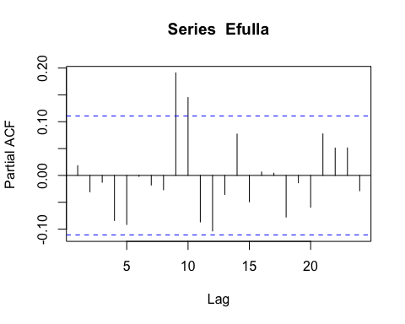 Still autocorrelation in the later lags

# corARMA structure

fDOM.mod.arma.2.2 <- gls(logDailyfDOM ~ site.ID,   
 na.action = na.omit,   
 data = mean_daily_2018,   
 weights = varfixed,  
 correlation = corARMA(form = ~ julian|site.ID, p = 2, q = 2))

# ACF plot

Ear1<-residuals(fDOM.mod.arma.2.2, type="normalized")  
I1<-!is.na(mean_daily_2018$logDailyfDOM)  
Efulla<-vector(length = length(mean_daily_2018$logDailyfDOM))  
Efulla<-NA  
Efulla[I1]<-Ear1  
acf(Efulla, na.action=na.pass)

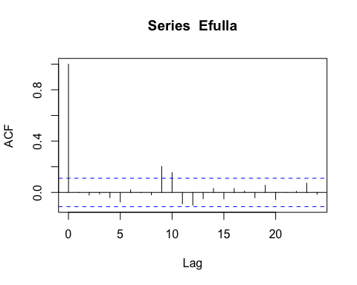

pacf(Efulla, na.action=na.pass)

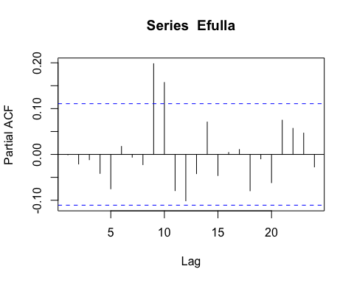 Still autocorrelation but this is the best one yet so lets interpret this model

# generalized linear hypotheses

mean_daily_2018$site.ID <- as.factor(mean_daily_2018$site.ID)  
site.ID.comp <- glht(fDOM.mod.arma.2.2, linfct = mcp(site.ID = "Tukey"))  
summary(site.ID.comp)

##   
## Simultaneous Tests for General Linear Hypotheses  
##   
## Multiple Comparisons of Means: Tukey Contrasts  
##   
##   
## Fit: gls(model = logDailyfDOM ~ site.ID, data = mean_daily_2018, correlation = corARMA(form = ~julian |   
## site.ID, p = 2, q = 2), weights = varfixed, na.action = na.omit)  
##   
## Linear Hypotheses:  
## Estimate Std. Error z value Pr(>|z|)   
## FRCH - CARI == 0 0.2128 0.1918 1.109 0.50107   
## MOOS - CARI == 0 0.6336 0.1801 3.518 0.00120 **  
## MOOS - FRCH == 0 0.4209 0.1231 3.417 0.00177 **  
## ---  
## Signif. codes: 0 '***' 0.001 '**' 0.01 '*' 0.05 '.' 0.1 ' ' 1  
## (Adjusted p values reported -- single-step method)

summary(fDOM.mod.arma.2.2)

## Generalized least squares fit by REML  
## Model: logDailyfDOM ~ site.ID   
## Data: mean_daily_2018   
## AIC BIC logLik  
## -372.1519 -336.2795 196.076  
##   
## Correlation Structure: ARMA(2,2)  
## Formula: ~julian | site.ID   
## Parameter estimate(s):  
## Phi1 Phi2 Theta1 Theta2   
## 0.9839719 -0.1593581 0.5944143 0.1568207   
## Variance function:  
## Structure: Different standard deviations per stratum  
## Formula: ~1 | site.ID   
## Parameter estimates:  
## CARI FRCH MOOS   
## 1.0000000 0.5945127 0.4394009   
##   
## Coefficients:  
## Value Std.Error t-value p-value  
## (Intercept) 4.261382 0.1644012 25.920617 0.0000  
## site.IDFRCH 0.212779 0.1917986 1.109387 0.2683  
## site.IDMOOS 0.633630 0.1800953 3.518302 0.0005  
##   
## Correlation:   
## (Intr) s.IDFR  
## site.IDFRCH -0.857   
## site.IDMOOS -0.913 0.782  
##   
## Standardized residuals:  
## Min Q1 Med Q3 Max   
## -1.71708505 -0.69634539 -0.02102211 0.58495557 2.06587702   
##   
## Residual standard error: 0.5501692   
## Degrees of freedom: 270 total; 267 residual

intervals(fDOM.mod.arma.2.2)

## Approximate 95% confidence intervals  
##   
## Coefficients:  
## lower est. upper  
## (Intercept) 3.9376942 4.2613819 4.5850697  
## site.IDFRCH -0.1648513 0.2127788 0.5904089  
## site.IDMOOS 0.2790421 0.6336297 0.9882173  
## attr(,"label")  
## [1] "Coefficients:"  
##   
## Correlation structure:  
## lower est. upper  
## Phi1 1.0423749 0.9839719 0.6538605  
## Phi2 -0.5591151 -0.1593581 0.3005179  
## Theta1 0.1131262 0.5944143 1.1101233  
## Theta2 -0.1789918 0.1568207 0.4599059  
## attr(,"label")  
## [1] "Correlation structure:"  
##   
## Variance function:  
## lower est. upper  
## FRCH 0.4828974 0.5945127 0.7319264  
## MOOS 0.3543717 0.4394009 0.5448323  
## attr(,"label")  
## [1] "Variance function:"  
##   
## Residual standard error:  
## lower est. upper   
## 0.4257610 0.5501692 0.7109297

plot(print(confint(site.ID.comp)))

##   
## Simultaneous Confidence Intervals  
##   
## Multiple Comparisons of Means: Tukey Contrasts  
##   
##   
## Fit: gls(model = logDailyfDOM ~ site.ID, data = mean_daily_2018, correlation = corARMA(form = ~julian |   
## site.ID, p = 2, q = 2), weights = varfixed, na.action = na.omit)  
##   
## Quantile = 2.3277  
## 95% family-wise confidence level  
##   
##   
## Linear Hypotheses:  
## Estimate lwr upr   
## FRCH - CARI == 0 0.2128 -0.2337 0.6592  
## MOOS - CARI == 0 0.6336 0.2144 1.0528  
## MOOS - FRCH == 0 0.4209 0.1342 0.7075

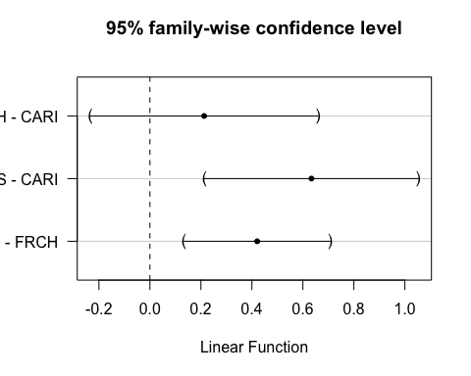

tab_model(fDOM.mod.arma.2.2)

## Warning: Argument 'df_method' is deprecated. Please use 'ci_method' instead.

logDailyfDOM

Predictors

Estimates

CI

p

(Intercept)

4.26

3.94 – 4.59

<0.001

site ID [FRCH]

0.21

-0.16 – 0.59

0.268

site ID [MOOS]

0.63

0.28 – 0.99

0.001

Observations

270

R2

0.392

This shows that FRCH and CARI are significantly different from CARI

### SPC

ggplot(mean_daily_2018, aes(x = julian, y = dailySPC, color = site.ID)) +  
 geom_line() +  
 scale_color_manual(values=c("#3288BD","#FF7F00", "#A6761D")) +  
 facet_wrap(~site.ID, scales = "free") +  
 theme_classic()

## Warning: Removed 7 row(s) containing missing values (geom_path).

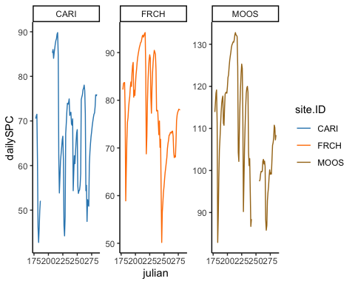

ggplot(mean_daily_2018, aes(x = site.ID, y = dailySPC, fill = site.ID)) +  
 geom_boxplot() +  
 scale_fill_manual(values=c("#3288BD","#FF7F00", "#A6761D"))

## Warning: Removed 30 rows containing non-finite values (stat_boxplot).

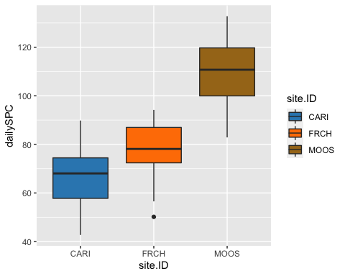

# corAR1 structure

SPC.mod.ar1 <- gls(dailySPC ~ site.ID,   
 na.action = na.omit,   
 data = mean_daily_2018,   
 correlation = corAR1(form = ~ julian|site.ID))

# diagnostic plots

plot(SPC.mod.ar1, resid(., type = "p") ~ fitted(.), abline = 0)

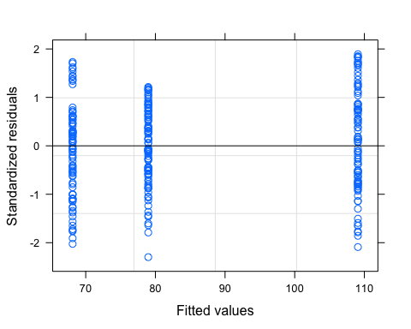

plot(SPC.mod.ar1, dailySPC ~ fitted(.) | site.ID, abline = c(0,1))

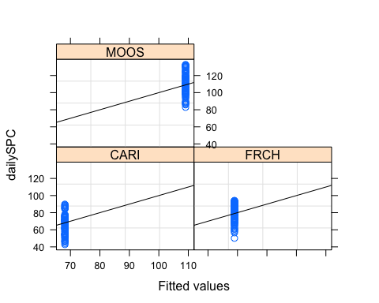

qqnorm(SPC.mod.ar1, abline = c(0,1))

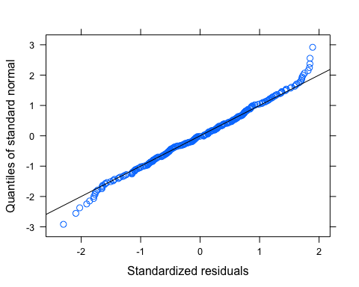 Variance looks good, so does qqnorm plot # ACF plot

Ear1<-residuals(SPC.mod.ar1, type="normalized")  
I1<-!is.na(mean_daily_2018$dailySPC)  
Efulla<-vector(length = length(mean_daily_2018$dailySPC))  
Efulla<-NA  
Efulla[I1]<-Ear1  
acf(Efulla, na.action=na.pass)

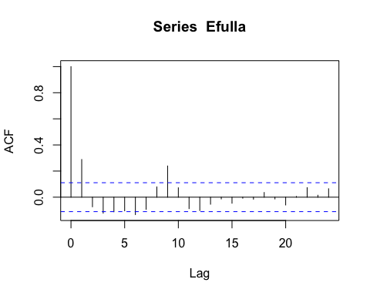

pacf(Efulla, na.action=na.pass)

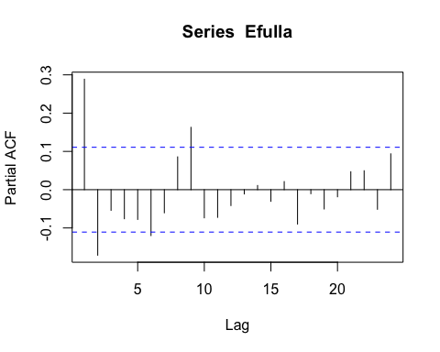 AR1 is not adequately handling the temporal autocorrelation

# corARMA structure

SPC.mod.arma.1.1 <- gls(dailySPC ~ site.ID,   
 na.action = na.omit,   
 data = mean_daily_2018,   
 correlation = corARMA(form = ~ julian|site.ID, p = 1, q = 1))

# ACF plot

Ear1<-residuals(SPC.mod.arma.1.1, type="normalized")  
I1<-!is.na(mean_daily_2018$dailySPC)  
Efulla<-vector(length = length(mean_daily_2018$dailySPC))  
Efulla<-NA  
Efulla[I1]<-Ear1  
acf(Efulla, na.action=na.pass)

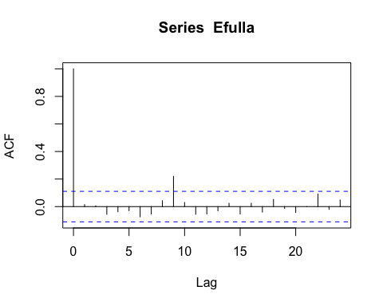

pacf(Efulla, na.action=na.pass)

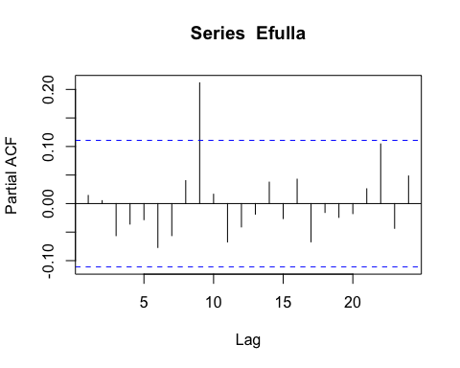 Still autocorrelation at the 9th lag but that is it

# corARMA structure

SPC.mod.arma.2.1 <- gls(dailySPC ~ site.ID,   
 na.action = na.omit,   
 data = mean_daily_2018,   
 correlation = corARMA(form = ~ julian|site.ID, p = 2, q = 1))

# ACF plot

Ear1<-residuals(SPC.mod.arma.2.1, type="normalized")  
I1<-!is.na(mean_daily_2018$dailySPC)  
Efulla<-vector(length = length(mean_daily_2018$dailySPC))  
Efulla<-NA  
Efulla[I1]<-Ear1  
acf(Efulla, na.action=na.pass)

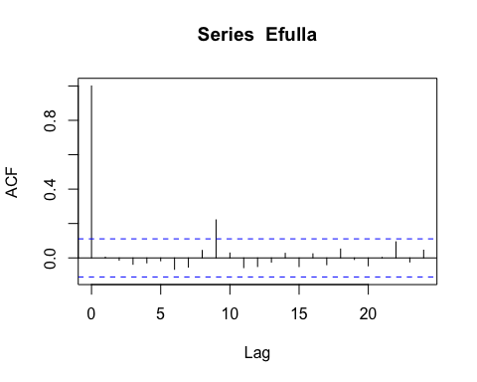

pacf(Efulla, na.action=na.pass)

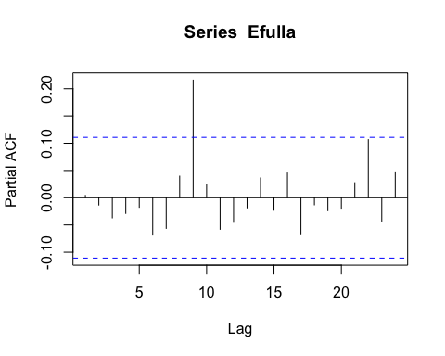 Still that 9th lag

# corARMA structure

SPC.mod.arma.1.2 <- gls(dailySPC ~ site.ID,   
 na.action = na.omit,   
 data = mean_daily_2018,   
 correlation = corARMA(form = ~ julian|site.ID, p = 1, q = 2))

# ACF plot

Ear1<-residuals(SPC.mod.arma.1.2, type="normalized")  
I1<-!is.na(mean_daily_2018$dailySPC)  
Efulla<-vector(length = length(mean_daily_2018$dailySPC))  
Efulla<-NA  
Efulla[I1]<-Ear1  
acf(Efulla, na.action=na.pass)

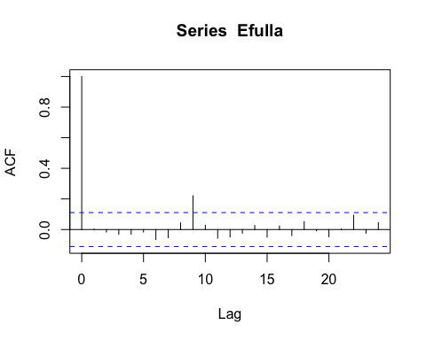

pacf(Efulla, na.action=na.pass)

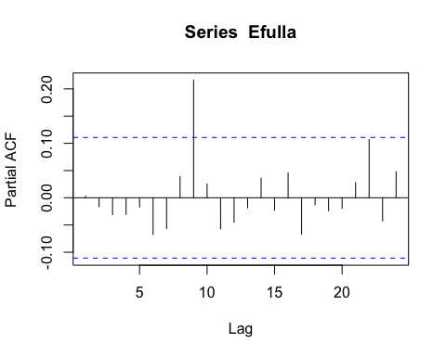 Still autocorrelation in the later lags

# corARMA structure

SPC.mod.arma.2.2 <- gls(dailySPC ~ site.ID,   
 na.action = na.omit,   
 data = mean_daily_2018,   
 correlation = corARMA(form = ~ julian|site.ID, p = 2, q = 2))

# ACF plot

Ear1<-residuals(SPC.mod.arma.2.2, type="normalized")  
I1<-!is.na(mean_daily_2018$dailySPC)  
Efulla<-vector(length = length(mean_daily_2018$dailySPC))  
Efulla<-NA  
Efulla[I1]<-Ear1  
acf(Efulla, na.action=na.pass)

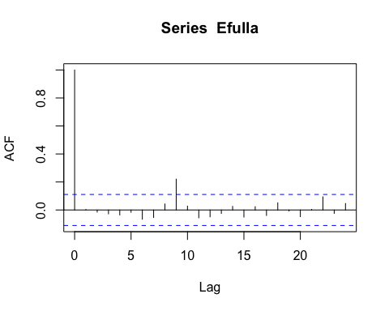

pacf(Efulla, na.action=na.pass)

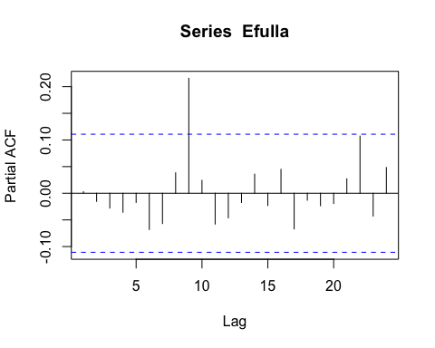 Still autocorrelation

# generalized linear hypotheses

site.ID.comp <- glht(SPC.mod.arma.1.1, linfct = mcp(site.ID = "Tukey"))  
summary(site.ID.comp)

##   
## Simultaneous Tests for General Linear Hypotheses  
##   
## Multiple Comparisons of Means: Tukey Contrasts  
##   
##   
## Fit: gls(model = dailySPC ~ site.ID, data = mean_daily_2018, correlation = corARMA(form = ~julian |   
## site.ID, p = 1, q = 1), na.action = na.omit)  
##   
## Linear Hypotheses:  
## Estimate Std. Error z value Pr(>|z|)   
## FRCH - CARI == 0 11.164 5.840 1.912 0.135   
## MOOS - CARI == 0 41.558 5.800 7.166 <1e-04 ***  
## MOOS - FRCH == 0 30.395 5.757 5.280 <1e-04 ***  
## ---  
## Signif. codes: 0 '***' 0.001 '**' 0.01 '*' 0.05 '.' 0.1 ' ' 1  
## (Adjusted p values reported -- single-step method)

summary(SPC.mod.arma.1.1)

## Generalized least squares fit by REML  
## Model: dailySPC ~ site.ID   
## Data: mean_daily_2018   
## AIC BIC logLik  
## 1706.817 1728.626 -847.4085  
##   
## Correlation Structure: ARMA(1,1)  
## Formula: ~julian | site.ID   
## Parameter estimate(s):  
## Phi1 Theta1   
## 0.8459489 0.3684211   
##   
## Coefficients:  
## Value Std.Error t-value p-value  
## (Intercept) 67.70660 4.159580 16.277269 0.000  
## site.IDFRCH 11.16352 5.840092 1.911531 0.057  
## site.IDMOOS 41.55833 5.799683 7.165620 0.000  
##   
## Correlation:   
## (Intr) s.IDFR  
## site.IDFRCH -0.712   
## site.IDMOOS -0.717 0.511  
##   
## Standardized residuals:  
## Min Q1 Med Q3 Max   
## -2.35651626 -0.66027617 0.07050021 0.73653737 1.93115831   
##   
## Residual standard error: 12.17516   
## Degrees of freedom: 283 total; 280 residual

intervals(SPC.mod.arma.1.1)

## Approximate 95% confidence intervals  
##   
## Coefficients:  
## lower est. upper  
## (Intercept) 59.5185845 67.70660 75.89462  
## site.IDFRCH -0.3325421 11.16352 22.65958  
## site.IDMOOS 30.1418080 41.55833 52.97484  
## attr(,"label")  
## [1] "Coefficients:"  
##   
## Correlation structure:  
## lower est. upper  
## Phi1 0.7582501 0.8459489 0.9035781  
## Theta1 0.2499449 0.3684211 0.4760281  
## attr(,"label")  
## [1] "Correlation structure:"  
##   
## Residual standard error:  
## lower est. upper   
## 9.715932 12.175157 15.256842

plot(print(confint(site.ID.comp)))

##   
## Simultaneous Confidence Intervals  
##   
## Multiple Comparisons of Means: Tukey Contrasts  
##   
##   
## Fit: gls(model = dailySPC ~ site.ID, data = mean_daily_2018, correlation = corARMA(form = ~julian |   
## site.ID, p = 1, q = 1), na.action = na.omit)  
##   
## Quantile = 2.3438  
## 95% family-wise confidence level  
##   
##   
## Linear Hypotheses:  
## Estimate lwr upr   
## FRCH - CARI == 0 11.1635 -2.5244 24.8514  
## MOOS - CARI == 0 41.5583 27.9651 55.1515  
## MOOS - FRCH == 0 30.3948 16.9025 43.8871

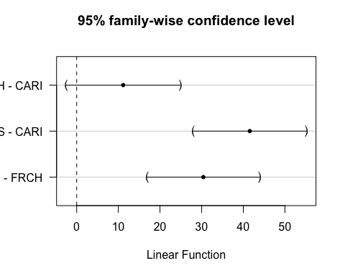 This shows that MOOS is significantly different than CARI and FRCH

### Turb

ggplot(mean_daily_2018, aes(x = julian, y = dailyTurb, color = site.ID)) +  
 geom_line() +  
 scale_color_manual(values=c("#3288BD","#FF7F00", "#A6761D")) +  
 facet_wrap(~site.ID, scales = "free") +  
 theme_classic()

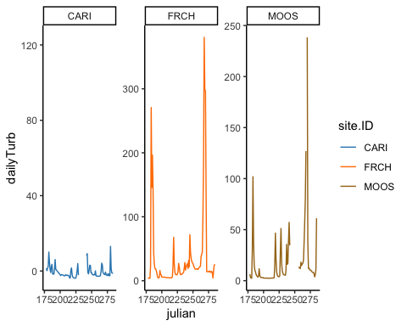

ggplot(mean_daily_2018, aes(x = site.ID, y = dailyTurb, fill = site.ID)) +  
 geom_boxplot() +  
 scale_fill_manual(values=c("#3288BD","#FF7F00", "#A6761D"))

## Warning: Removed 25 rows containing non-finite values (stat_boxplot).

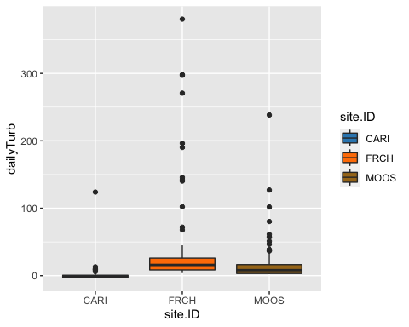

# corAR1 structure

turb.mod.ar1 <- gls(dailyTurb ~ site.ID,   
 na.action = na.omit,   
 data = mean_daily_2018,   
 correlation = corAR1(form = ~ julian|site.ID))

# diagnostic plots

plot(turb.mod.ar1, resid(., type = "p") ~ fitted(.), abline = 0)

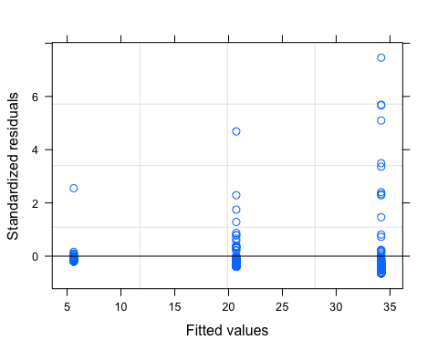

plot(turb.mod.ar1, dailyTurb ~ fitted(.) | site.ID, abline = c(0,1))

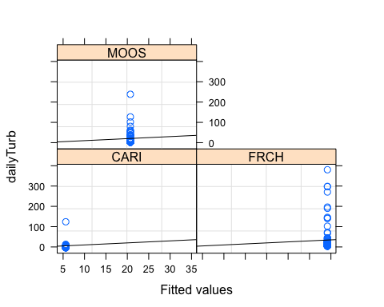

qqnorm(turb.mod.ar1, abline = c(0,1))

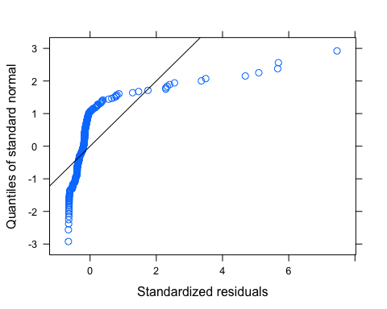 Looks like we have lots of outliers here but our normality isnt good either so lets log transform first and then investigate outliers

# corAR1 structure

mean_daily_2018$logDailyTurb <- log(mean_daily_2018$dailyTurb)

## Warning in log(mean_daily_2018$dailyTurb): NaNs produced

turb.mod.ar1.log <- gls(logDailyTurb ~ site.ID,   
 na.action = na.omit,   
 data = mean_daily_2018,   
 correlation = corAR1(form = ~ julian|site.ID))

# diagnostic plots

plot(turb.mod.ar1.log, resid(., type = "p") ~ fitted(.), abline = 0)

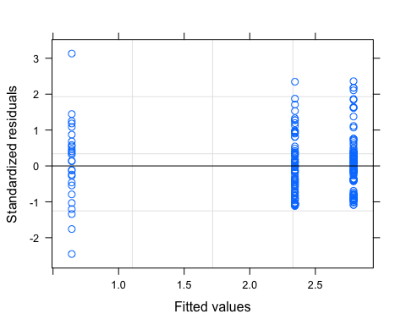

plot(turb.mod.ar1.log, logDailyTurb ~ fitted(.) | site.ID, abline = c(0,1))

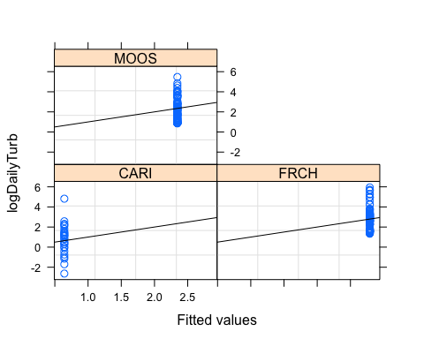

qqnorm(turb.mod.ar1.log, abline = c(0,1))

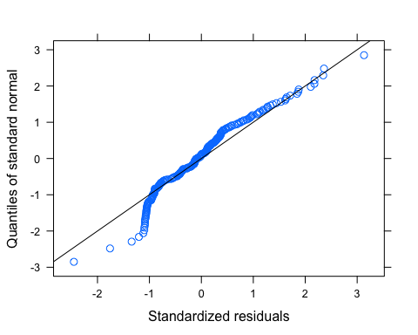 It looks like we may need to further transform Turbidity

# 2019

mean_daily_2019 <- subset(mean_daily, year == "2019")  
mean_daily_2019$site.ID <- as.factor(mean_daily_2019$site.ID)  
ggplot(mean_daily_2019, aes(x = julian, y = dailyNO3, color = site.ID)) +  
 geom_line() +  
 scale_color_manual(values=c("#3288BD","#FF7F00", "#A6761D", "#6A3D9A", "#66C2A5", "#E7298A")) +  
 facet_wrap(~site.ID, scales = "free") +  
 theme_classic()

## Warning: Removed 1 row(s) containing missing values (geom_path).

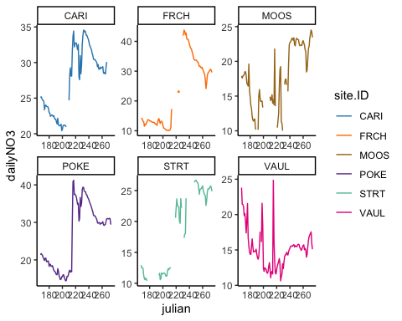

ggplot(mean_daily_2019, aes(x = site.ID, y = dailyNO3, fill = site.ID)) +  
 geom_boxplot() +  
 scale_fill_manual(values=c("#3288BD","#FF7F00", "#A6761D", "#6A3D9A", "#66C2A5", "#E7298A"))

## Warning: Removed 69 rows containing non-finite values (stat_boxplot).

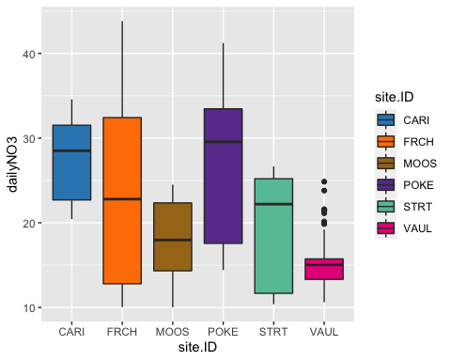 # CorAR1 structure #

varfixed <- varIdent(form = ~ 1|site.ID)  
  
no3.mod.gls <- gls(dailyNO3 ~ site.ID,   
 na.action = na.omit,   
 data = mean_daily_2019,   
 weights = varfixed,  
 correlation = corAR1(form = ~ julian|site.ID))

# diagnostic plots

plot(no3.mod.gls, resid(., type = "p") ~ fitted(.), abline = 0)

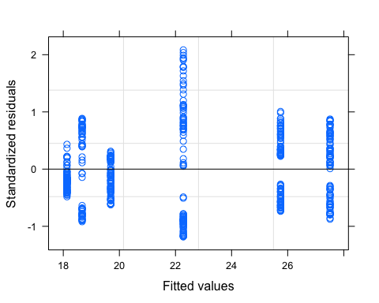

plot(no3.mod.gls, dailyNO3 ~ fitted(.) | site.ID, abline = c(0,1))

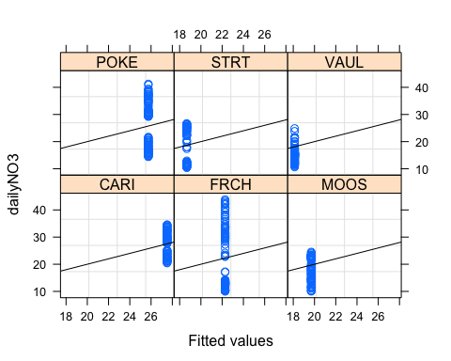

qqnorm(no3.mod.gls, abline = c(0,1))

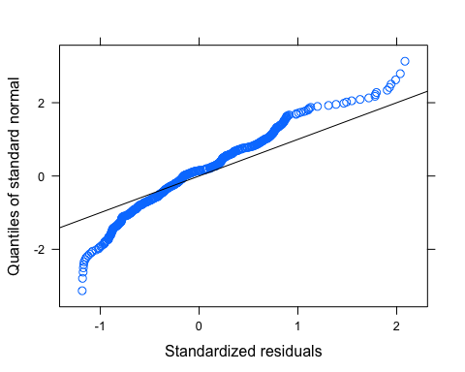 Our normality is not great…lets log transform and variance is heterogeneous even after the varIdent function

mean_daily_2019$logDailyNO3 <- log(abs(mean_daily_2019$dailyNO3))  
  
no3.mod.gls.log <- gls(logDailyNO3 ~ site.ID,   
 na.action = na.omit,   
 data = mean_daily_2019,   
 correlation = corAR1(form = ~ julian|site.ID))

# diagnostic plots

plot(no3.mod.gls.log, resid(., type = "p") ~ fitted(.), abline = 0)

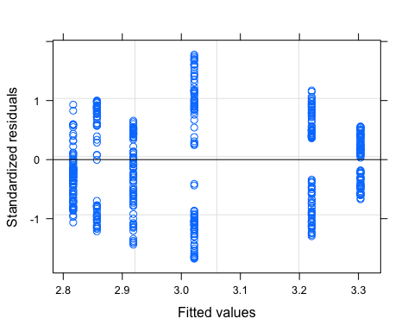

plot(no3.mod.gls.log, logDailyNO3 ~ fitted(.) | site.ID, abline = c(0,1))

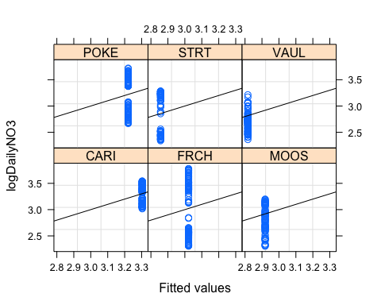

qqnorm(no3.mod.gls.log, abline = c(0,1))

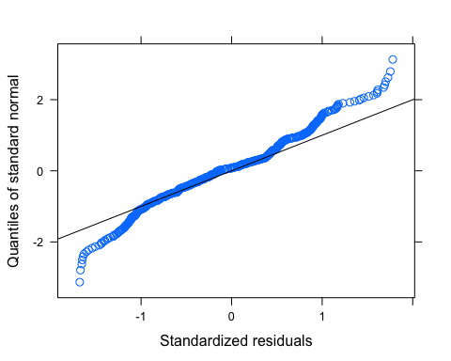 Makes the upper tail a little worse….lets stick with no log transformation

# ACF plot

Ear1<-residuals(no3.mod.gls.log, type="normalized")  
I1<-!is.na(mean_daily_2019$logDailyNO3)  
Efulla<-vector(length = length(mean_daily_2019$logDailyNO3))  
Efulla<-NA  
Efulla[I1]<-Ear1  
acf(Efulla, na.action=na.pass)

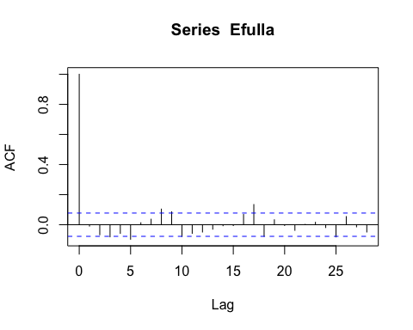

pacf(Efulla, na.action=na.pass)

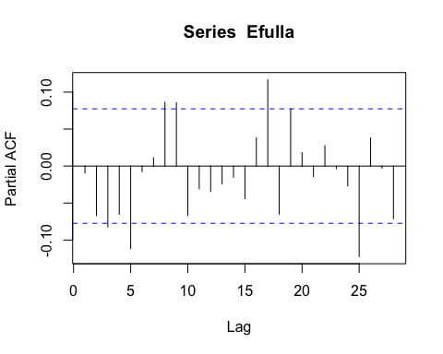 AR1 is not adequately handling the temporal autocorrelation

# corARMA structure

NO3.mod.arma.1.1 <- gls(logDailyNO3 ~ site.ID,   
 na.action = na.omit,   
 data = mean_daily_2019,  
 weights = varfixed,  
 correlation = corARMA(form = ~ julian|site.ID, p = 1, q = 1))

# ACF plot

Ear1<-residuals(NO3.mod.arma.1.1, type="normalized")  
I1<-!is.na(mean_daily_2019$logDailyNO3)  
Efulla<-vector(length = length(mean_daily_2019$logDailyNO3))  
Efulla<-NA  
Efulla[I1]<-Ear1  
acf(Efulla, na.action=na.pass)

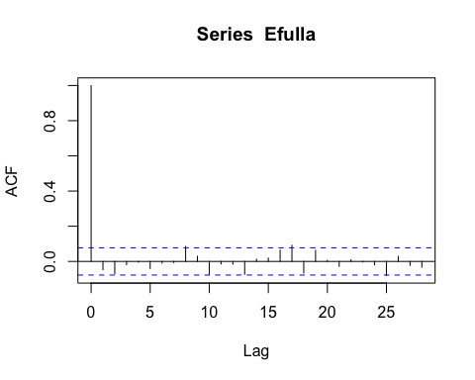

pacf(Efulla, na.action=na.pass)

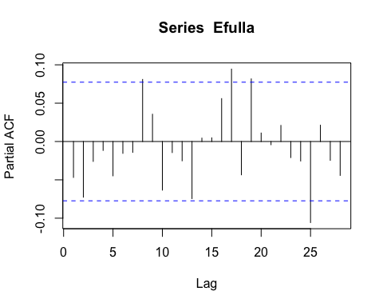 Still autocorrelation

# corARMA structure

NO3.mod.arma.2.1 <- gls(logDailyNO3 ~ site.ID,   
 na.action = na.omit,   
 data = mean_daily_2019,  
 weights = varfixed,  
 correlation = corARMA(form = ~ julian|site.ID, p = 2, q = 1))

# ACF plot

Ear1<-residuals(NO3.mod.arma.2.1, type="normalized")  
I1<-!is.na(mean_daily_2019$logDailyNO3)  
Efulla<-vector(length = length(mean_daily_2019$logDailyNO3))  
Efulla<-NA  
Efulla[I1]<-Ear1  
acf(Efulla, na.action=na.pass)

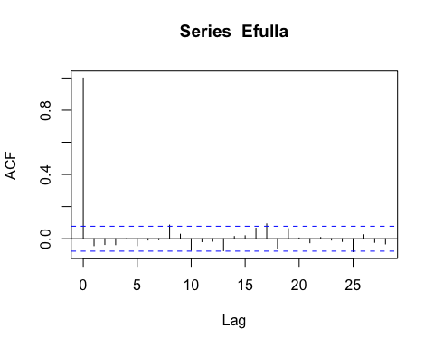

pacf(Efulla, na.action=na.pass)

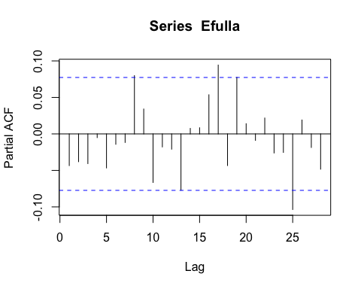 Still autocorrelation

# corARMA structure

NO3.mod.arma.1.2 <- gls(logDailyNO3 ~ site.ID,   
 na.action = na.omit,   
 data = mean_daily_2019,  
 weights = varfixed,  
 correlation = corARMA(form = ~ julian|site.ID, p = 1, q = 2))

# ACF plot

Ear1<-residuals(NO3.mod.arma.1.2, type="normalized")  
I1<-!is.na(mean_daily_2019$logDailyNO3)  
Efulla<-vector(length = length(mean_daily_2019$logDailyNO3))  
Efulla<-NA  
Efulla[I1]<-Ear1  
acf(Efulla, na.action=na.pass)

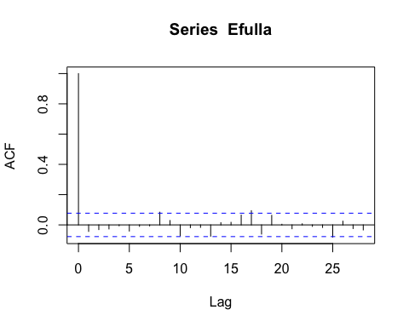

pacf(Efulla, na.action=na.pass)

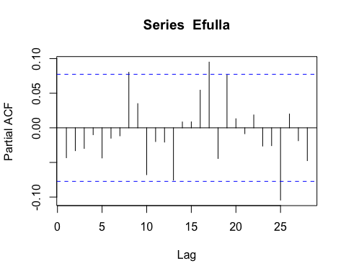

# corARMA structure

NO3.mod.arma.2.2 <- gls(logDailyNO3 ~ site.ID,   
 na.action = na.omit,   
 data = mean_daily_2019,   
 weights = varfixed,  
 correlation = corARMA(form = ~ julian|site.ID, p = 2, q = 2))

# ACF plot

Ear1<-residuals(NO3.mod.arma.2.2, type="normalized")  
I1<-!is.na(mean_daily_2019$logDailyNO3)  
Efulla<-vector(length = length(mean_daily_2019$logDailyNO3))  
Efulla<-NA  
Efulla[I1]<-Ear1  
acf(Efulla, na.action=na.pass)

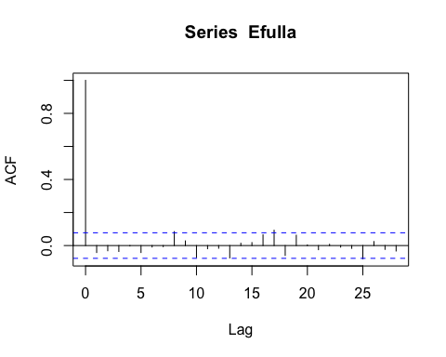

pacf(Efulla, na.action=na.pass)

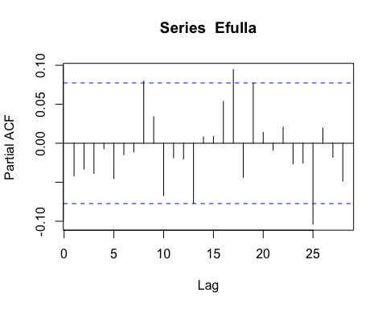

# generalized linear hypotheses

site.ID.comp <- glht(NO3.mod.arma.2.2, linfct = mcp(site.ID = "Tukey"))  
summary(site.ID.comp)

##   
## Simultaneous Tests for General Linear Hypotheses  
##   
## Multiple Comparisons of Means: Tukey Contrasts  
##   
##   
## Fit: gls(model = logDailyNO3 ~ site.ID, data = mean_daily_2019, correlation = corARMA(form = ~julian |   
## site.ID, p = 2, q = 2), weights = varfixed, na.action = na.omit)  
##   
## Linear Hypotheses:  
## Estimate Std. Error z value Pr(>|z|)  
## FRCH - CARI == 0 -0.284975 0.440151 -0.647 0.986  
## MOOS - CARI == 0 -0.356273 0.806216 -0.442 0.998  
## POKE - CARI == 0 -0.084199 0.487166 -0.173 1.000  
## STRT - CARI == 0 -0.439283 0.417679 -1.052 0.890  
## VAUL - CARI == 0 -0.446532 0.748500 -0.597 0.990  
## MOOS - FRCH == 0 -0.071298 0.865167 -0.082 1.000  
## POKE - FRCH == 0 0.200776 0.579535 0.346 0.999  
## STRT - FRCH == 0 -0.154308 0.522480 -0.295 1.000  
## VAUL - FRCH == 0 -0.161557 0.811654 -0.199 1.000  
## POKE - MOOS == 0 0.272074 0.890007 0.306 1.000  
## STRT - MOOS == 0 -0.083010 0.853954 -0.097 1.000  
## VAUL - MOOS == 0 -0.090259 1.055951 -0.085 1.000  
## STRT - POKE == 0 -0.355084 0.562657 -0.631 0.987  
## VAUL - POKE == 0 -0.362333 0.838081 -0.432 0.998  
## VAUL - STRT == 0 -0.007249 0.799690 -0.009 1.000  
## (Adjusted p values reported -- single-step method)

summary(NO3.mod.arma.2.2)

## Generalized least squares fit by REML  
## Model: logDailyNO3 ~ site.ID   
## Data: mean_daily_2019   
## AIC BIC logLik  
## -1315.553 -1246.107 673.7766  
##   
## Correlation Structure: ARMA(2,2)  
## Formula: ~julian | site.ID   
## Parameter estimate(s):  
## Phi1 Phi2 Theta1 Theta2   
## 0.75880935 0.22851235 0.37473208 -0.02172866   
## Variance function:  
## Structure: Different standard deviations per stratum  
## Formula: ~1 | site.ID   
## Parameter estimates:  
## CARI FRCH MOOS POKE STRT VAUL   
## 1.000000 1.772883 3.599524 2.020131 1.651637 3.320650   
##   
## Coefficients:  
## Value Std.Error t-value p-value  
## (Intercept) 3.306199 0.2181774 15.153718 0.0000  
## site.IDFRCH -0.284975 0.4401507 -0.647449 0.5176  
## site.IDMOOS -0.356273 0.8062161 -0.441908 0.6587  
## site.IDPOKE -0.084199 0.4871659 -0.172835 0.8628  
## site.IDSTRT -0.439283 0.4176786 -1.051725 0.2934  
## site.IDVAUL -0.446532 0.7484998 -0.596570 0.5510  
##   
## Correlation:   
## (Intr) s.IDFR s.IDMO s.IDPO s.IDST  
## site.IDFRCH -0.496   
## site.IDMOOS -0.271 0.134   
## site.IDPOKE -0.448 0.222 0.121   
## site.IDSTRT -0.522 0.259 0.141 0.234   
## site.IDVAUL -0.291 0.144 0.079 0.131 0.152  
##   
## Standardized residuals:  
## Min Q1 Med Q3 Max   
## -1.4989578 -0.5478422 -0.1158511 0.4028392 1.5925859   
##   
## Residual standard error: 0.2687015   
## Degrees of freedom: 573 total; 567 residual

plot(print(confint(site.ID.comp)))

##   
## Simultaneous Confidence Intervals  
##   
## Multiple Comparisons of Means: Tukey Contrasts  
##   
##   
## Fit: gls(model = logDailyNO3 ~ site.ID, data = mean_daily_2019, correlation = corARMA(form = ~julian |   
## site.ID, p = 2, q = 2), weights = varfixed, na.action = na.omit)  
##   
## Quantile = 2.8112  
## 95% family-wise confidence level  
##   
##   
## Linear Hypotheses:  
## Estimate lwr upr   
## FRCH - CARI == 0 -0.284975 -1.522310 0.952360  
## MOOS - CARI == 0 -0.356273 -2.622678 1.910131  
## POKE - CARI == 0 -0.084199 -1.453702 1.285303  
## STRT - CARI == 0 -0.439283 -1.613446 0.734879  
## VAUL - CARI == 0 -0.446532 -2.550687 1.657622  
## MOOS - FRCH == 0 -0.071298 -2.503424 2.360827  
## POKE - FRCH == 0 0.200776 -1.428390 1.829942  
## STRT - FRCH == 0 -0.154308 -1.623084 1.314468  
## VAUL - FRCH == 0 -0.161557 -2.443248 2.120133  
## POKE - MOOS == 0 0.272074 -2.229880 2.774028  
## STRT - MOOS == 0 -0.083010 -2.483613 2.317593  
## VAUL - MOOS == 0 -0.090259 -3.058710 2.878192  
## STRT - POKE == 0 -0.355084 -1.936805 1.226637  
## VAUL - POKE == 0 -0.362333 -2.718315 1.993649  
## VAUL - STRT == 0 -0.007249 -2.255309 2.240810

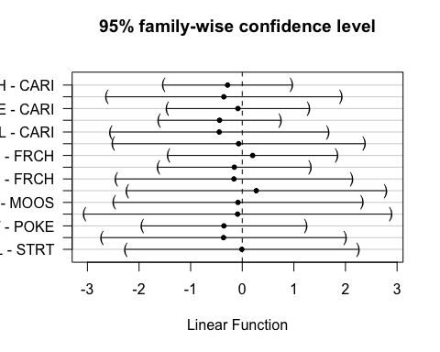 This shows significance for any of the sites

### fDOM

ggplot(mean_daily_2019, aes(x = julian, y = dailyfDOM, color = site.ID)) +  
 geom_line() +  
 scale_color_manual(values=c("#3288BD","#FF7F00", "#A6761D", "#6A3D9A", "#66C2A5", "#E7298A")) +  
 facet_wrap(~site.ID, scales = "free") +  
 theme_classic()

## Warning: Removed 1 row(s) containing missing values (geom_path).

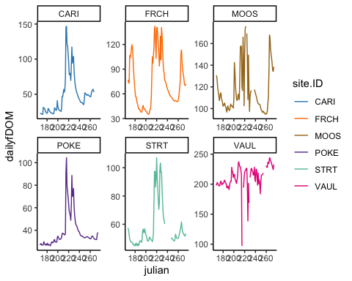

ggplot(mean_daily_2019, aes(x = site.ID, y = dailyfDOM, fill = site.ID)) +  
 geom_boxplot() +  
 scale_fill_manual(values=c("#3288BD","#FF7F00", "#A6761D", "#6A3D9A", "#66C2A5", "#E7298A"))

## Warning: Removed 23 rows containing non-finite values (stat_boxplot).

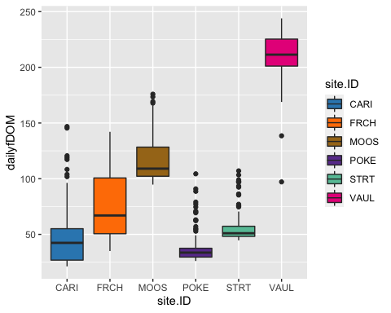

# corAR1 structure

fDOM.mod.ar1 <- gls(dailyfDOM ~ site.ID,   
 na.action = na.omit,   
 data = mean_daily_2019,   
 correlation = corAR1(form = ~ julian|site.ID))

# diagnostic plots

plot(fDOM.mod.ar1, resid(., type = "p") ~ fitted(.), abline = 0)

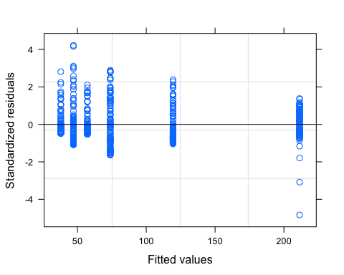

plot(fDOM.mod.ar1, dailyfDOM ~ fitted(.) | site.ID, abline = c(0,1))

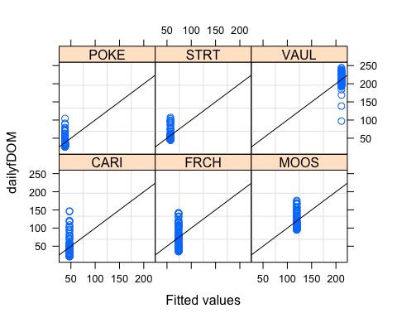

qqnorm(fDOM.mod.ar1, abline = c(0,1))

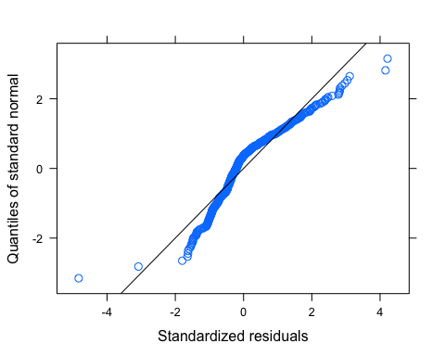 Let me log transform to see if its better

# log transformed

mean_daily_2019$logDailyfDOM <- log(mean_daily_2019$dailyfDOM)  
  
fDOM.mod.ar1.log <- gls(logDailyfDOM ~ site.ID,   
 na.action = na.omit,   
 data = mean_daily_2019,  
 weights = varfixed,  
 correlation = corAR1(form = ~ julian|site.ID))

# diagnostic plots

plot(fDOM.mod.ar1.log, resid(., type = "p") ~ fitted(.), abline = 0)

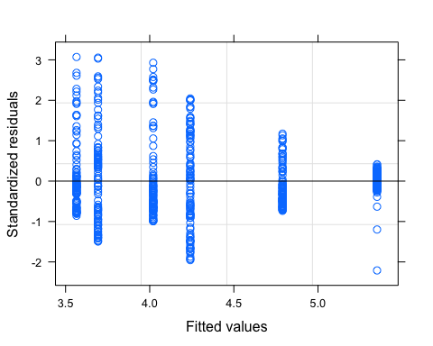

plot(fDOM.mod.ar1.log, logDailyfDOM ~ fitted(.) | site.ID, abline = c(0,1))

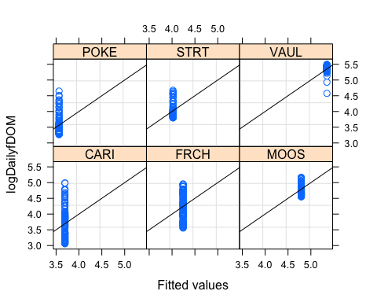

qqnorm(fDOM.mod.ar1.log, abline = c(0,1))

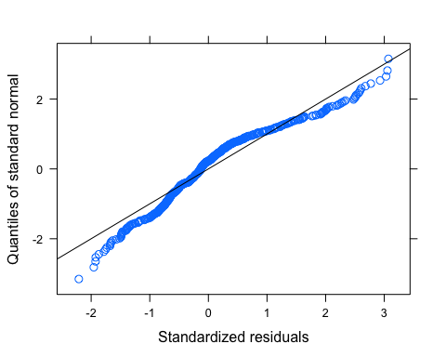 It is better but do we need to further transform? our variance looks not so homogeneous even after the varIdent function

# ACF plot

Ear1<-residuals(fDOM.mod.ar1.log, type="normalized")  
I1<-!is.na(mean_daily_2019$logDailyfDOM)  
Efulla<-vector(length = length(mean_daily_2019$logDailyfDOM))  
Efulla<-NA  
Efulla[I1]<-Ear1  
acf(Efulla, na.action=na.pass)

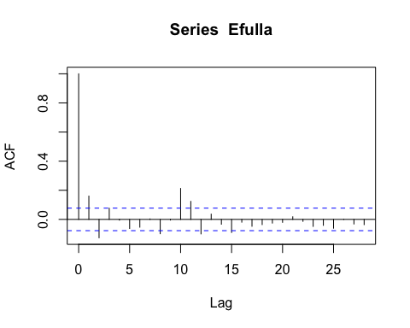

pacf(Efulla, na.action=na.pass)

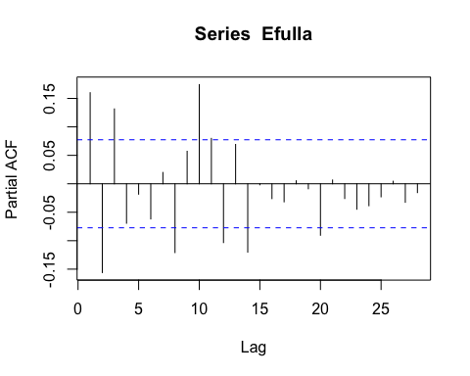 AR1 is not adequately handling the temporal autocorrelation

# corARMA structure

fDOM.mod.arma.1.1 <- gls(logDailyfDOM ~ site.ID,   
 na.action = na.omit,   
 data = mean_daily_2019,   
 weights = varfixed,  
 correlation = corARMA(form = ~ julian|site.ID, p = 1, q = 1))

# ACF plot

Ear1<-residuals(fDOM.mod.arma.1.1, type="normalized")  
I1<-!is.na(mean_daily_2019$logDailyfDOM)  
Efulla<-vector(length = length(mean_daily_2019$logDailyfDOM))  
Efulla<-NA  
Efulla[I1]<-Ear1  
acf(Efulla, na.action=na.pass)

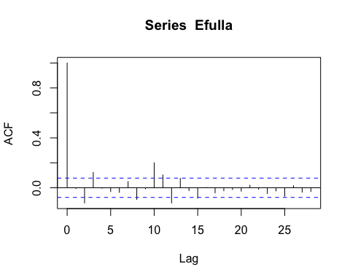

pacf(Efulla, na.action=na.pass)

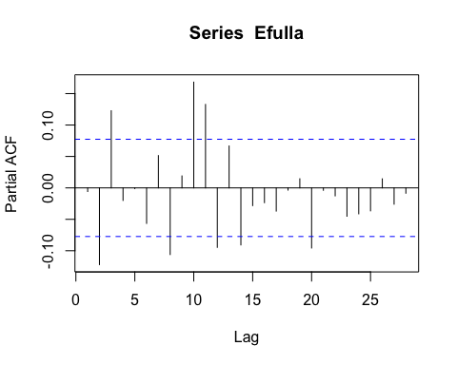 Still autocorrelation

# corARMA structure

fDOM.mod.arma.2.1 <- gls(logDailyfDOM ~ site.ID,   
 na.action = na.omit,   
 data = mean_daily_2019,   
 weights = varfixed,  
 correlation = corARMA(form = ~ julian|site.ID, p = 2, q = 1))

# ACF plot

Ear1<-residuals(fDOM.mod.arma.2.1, type="normalized")  
I1<-!is.na(mean_daily_2019$logDailyfDOM)  
Efulla<-vector(length = length(mean_daily_2019$logDailyfDOM))  
Efulla<-NA  
Efulla[I1]<-Ear1  
acf(Efulla, na.action=na.pass)

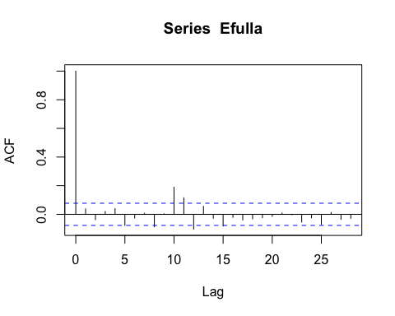

pacf(Efulla, na.action=na.pass)

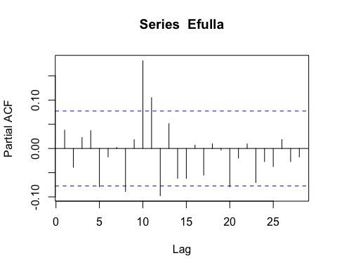 gets worse in the later lags

# corARMA structure

fDOM.mod.arma.1.2 <- gls(logDailyfDOM ~ site.ID,   
 na.action = na.omit,   
 data = mean_daily_2019,  
 weights = varfixed,  
 correlation = corARMA(form = ~ julian|site.ID, p = 1, q = 2))

# ACF plot

Ear1<-residuals(fDOM.mod.arma.1.2, type="normalized")  
I1<-!is.na(mean_daily_2019$logDailyfDOM)  
Efulla<-vector(length = length(mean_daily_2019$logDailyfDOM))  
Efulla<-NA  
Efulla[I1]<-Ear1  
acf(Efulla, na.action=na.pass)

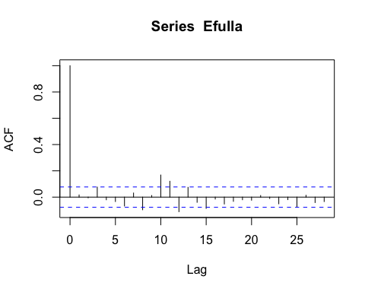

pacf(Efulla, na.action=na.pass)

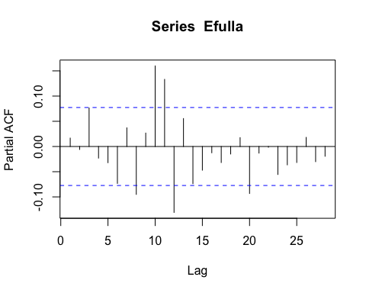 Still autocorrelation in the later lags

# corARMA structure

fDOM.mod.arma.2.2 <- gls(logDailyfDOM ~ site.ID,   
 na.action = na.omit,   
 data = mean_daily_2019,   
 weights = varfixed,  
 correlation = corARMA(form = ~ julian|site.ID, p = 2, q = 2))

# ACF plot

Ear1<-residuals(fDOM.mod.arma.2.2, type="normalized")  
I1<-!is.na(mean_daily_2019$logDailyfDOM)  
Efulla<-vector(length = length(mean_daily_2019$logDailyfDOM))  
Efulla<-NA  
Efulla[I1]<-Ear1  
acf(Efulla, na.action=na.pass)

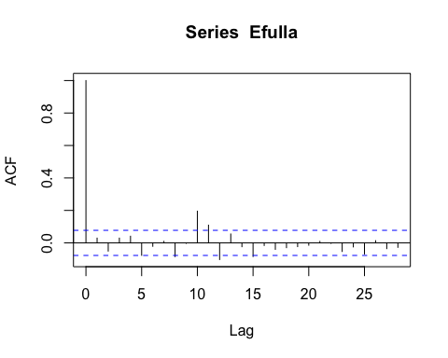

pacf(Efulla, na.action=na.pass)

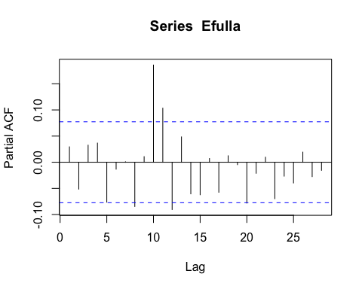 Still autocorrelation but this is the best one yet so lets interpret this model

# generalized linear hypotheses

site.ID.comp <- glht(fDOM.mod.arma.2.2, linfct = mcp(site.ID = "Tukey"))  
summary(site.ID.comp)

##   
## Simultaneous Tests for General Linear Hypotheses  
##   
## Multiple Comparisons of Means: Tukey Contrasts  
##   
##   
## Fit: gls(model = logDailyfDOM ~ site.ID, data = mean_daily_2019, correlation = corARMA(form = ~julian |   
## site.ID, p = 2, q = 2), weights = varfixed, na.action = na.omit)  
##   
## Linear Hypotheses:  
## Estimate Std. Error z value Pr(>|z|)   
## FRCH - CARI == 0 0.5274 0.2582 2.043 0.3106   
## MOOS - CARI == 0 1.0774 0.2475 4.353 <0.001 ***  
## POKE - CARI == 0 -0.1361 0.2559 -0.532 0.9947   
## STRT - CARI == 0 0.3165 0.2210 1.432 0.7000   
## VAUL - CARI == 0 1.6437 0.2639 6.229 <0.001 ***  
## MOOS - FRCH == 0 0.5500 0.2212 2.487 0.1240   
## POKE - FRCH == 0 -0.6635 0.2305 -2.879 0.0445 *   
## STRT - FRCH == 0 -0.2108 0.1910 -1.104 0.8761   
## VAUL - FRCH == 0 1.1163 0.2393 4.664 <0.001 ***  
## POKE - MOOS == 0 -1.2136 0.2185 -5.555 <0.001 ***  
## STRT - MOOS == 0 -0.7609 0.1764 -4.314 <0.001 ***  
## VAUL - MOOS == 0 0.5663 0.2278 2.486 0.1241   
## STRT - POKE == 0 0.4527 0.1879 2.409 0.1484   
## VAUL - POKE == 0 1.7798 0.2369 7.515 <0.001 ***  
## VAUL - STRT == 0 1.3271 0.1987 6.680 <0.001 ***  
## ---  
## Signif. codes: 0 '***' 0.001 '**' 0.01 '*' 0.05 '.' 0.1 ' ' 1  
## (Adjusted p values reported -- single-step method)

summary(fDOM.mod.arma.2.2)

## Generalized least squares fit by REML  
## Model: logDailyfDOM ~ site.ID   
## Data: mean_daily_2019   
## AIC BIC logLik  
## -1009.09 -938.3959 520.5449  
##   
## Correlation Structure: ARMA(2,2)  
## Formula: ~julian | site.ID   
## Parameter estimate(s):  
## Phi1 Phi2 Theta1 Theta2   
## 0.25089116 0.63774740 0.92388021 0.03717597   
## Variance function:  
## Structure: Different standard deviations per stratum  
## Formula: ~1 | site.ID   
## Parameter estimates:  
## CARI FRCH MOOS POKE STRT VAUL   
## 1.0000000 0.8513131 0.7619040 0.8325413 0.4982190 0.8965888   
##   
## Coefficients:  
## Value Std.Error t-value p-value  
## (Intercept) 3.705141 0.1987383 18.643319 0.0000  
## site.IDFRCH 0.527399 0.2581724 2.042818 0.0415  
## site.IDMOOS 1.077432 0.2475074 4.353130 0.0000  
## site.IDPOKE -0.136140 0.2558683 -0.532069 0.5949  
## site.IDSTRT 0.316550 0.2209950 1.432383 0.1525  
## site.IDVAUL 1.643691 0.2638625 6.229344 0.0000  
##   
## Correlation:   
## (Intr) s.IDFR s.IDMO s.IDPO s.IDST  
## site.IDFRCH -0.770   
## site.IDMOOS -0.803 0.618   
## site.IDPOKE -0.777 0.598 0.624   
## site.IDSTRT -0.899 0.692 0.722 0.698   
## site.IDVAUL -0.753 0.580 0.605 0.585 0.677  
##   
## Standardized residuals:  
## Min Q1 Med Q3 Max   
## -2.0712312 -0.5896939 -0.1334116 0.3379417 3.1437878   
##   
## Residual standard error: 0.4161263   
## Degrees of freedom: 619 total; 613 residual

intervals(fDOM.mod.arma.2.2)

## Approximate 95% confidence intervals  
##   
## Coefficients:  
## lower est. upper  
## (Intercept) 3.31485067 3.7051411 4.0954316  
## site.IDFRCH 0.02038957 0.5273992 1.0344088  
## site.IDMOOS 0.59136658 1.0774318 1.5634970  
## site.IDPOKE -0.63862440 -0.1361397 0.3663451  
## site.IDSTRT -0.11744974 0.3165495 0.7505488  
## site.IDVAUL 1.12550642 1.6436906 2.1618748  
## attr(,"label")  
## [1] "Coefficients:"  
##   
## Correlation structure:  
## lower est. upper  
## Phi1 0.1802493 0.25089116 0.1754639  
## Phi2 0.3837517 0.63774740 0.8020324  
## Theta1 0.5911321 0.92388021 1.1570010  
## Theta2 -0.1252026 0.03717597 0.1976148  
## attr(,"label")  
## [1] "Correlation structure:"  
##   
## Variance function:  
## lower est. upper  
## FRCH 0.6990968 0.8513131 1.0366718  
## MOOS 0.6257496 0.7619040 0.9276839  
## POKE 0.6865054 0.8325413 1.0096425  
## STRT 0.4071402 0.4982190 0.6096724  
## VAUL 0.7362804 0.8965888 1.0918008  
## attr(,"label")  
## [1] "Variance function:"  
##   
## Residual standard error:  
## lower est. upper   
## 0.3188340 0.4161263 0.5431073

plot(print(confint(site.ID.comp)))

##   
## Simultaneous Confidence Intervals  
##   
## Multiple Comparisons of Means: Tukey Contrasts  
##   
##   
## Fit: gls(model = logDailyfDOM ~ site.ID, data = mean_daily_2019, correlation = corARMA(form = ~julian |   
## site.ID, p = 2, q = 2), weights = varfixed, na.action = na.omit)  
##   
## Quantile = 2.8386  
## 95% family-wise confidence level  
##   
##   
## Linear Hypotheses:  
## Estimate lwr upr   
## FRCH - CARI == 0 0.527399 -0.205439 1.260237  
## MOOS - CARI == 0 1.077432 0.374867 1.779996  
## POKE - CARI == 0 -0.136140 -0.862437 0.590158  
## STRT - CARI == 0 0.316550 -0.310758 0.943857  
## VAUL - CARI == 0 1.643691 0.894701 2.392680  
## MOOS - FRCH == 0 0.550033 -0.077790 1.177856  
## POKE - FRCH == 0 -0.663539 -1.317812 -0.009266  
## STRT - FRCH == 0 -0.210850 -0.753141 0.331441  
## VAUL - FRCH == 0 1.116291 0.436917 1.795666  
## POKE - MOOS == 0 -1.213571 -1.833748 -0.593395  
## STRT - MOOS == 0 -0.760882 -1.261507 -0.260257  
## VAUL - MOOS == 0 0.566259 -0.080345 1.212862  
## STRT - POKE == 0 0.452689 -0.080730 0.986109  
## VAUL - POKE == 0 1.779830 1.107516 2.452145  
## VAUL - STRT == 0 1.327141 0.763214 1.891068

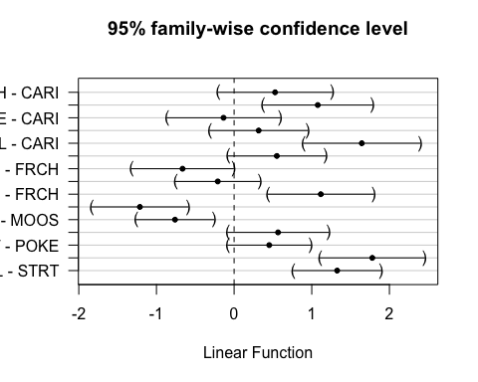 This shows that VAUL is different from CARI, FRCH, POKE, STRT MOOS is different than CARI, POKE, STRT

### SPC

ggplot(mean_daily_2019, aes(x = julian, y = dailySPC, color = site.ID)) +  
 geom_line() +  
 scale_color_manual(values=c("#3288BD","#FF7F00", "#A6761D", "#6A3D9A", "#66C2A5", "#E7298A")) +  
 facet_wrap(~site.ID, scales = "free") +  
 theme_classic()

## Warning: Removed 1 row(s) containing missing values (geom_path).

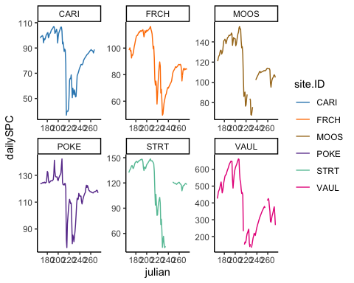

ggplot(mean_daily_2019, aes(x = site.ID, y = dailySPC, fill = site.ID)) +  
 geom_boxplot() +  
 scale_fill_manual(values=c("#3288BD","#FF7F00", "#A6761D", "#6A3D9A", "#66C2A5", "#E7298A"))

## Warning: Removed 27 rows containing non-finite values (stat_boxplot).

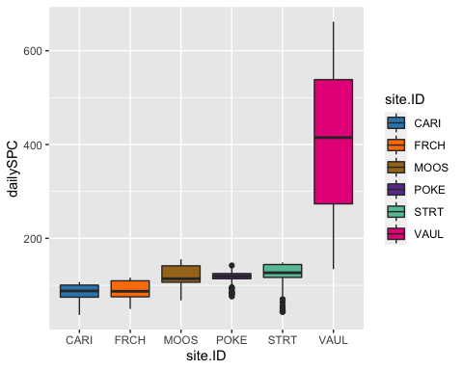

# corAR1 structure

SPC.mod.ar1 <- gls(dailySPC ~ site.ID,   
 na.action = na.omit,   
 data = mean_daily_2019,   
 correlation = corAR1(form = ~ julian|site.ID))

# diagnostic plots

plot(SPC.mod.ar1, resid(., type = "p") ~ fitted(.), abline = 0)

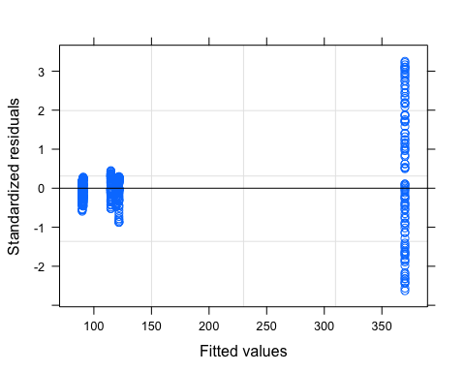

plot(SPC.mod.ar1, dailySPC ~ fitted(.) | site.ID, abline = c(0,1))

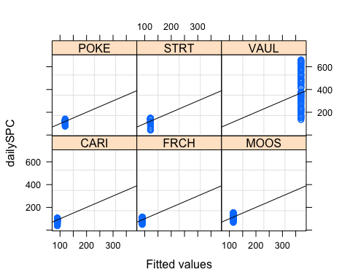

qqnorm(SPC.mod.ar1, abline = c(0,1))

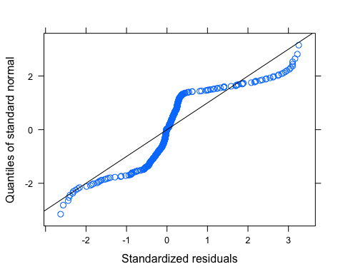 VAUL has way more heterogeneity that needs to be dealt with

mean_daily_2019$logDailySPC <- log(abs(mean_daily_2019$dailySPC))  
  
SPC.mod.ar1.log <- gls(logDailySPC ~ site.ID,   
 na.action = na.omit,   
 data = mean_daily_2019,   
 weights = varfixed,  
 correlation = corAR1(form = ~ julian|site.ID))

# diagnostic plots

plot(SPC.mod.ar1.log, resid(., type = "p") ~ fitted(.), abline = 0)

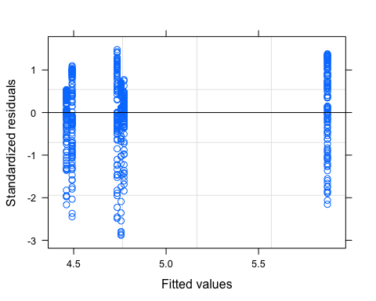

plot(SPC.mod.ar1.log, dailySPC ~ fitted(.) | site.ID, abline = c(0,1))

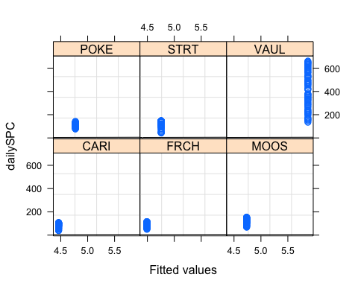

qqnorm(SPC.mod.ar1.log, abline = c(0,1))

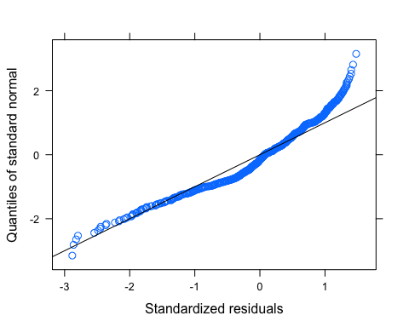 normality plot doesnt look the best

# ACF plot

Ear1<-residuals(SPC.mod.ar1.log, type="normalized")  
I1<-!is.na(mean_daily_2019$logDailySPC)  
Efulla<-vector(length = length(mean_daily_2019$logDailySPC))  
Efulla<-NA  
Efulla[I1]<-Ear1  
acf(Efulla, na.action=na.pass)

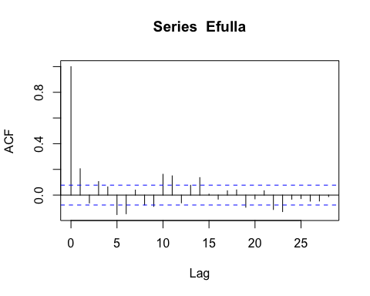

pacf(Efulla, na.action=na.pass)

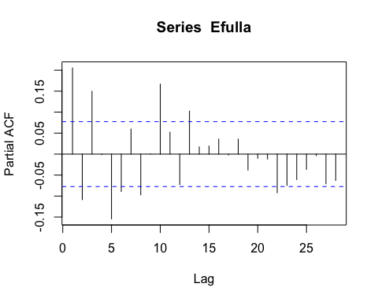 AR1 is not adequately handling the temporal autocorrelation

# corARMA structure

SPC.mod.arma.1.1 <- gls(logDailySPC ~ site.ID,   
 na.action = na.omit,   
 data = mean_daily_2019,   
 weights = varfixed,  
 correlation = corARMA(form = ~ julian|site.ID, p = 1, q = 1))

# ACF plot

Ear1<-residuals(SPC.mod.arma.1.1, type="normalized")  
I1<-!is.na(mean_daily_2019$logDailySPC)  
Efulla<-vector(length = length(mean_daily_2019$logDailySPC))  
Efulla<-NA  
Efulla[I1]<-Ear1  
acf(Efulla, na.action=na.pass)

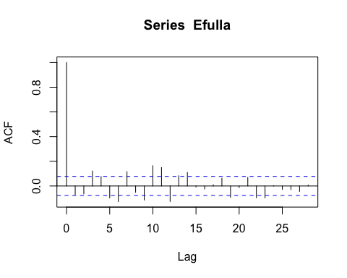

pacf(Efulla, na.action=na.pass)

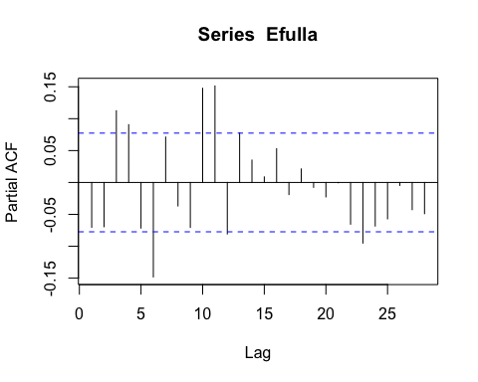 Still autocorrelation

# corARMA structure

SPC.mod.arma.2.1 <- gls(logDailySPC ~ site.ID,   
 na.action = na.omit,   
 data = mean_daily_2019,   
 weights = varfixed,  
 correlation = corARMA(form = ~ julian|site.ID, p = 2, q = 1))

# ACF plot

Ear1<-residuals(SPC.mod.arma.2.1, type="normalized")  
I1<-!is.na(mean_daily_2019$logDailySPC)  
Efulla<-vector(length = length(mean_daily_2019$logDailySPC))  
Efulla<-NA  
Efulla[I1]<-Ear1  
acf(Efulla, na.action=na.pass)

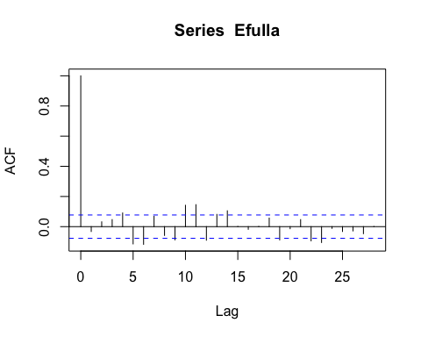

pacf(Efulla, na.action=na.pass)

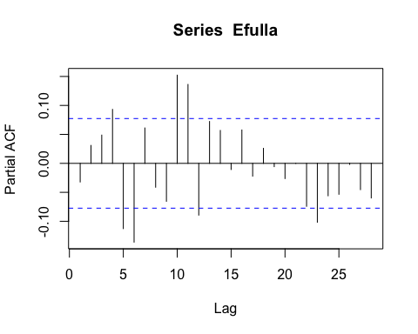 Still autocorrelation

# corARMA structure

SPC.mod.arma.1.2 <- gls(logDailySPC ~ site.ID,   
 na.action = na.omit,   
 data = mean_daily_2019,  
 weights = varfixed,  
 correlation = corARMA(form = ~ julian|site.ID, p = 1, q = 2))

# ACF plot

Ear1<-residuals(SPC.mod.arma.1.2, type="normalized")  
I1<-!is.na(mean_daily_2019$logDailySPC)  
Efulla<-vector(length = length(mean_daily_2019$logDailySPC))  
Efulla<-NA  
Efulla[I1]<-Ear1  
acf(Efulla, na.action=na.pass)

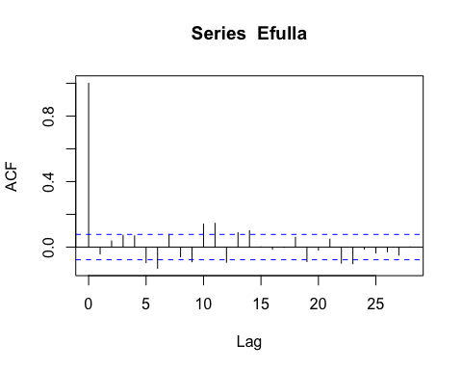

pacf(Efulla, na.action=na.pass)

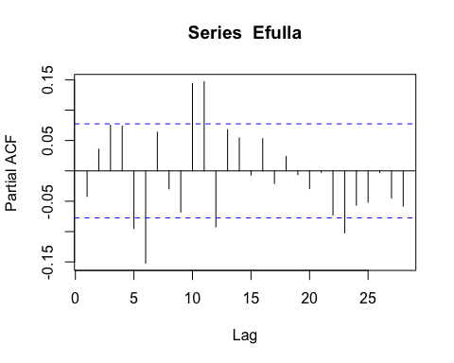 Still autocorrelation in the later lags

# corARMA structure

SPC.mod.arma.2.2 <- gls(logDailySPC ~ site.ID,   
 na.action = na.omit,   
 data = mean_daily_2019,   
 weights = varfixed,  
 correlation = corARMA(form = ~ julian|site.ID, p = 2, q = 2))

# ACF plot

Ear1<-residuals(SPC.mod.arma.2.2, type="normalized")  
I1<-!is.na(mean_daily_2019$logDailySPC)  
Efulla<-vector(length = length(mean_daily_2019$logDailySPC))  
Efulla<-NA  
Efulla[I1]<-Ear1  
acf(Efulla, na.action=na.pass)

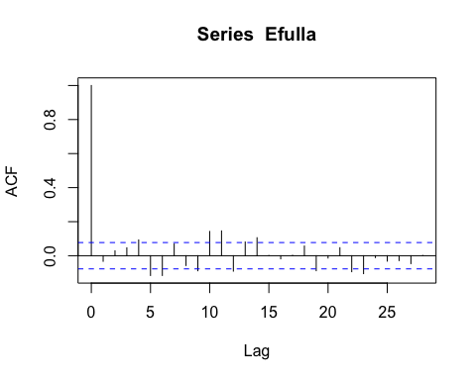

pacf(Efulla, na.action=na.pass)

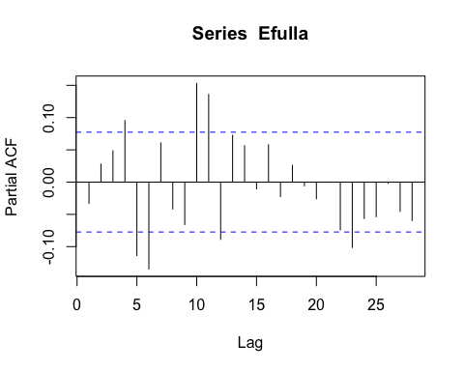 Still autocorrelation

# generalized linear hypotheses

site.ID.comp <- glht(SPC.mod.arma.1.1, linfct = mcp(site.ID = "Tukey"))  
summary(site.ID.comp)

##   
## Simultaneous Tests for General Linear Hypotheses  
##   
## Multiple Comparisons of Means: Tukey Contrasts  
##   
##   
## Fit: gls(model = logDailySPC ~ site.ID, data = mean_daily_2019, correlation = corARMA(form = ~julian |   
## site.ID, p = 1, q = 1), weights = varfixed, na.action = na.omit)  
##   
## Linear Hypotheses:  
## Estimate Std. Error z value Pr(>|z|)   
## FRCH - CARI == 0 0.046013 0.245975 0.187 0.999966   
## MOOS - CARI == 0 0.296333 0.236200 1.255 0.800152   
## POKE - CARI == 0 0.326599 0.244302 1.337 0.753551   
## STRT - CARI == 0 0.297759 0.275943 1.079 0.883609   
## VAUL - CARI == 0 1.433212 0.300430 4.771 < 1e-04 ***  
## MOOS - FRCH == 0 0.250320 0.155188 1.613 0.575504   
## POKE - FRCH == 0 0.280586 0.167262 1.678 0.532084   
## STRT - FRCH == 0 0.251746 0.210802 1.194 0.831546   
## VAUL - FRCH == 0 1.387199 0.241973 5.733 < 1e-04 ***  
## POKE - MOOS == 0 0.030266 0.152522 0.198 0.999954   
## STRT - MOOS == 0 0.001426 0.199309 0.007 1.000000   
## VAUL - MOOS == 0 1.136879 0.232029 4.900 < 1e-04 ***  
## STRT - POKE == 0 -0.028840 0.208847 -0.138 0.999992   
## VAUL - POKE == 0 1.106613 0.240272 4.606 < 1e-04 ***  
## VAUL - STRT == 0 1.135453 0.272381 4.169 0.000387 ***  
## ---  
## Signif. codes: 0 '***' 0.001 '**' 0.01 '*' 0.05 '.' 0.1 ' ' 1  
## (Adjusted p values reported -- single-step method)

summary(SPC.mod.arma.1.1)

## Generalized least squares fit by REML  
## Model: logDailySPC ~ site.ID   
## Data: mean_daily_2019   
## AIC BIC logLik  
## -1557.514 -1495.748 792.7568  
##   
## Correlation Structure: ARMA(1,1)  
## Formula: ~julian | site.ID   
## Parameter estimate(s):  
## Phi1 Theta1   
## 0.9481807 0.4216002   
## Variance function:  
## Structure: Different standard deviations per stratum  
## Formula: ~1 | site.ID   
## Parameter estimates:  
## CARI FRCH MOOS POKE STRT VAUL   
## 1.0000000 0.5728116 0.4696990 0.5562545 0.8261418 1.0030384   
##   
## Coefficients:  
## Value Std.Error t-value p-value  
## (Intercept) 4.441011 0.2147218 20.682629 0.0000  
## site.IDFRCH 0.046013 0.2459754 0.187063 0.8517  
## site.IDMOOS 0.296333 0.2361998 1.254586 0.2101  
## site.IDPOKE 0.326599 0.2443021 1.336865 0.1818  
## site.IDSTRT 0.297759 0.2759429 1.079062 0.2810  
## site.IDVAUL 1.433212 0.3004296 4.770543 0.0000  
##   
## Correlation:   
## (Intr) s.IDFR s.IDMO s.IDPO s.IDST  
## site.IDFRCH -0.873   
## site.IDMOOS -0.909 0.794   
## site.IDPOKE -0.879 0.767 0.799   
## site.IDSTRT -0.778 0.679 0.707 0.684   
## site.IDVAUL -0.715 0.624 0.650 0.628 0.556  
##   
## Standardized residuals:  
## Min Q1 Med Q3 Max   
## -2.8966097 -0.3273065 0.1200072 0.6104584 1.6087762   
##   
## Residual standard error: 0.4071902   
## Degrees of freedom: 615 total; 609 residual

intervals(SPC.mod.arma.1.1)

## Approximate 95% confidence intervals  
##   
## Coefficients:  
## lower est. upper  
## (Intercept) 4.0193257 4.44101068 4.8626957  
## site.IDFRCH -0.4370499 0.04601294 0.5290758  
## site.IDMOOS -0.1675321 0.29633292 0.7601979  
## site.IDPOKE -0.1531780 0.32659894 0.8063758  
## site.IDSTRT -0.2441558 0.29775941 0.8396746  
## site.IDVAUL 0.8432085 1.43321219 2.0232159  
## attr(,"label")  
## [1] "Coefficients:"  
##   
## Correlation structure:  
## lower est. upper  
## Phi1 0.9081883 0.9481807 0.9710173  
## Theta1 0.3209344 0.4216002 0.5128465  
## attr(,"label")  
## [1] "Correlation structure:"  
##   
## Variance function:  
## lower est. upper  
## FRCH 0.4713993 0.5728116 0.6960408  
## MOOS 0.3837587 0.4696990 0.5748852  
## POKE 0.4571222 0.5562545 0.6768846  
## STRT 0.6750387 0.8261418 1.0110683  
## VAUL 0.8208348 1.0030384 1.2256864  
## attr(,"label")  
## [1] "Variance function:"  
##   
## Residual standard error:  
## lower est. upper   
## 0.2958803 0.4071902 0.5603747

plot(print(confint(site.ID.comp)))

##   
## Simultaneous Confidence Intervals  
##   
## Multiple Comparisons of Means: Tukey Contrasts  
##   
##   
## Fit: gls(model = logDailySPC ~ site.ID, data = mean_daily_2019, correlation = corARMA(form = ~julian |   
## site.ID, p = 1, q = 1), weights = varfixed, na.action = na.omit)  
##   
## Quantile = 2.8255  
## 95% family-wise confidence level  
##   
##   
## Linear Hypotheses:  
## Estimate lwr upr   
## FRCH - CARI == 0 0.046013 -0.648991 0.741017  
## MOOS - CARI == 0 0.296333 -0.371050 0.963716  
## POKE - CARI == 0 0.326599 -0.363677 1.016875  
## STRT - CARI == 0 0.297759 -0.481918 1.077437  
## VAUL - CARI == 0 1.433212 0.584348 2.282076  
## MOOS - FRCH == 0 0.250320 -0.188164 0.688804  
## POKE - FRCH == 0 0.280586 -0.192013 0.753185  
## STRT - FRCH == 0 0.251746 -0.343875 0.847368  
## VAUL - FRCH == 0 1.387199 0.703504 2.070894  
## POKE - MOOS == 0 0.030266 -0.400686 0.461218  
## STRT - MOOS == 0 0.001426 -0.561721 0.564574  
## VAUL - MOOS == 0 1.136879 0.481281 1.792477  
## STRT - POKE == 0 -0.028840 -0.618938 0.561259  
## VAUL - POKE == 0 1.106613 0.427725 1.785502  
## VAUL - STRT == 0 1.135453 0.365839 1.905066

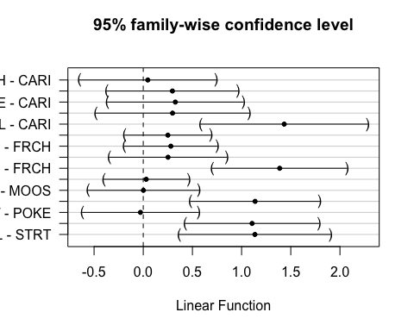 This shows that MOOS is significantly different than CARI and FRCH

### Turb

ggplot(mean_daily_2019, aes(x = julian, y = dailyTurb, color = site.ID)) +  
 geom_line() +  
 scale_color_manual(values=c("#3288BD","#FF7F00", "#A6761D", "#6A3D9A", "#66C2A5", "#E7298A")) +  
 facet_wrap(~site.ID, scales = "free") +  
 theme_classic()

## Warning: Removed 1 row(s) containing missing values (geom_path).

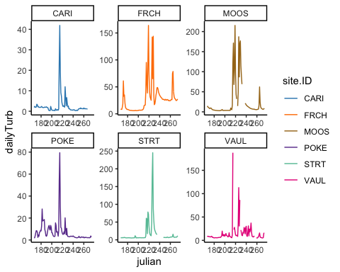

ggplot(mean_daily_2019, aes(x = site.ID, y = dailyTurb, fill = site.ID)) +  
 geom_boxplot() +  
 scale_fill_manual(values=c("#3288BD","#FF7F00", "#A6761D", "#6A3D9A", "#66C2A5", "#E7298A"))

## Warning: Removed 23 rows containing non-finite values (stat_boxplot).

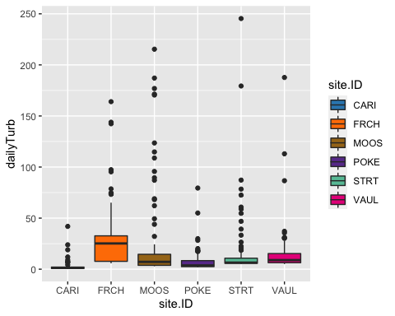

# corAR1 structure

turb.mod.ar1 <- gls(dailyTurb ~ site.ID,   
 na.action = na.omit,   
 data = mean_daily_2019,   
 correlation = corAR1(form = ~ julian|site.ID))

# diagnostic plots

plot(turb.mod.ar1, resid(., type = "p") ~ fitted(.), abline = 0)

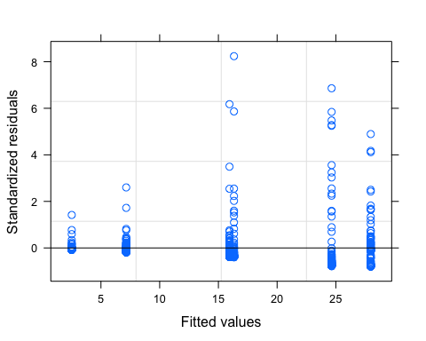

plot(turb.mod.ar1, dailyTurb ~ fitted(.) | site.ID, abline = c(0,1))

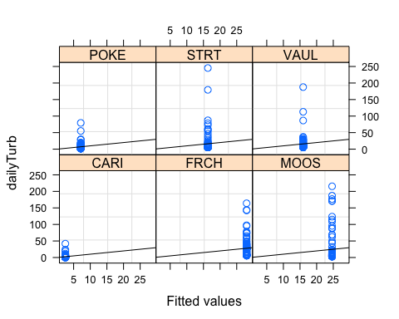

qqnorm(turb.mod.ar1, abline = c(0,1))

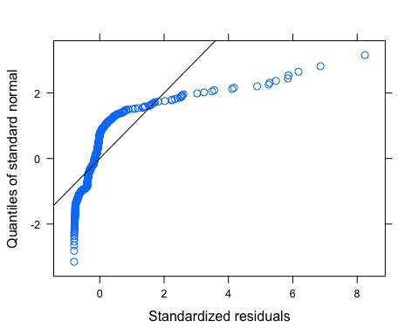 Looks like we have lots of outliers here but our normality isnt good either so lets log transform first and then investigate outliers

# corAR1 structure

mean_daily_2019$logDailyTurb <- log(mean_daily_2019$dailyTurb)  
  
turb.mod.ar1.log <- gls(logDailyTurb ~ site.ID,   
 na.action = na.omit,   
 data = mean_daily_2019,   
 correlation = corAR1(form = ~ julian|site.ID))

# diagnostic plots

plot(turb.mod.ar1.log, resid(., type = "p") ~ fitted(.), abline = 0)

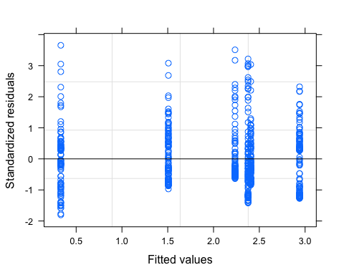

plot(turb.mod.ar1.log, logDailyTurb ~ fitted(.) | site.ID, abline = c(0,1))

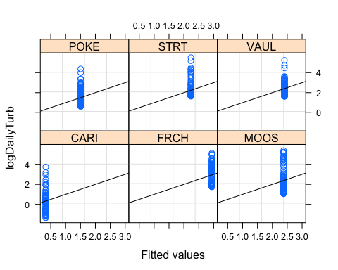

qqnorm(turb.mod.ar1.log, abline = c(0,1))

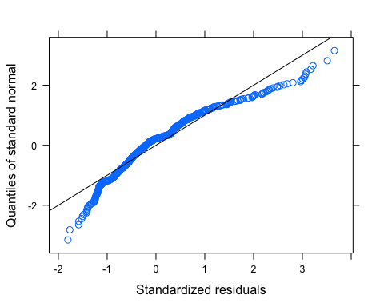 This may need further transformation but it looks a lot better

# ACF plot

Ear1<-residuals(turb.mod.ar1.log, type="normalized")  
I1<-!is.na(mean_daily_2019$logDailyTurb)  
Efulla<-vector(length = length(mean_daily_2019$logDailyTurb))  
Efulla<-NA  
Efulla[I1]<-Ear1  
acf(Efulla, na.action=na.pass)

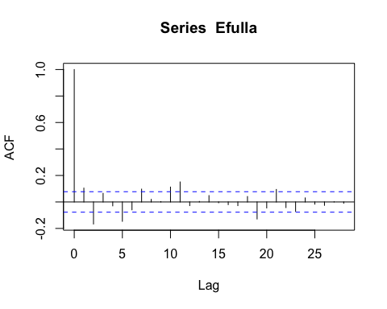

pacf(Efulla, na.action=na.pass)

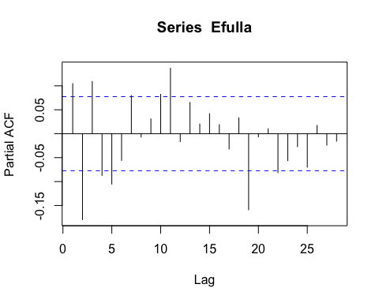 AR1 is not adequately handling the temporal autocorrelation

# corARMA structure

turb.mod.arma.1.1 <- gls(logDailyTurb ~ site.ID,   
 na.action = na.omit,   
 data = mean_daily_2019,   
 correlation = corARMA(form = ~ julian|site.ID, p = 1, q = 1))

# ACF plot

Ear1<-residuals(turb.mod.arma.1.1, type="normalized")  
I1<-!is.na(mean_daily_2019$logDailyTurb)  
Efulla<-vector(length = length(mean_daily_2019$logDailyTurb))  
Efulla<-NA  
Efulla[I1]<-Ear1  
acf(Efulla, na.action=na.pass)

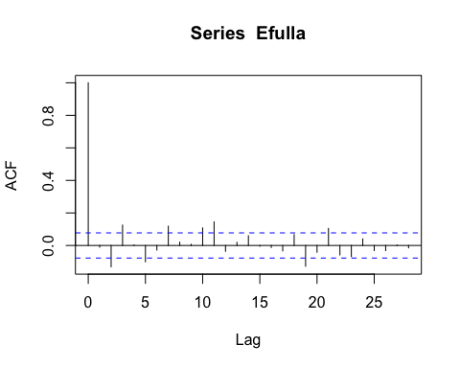

pacf(Efulla, na.action=na.pass)

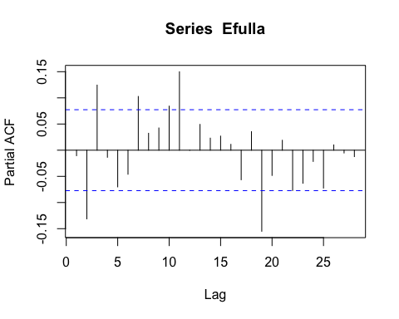 Still autocorrelation

# corARMA structure

turb.mod.arma.1.2 <- gls(logDailyTurb ~ site.ID,   
 na.action = na.omit,   
 data = mean_daily_2019,   
 correlation = corARMA(form = ~ julian|site.ID, p = 1, q = 2))

# ACF plot

Ear1<-residuals(turb.mod.arma.1.2, type="normalized")  
I1<-!is.na(mean_daily_2019$logDailyTurb)  
Efulla<-vector(length = length(mean_daily_2019$logDailyTurb))  
Efulla<-NA  
Efulla[I1]<-Ear1  
acf(Efulla, na.action=na.pass)

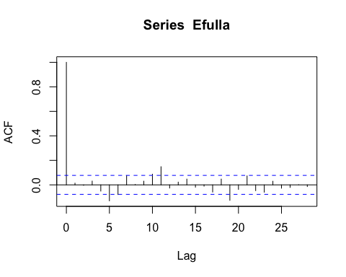

pacf(Efulla, na.action=na.pass)

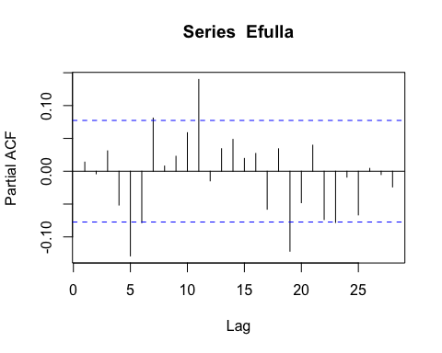 Still autocorrelation

# corARMA structure

turb.mod.arma.2.1 <- gls(logDailyTurb ~ site.ID,   
 na.action = na.omit,   
 data = mean_daily_2019,   
 correlation = corARMA(form = ~ julian|site.ID, p = 2, q = 1))

# ACF plot

Ear1<-residuals(turb.mod.arma.2.1, type="normalized")  
I1<-!is.na(mean_daily_2019$logDailyTurb)  
Efulla<-vector(length = length(mean_daily_2019$logDailyTurb))  
Efulla<-NA  
Efulla[I1]<-Ear1  
acf(Efulla, na.action=na.pass)

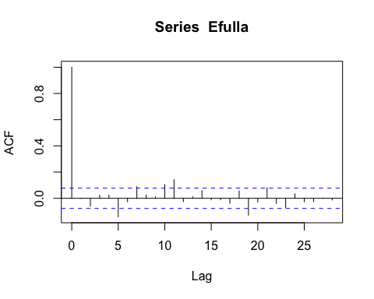

pacf(Efulla, na.action=na.pass)

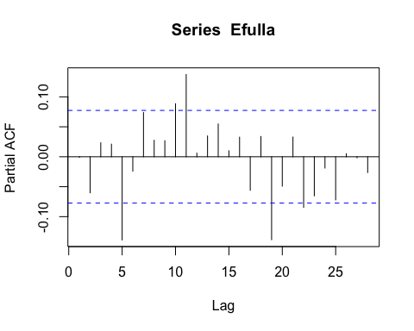 Still autocorrelation

# corARMA structure

turb.mod.arma.2.2 <- gls(logDailyTurb ~ site.ID,   
 na.action = na.omit,   
 data = mean_daily_2019,   
 correlation = corARMA(form = ~ julian|site.ID, p = 2, q = 2))

# ACF plot

Ear1<-residuals(turb.mod.arma.2.2, type="normalized")  
I1<-!is.na(mean_daily_2019$logDailyTurb)  
Efulla<-vector(length = length(mean_daily_2019$logDailyTurb))  
Efulla<-NA  
Efulla[I1]<-Ear1  
acf(Efulla, na.action=na.pass)

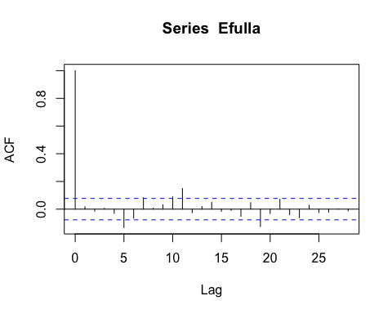

pacf(Efulla, na.action=na.pass)

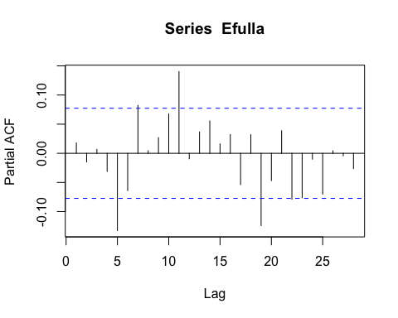 Still autocorrelation # generalized linear hypotheses

site.ID.comp <- glht(turb.mod.arma.2.2, linfct = mcp(site.ID = "Tukey"))  
summary(site.ID.comp)

##   
## Simultaneous Tests for General Linear Hypotheses  
##   
## Multiple Comparisons of Means: Tukey Contrasts  
##   
##   
## Fit: gls(model = logDailyTurb ~ site.ID, data = mean_daily_2019, correlation = corARMA(form = ~julian |   
## site.ID, p = 2, q = 2), na.action = na.omit)  
##   
## Linear Hypotheses:  
## Estimate Std. Error z value Pr(>|z|)   
## FRCH - CARI == 0 2.60469 0.48129 5.412 < 0.001 ***  
## MOOS - CARI == 0 2.04628 0.48156 4.249 < 0.001 ***  
## POKE - CARI == 0 1.17374 0.48129 2.439 0.14293   
## STRT - CARI == 0 1.90188 0.48308 3.937 0.00119 **   
## VAUL - CARI == 0 2.07587 0.48138 4.312 < 0.001 ***  
## MOOS - FRCH == 0 -0.55840 0.47447 -1.177 0.84802   
## POKE - FRCH == 0 -1.43094 0.47419 -3.018 0.03070 *   
## STRT - FRCH == 0 -0.70280 0.47602 -1.476 0.67944   
## VAUL - FRCH == 0 -0.52882 0.47429 -1.115 0.87539   
## POKE - MOOS == 0 -0.87254 0.47447 -1.839 0.44046   
## STRT - MOOS == 0 -0.14440 0.47630 -0.303 0.99966   
## VAUL - MOOS == 0 0.02958 0.47457 0.062 1.00000   
## STRT - POKE == 0 0.72814 0.47602 1.530 0.64502   
## VAUL - POKE == 0 0.90212 0.47429 1.902 0.40073   
## VAUL - STRT == 0 0.17398 0.47611 0.365 0.99915   
## ---  
## Signif. codes: 0 '***' 0.001 '**' 0.01 '*' 0.05 '.' 0.1 ' ' 1  
## (Adjusted p values reported -- single-step method)

summary(turb.mod.arma.2.2)

## Generalized least squares fit by REML  
## Model: logDailyTurb ~ site.ID   
## Data: mean_daily_2019   
## AIC BIC logLik  
## 769.8181 818.4201 -373.909  
##   
## Correlation Structure: ARMA(2,2)  
## Formula: ~julian | site.ID   
## Parameter estimate(s):  
## Phi1 Phi2 Theta1 Theta2   
## 0.6531021 0.2055260 0.3614419 -0.1613525   
##   
## Coefficients:  
## Value Std.Error t-value p-value  
## (Intercept) 0.3292224 0.3452630 0.953541 0.3407  
## site.IDFRCH 2.6046851 0.4812854 5.411935 0.0000  
## site.IDMOOS 2.0462827 0.4815598 4.249280 0.0000  
## site.IDPOKE 1.1737437 0.4812854 2.438769 0.0150  
## site.IDSTRT 1.9018808 0.4830844 3.936954 0.0001  
## site.IDVAUL 2.0758650 0.4813798 4.312322 0.0000  
##   
## Correlation:   
## (Intr) s.IDFR s.IDMO s.IDPO s.IDST  
## site.IDFRCH -0.717   
## site.IDMOOS -0.717 0.514   
## site.IDPOKE -0.717 0.515 0.514   
## site.IDSTRT -0.715 0.513 0.512 0.513   
## site.IDVAUL -0.717 0.515 0.514 0.515 0.513  
##   
## Standardized residuals:  
## Min Q1 Med Q3 Max   
## -1.7929422 -0.6279931 -0.2021591 0.4690495 3.6403185   
##   
## Residual standard error: 0.9357289   
## Degrees of freedom: 619 total; 613 residual

intervals(turb.mod.arma.2.2)

## Approximate 95% confidence intervals  
##   
## Coefficients:  
## lower est. upper  
## (Intercept) -0.3488195 0.3292224 1.007264  
## site.IDFRCH 1.6595170 2.6046851 3.549853  
## site.IDMOOS 1.1005756 2.0462827 2.991990  
## site.IDPOKE 0.2285755 1.1737437 2.118912  
## site.IDSTRT 0.9531797 1.9018808 2.850582  
## site.IDVAUL 1.1305114 2.0758650 3.021219  
## attr(,"label")  
## [1] "Coefficients:"  
##   
## Correlation structure:  
## lower est. upper  
## Phi1 0.5005854 0.6531021 0.38118770  
## Phi2 -0.2718498 0.2055260 0.60172773  
## Theta1 -0.1811725 0.3614419 0.84600317  
## Theta2 -0.3282221 -0.1613525 0.01528314  
## attr(,"label")  
## [1] "Correlation structure:"  
##   
## Residual standard error:  
## lower est. upper   
## 0.7915584 0.9357289 1.1061578

plot(print(confint(site.ID.comp)))

##   
## Simultaneous Confidence Intervals  
##   
## Multiple Comparisons of Means: Tukey Contrasts  
##   
##   
## Fit: gls(model = logDailyTurb ~ site.ID, data = mean_daily_2019, correlation = corARMA(form = ~julian |   
## site.ID, p = 2, q = 2), na.action = na.omit)  
##   
## Quantile = 2.8487  
## 95% family-wise confidence level  
##   
##   
## Linear Hypotheses:  
## Estimate lwr upr   
## FRCH - CARI == 0 2.60469 1.23365 3.97572  
## MOOS - CARI == 0 2.04628 0.67446 3.41810  
## POKE - CARI == 0 1.17374 -0.19730 2.54478  
## STRT - CARI == 0 1.90188 0.52572 3.27804  
## VAUL - CARI == 0 2.07587 0.70456 3.44717  
## MOOS - FRCH == 0 -0.55840 -1.91003 0.79322  
## POKE - FRCH == 0 -1.43094 -2.78177 -0.08011  
## STRT - FRCH == 0 -0.70280 -2.05884 0.65323  
## VAUL - FRCH == 0 -0.52882 -1.87993 0.82229  
## POKE - MOOS == 0 -0.87254 -2.22416 0.47909  
## STRT - MOOS == 0 -0.14440 -1.50123 1.21242  
## VAUL - MOOS == 0 0.02958 -1.32232 1.38148  
## STRT - POKE == 0 0.72814 -0.62790 2.08417  
## VAUL - POKE == 0 0.90212 -0.44898 2.25323  
## VAUL - STRT == 0 0.17398 -1.18232 1.53029

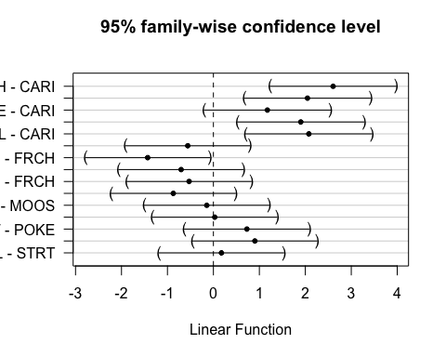 This shows that CARI is different than FRCH, MOOS, STRT, VAUL

# 2020

mean_daily_2020 <- subset(mean_daily, year == "2020")  
mean_daily_2020$site.ID <- as.factor(mean_daily_2020$site.ID)  
  
ggplot(mean_daily_2020, aes(x = julian, y = dailyNO3, color = site.ID)) +  
 geom_line() +  
 scale_color_manual(values=c("#3288BD","#FF7F00", "#A6761D", "#6A3D9A", "#66C2A5", "#E7298A")) +  
 facet_wrap(~site.ID, scales = "free") +  
 theme_classic()

## Warning: Removed 22 row(s) containing missing values (geom_path).

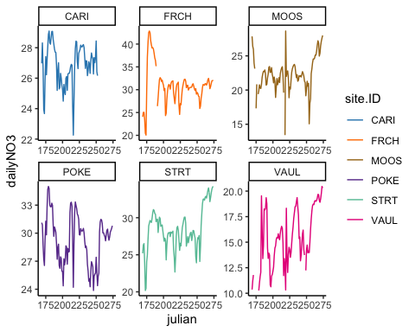

ggplot(mean_daily_2020, aes(x = site.ID, y = dailyNO3, fill = site.ID)) +  
 geom_boxplot() +  
 scale_fill_manual(values=c("#3288BD","#FF7F00", "#A6761D", "#6A3D9A", "#66C2A5", "#E7298A"))

## Warning: Removed 34 rows containing non-finite values (stat_boxplot).

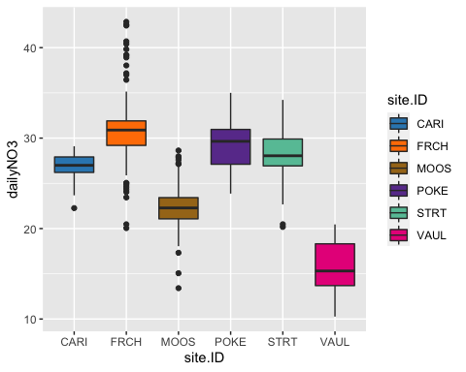 # CorAR1 structure #

no3.mod.gls <- gls(dailyNO3 ~ site.ID,   
 na.action = na.omit,   
 data = mean_daily_2020,   
 weights = varfixed,  
 correlation = corAR1(form = ~ julian|site.ID))

# diagnostic plots

plot(no3.mod.gls, resid(., type = "p") ~ fitted(.), abline = 0)

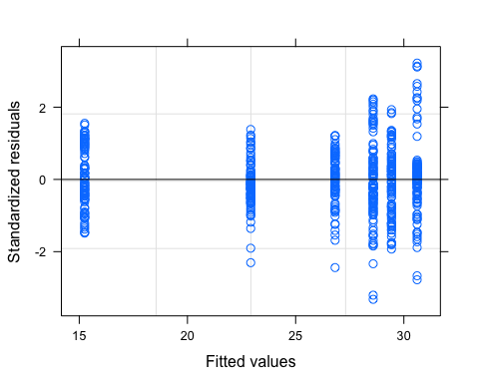

plot(no3.mod.gls, dailyNO3 ~ fitted(.) | site.ID, abline = c(0,1))

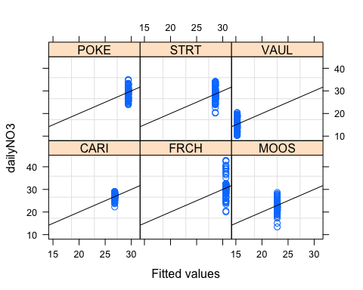

qqnorm(no3.mod.gls, abline = c(0,1))

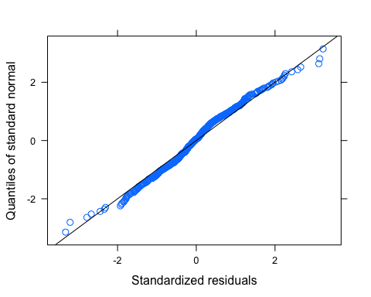 Looks like we have a couple outliers that could be removed

# ACF plot

Ear1<-residuals(no3.mod.gls, type="normalized")  
I1<-!is.na(mean_daily_2020$dailyNO3)  
Efulla<-vector(length = length(mean_daily_2020$dailyNO3))  
Efulla<-NA  
Efulla[I1]<-Ear1  
acf(Efulla, na.action=na.pass)

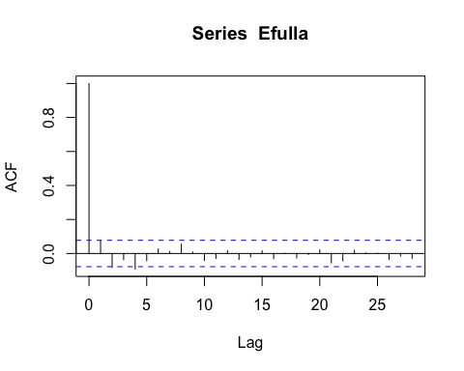

pacf(Efulla, na.action=na.pass)

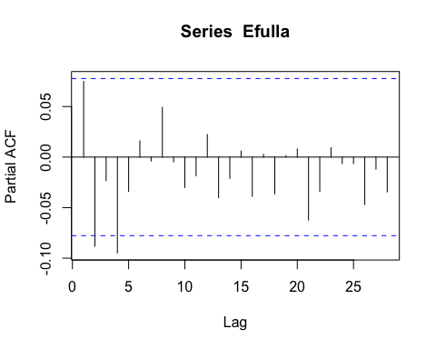 AR1 is doing a pretty good job

# corARMA structure

NO3.mod.arma.1.1 <- gls(dailyNO3 ~ site.ID,   
 na.action = na.omit,   
 data = mean_daily_2020,   
 weights = varfixed,  
 correlation = corARMA(form = ~ julian|site.ID, p = 1, q = 1))

# ACF plot

Ear1<-residuals(NO3.mod.arma.1.1, type="normalized")  
I1<-!is.na(mean_daily_2020$dailyNO3)  
Efulla<-vector(length = length(mean_daily_2020$dailyNO3))  
Efulla<-NA  
Efulla[I1]<-Ear1  
acf(Efulla, na.action=na.pass)

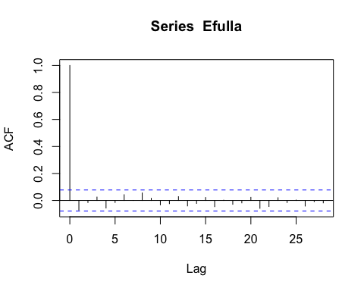

pacf(Efulla, na.action=na.pass)

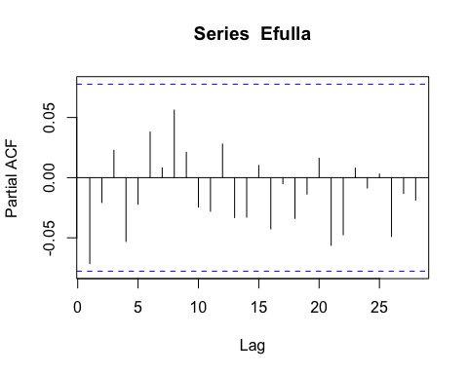 We can stop here!

# generalized linear hypotheses

site.ID.comp <- glht(NO3.mod.arma.1.1, linfct = mcp(site.ID = "Tukey"))  
summary(site.ID.comp)

## Warning in RET$pfunction("adjusted", ...): Completion with error > abseps

##   
## Simultaneous Tests for General Linear Hypotheses  
##   
## Multiple Comparisons of Means: Tukey Contrasts  
##   
##   
## Fit: gls(model = dailyNO3 ~ site.ID, data = mean_daily_2020, correlation = corARMA(form = ~julian |   
## site.ID, p = 1, q = 1), weights = varfixed, na.action = na.omit)  
##   
## Linear Hypotheses:  
## Estimate Std. Error z value Pr(>|z|)   
## FRCH - CARI == 0 3.8935 1.1726 3.320 0.01103 *   
## MOOS - CARI == 0 -4.1214 1.4117 -2.919 0.03896 *   
## POKE - CARI == 0 2.5402 1.0045 2.529 0.11071   
## STRT - CARI == 0 1.7024 0.9150 1.861 0.41518   
## VAUL - CARI == 0 -11.5631 1.1741 -9.848 < 0.001 ***  
## MOOS - FRCH == 0 -8.0148 1.6420 -4.881 < 0.001 ***  
## POKE - FRCH == 0 -1.3533 1.3085 -1.034 0.90230   
## STRT - FRCH == 0 -2.1911 1.2411 -1.765 0.47682   
## VAUL - FRCH == 0 -15.4566 1.4428 -10.713 < 0.001 ***  
## POKE - MOOS == 0 6.6616 1.5265 4.364 < 0.001 ***  
## STRT - MOOS == 0 5.8238 1.4692 3.964 0.00104 **   
## VAUL - MOOS == 0 -7.4417 1.6431 -4.529 < 0.001 ***  
## STRT - POKE == 0 -0.8378 1.0837 -0.773 0.97061   
## VAUL - POKE == 0 -14.1033 1.3099 -10.767 < 0.001 ***  
## VAUL - STRT == 0 -13.2655 1.2426 -10.676 < 0.001 ***  
## ---  
## Signif. codes: 0 '***' 0.001 '**' 0.01 '*' 0.05 '.' 0.1 ' ' 1  
## (Adjusted p values reported -- single-step method)

summary(NO3.mod.arma.1.1)

## Generalized least squares fit by REML  
## Model: dailyNO3 ~ site.ID   
## Data: mean_daily_2020   
## AIC BIC logLik  
## 2189.876 2251.34 -1080.938  
##   
## Correlation Structure: ARMA(1,1)  
## Formula: ~julian | site.ID   
## Parameter estimate(s):  
## Phi1 Theta1   
## 0.8020164 0.2656968   
## Variance function:  
## Structure: Different standard deviations per stratum  
## Formula: ~1 | site.ID   
## Parameter estimates:  
## CARI FRCH MOOS POKE STRT VAUL   
## 1.000000 1.956783 2.470860 1.575048 1.359158 1.948604   
##   
## Coefficients:  
## Value Std.Error t-value p-value  
## (Intercept) 26.821023 0.5795501 46.27904 0.0000  
## site.IDFRCH 3.893470 1.1726024 3.32037 0.0010  
## site.IDMOOS -4.121372 1.4117473 -2.91934 0.0036  
## site.IDPOKE 2.540205 1.0045145 2.52879 0.0117  
## site.IDSTRT 1.702411 0.9149617 1.86064 0.0633  
## site.IDVAUL -11.563099 1.1741264 -9.84826 0.0000  
##   
## Correlation:   
## (Intr) s.IDFR s.IDMO s.IDPO s.IDST  
## site.IDFRCH -0.494   
## site.IDMOOS -0.411 0.203   
## site.IDPOKE -0.577 0.285 0.237   
## site.IDSTRT -0.633 0.313 0.260 0.365   
## site.IDVAUL -0.494 0.244 0.203 0.285 0.313  
##   
## Standardized residuals:  
## Min Q1 Med Q3 Max   
## -3.43581106 -0.48517399 -0.03113143 0.48330817 3.47411983   
##   
## Residual standard error: 1.786066   
## Degrees of freedom: 602 total; 596 residual

intervals(NO3.mod.arma.1.1)

## Approximate 95% confidence intervals  
##   
## Coefficients:  
## lower est. upper  
## (Intercept) 25.68281466 26.821023 27.959232  
## site.IDFRCH 1.59053524 3.893470 6.196406  
## site.IDMOOS -6.89397596 -4.121372 -1.348767  
## site.IDPOKE 0.56738632 2.540205 4.513023  
## site.IDSTRT -0.09452992 1.702411 3.499352  
## site.IDVAUL -13.86902732 -11.563099 -9.257171  
## attr(,"label")  
## [1] "Coefficients:"  
##   
## Correlation structure:  
## lower est. upper  
## Phi1 0.7287061 0.8020164 0.8571534  
## Theta1 0.1500626 0.2656968 0.3741601  
## attr(,"label")  
## [1] "Correlation structure:"  
##   
## Variance function:  
## lower est. upper  
## FRCH 1.591906 1.956783 2.405293  
## MOOS 2.000619 2.470860 3.051630  
## POKE 1.283585 1.575048 1.932693  
## STRT 1.106001 1.359158 1.670260  
## VAUL 1.577424 1.948604 2.407125  
## attr(,"label")  
## [1] "Variance function:"  
##   
## Residual standard error:  
## lower est. upper   
## 1.446608 1.786066 2.205180

plot(print(confint(site.ID.comp)))

##   
## Simultaneous Confidence Intervals  
##   
## Multiple Comparisons of Means: Tukey Contrasts  
##   
##   
## Fit: gls(model = dailyNO3 ~ site.ID, data = mean_daily_2020, correlation = corARMA(form = ~julian |   
## site.ID, p = 1, q = 1), weights = varfixed, na.action = na.omit)  
##   
## Quantile = 2.8317  
## 95% family-wise confidence level  
##   
##   
## Linear Hypotheses:  
## Estimate lwr upr   
## FRCH - CARI == 0 3.8935 0.5730 7.2139  
## MOOS - CARI == 0 -4.1214 -8.1190 -0.1237  
## POKE - CARI == 0 2.5402 -0.3043 5.3847  
## STRT - CARI == 0 1.7024 -0.8885 4.2933  
## VAUL - CARI == 0 -11.5631 -14.8879 -8.2383  
## MOOS - FRCH == 0 -8.0148 -12.6646 -3.3651  
## POKE - FRCH == 0 -1.3533 -5.0587 2.3522  
## STRT - FRCH == 0 -2.1911 -5.7056 1.3235  
## VAUL - FRCH == 0 -15.4566 -19.5423 -11.3708  
## POKE - MOOS == 0 6.6616 2.3389 10.9843  
## STRT - MOOS == 0 5.8238 1.6635 9.9840  
## VAUL - MOOS == 0 -7.4417 -12.0946 -2.7889  
## STRT - POKE == 0 -0.8378 -3.9066 2.2310  
## VAUL - POKE == 0 -14.1033 -17.8126 -10.3940  
## VAUL - STRT == 0 -13.2655 -16.7841 -9.7469

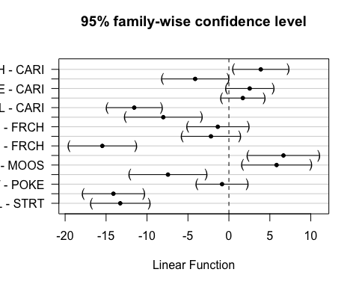 This shows significance for STRT and CARI FRCH and MOOS, VAUL MOOS and POKE,STRT, VAUL VAUL and POKE,STRT

### fDOM

ggplot(mean_daily_2020, aes(x = julian, y = dailyfDOM, color = site.ID)) +  
 geom_line() +  
 scale_color_manual(values=c("#3288BD","#FF7F00", "#A6761D", "#6A3D9A", "#66C2A5", "#E7298A")) +  
 facet_wrap(~site.ID, scales = "free") +  
 theme_classic()

## Warning: Removed 22 row(s) containing missing values (geom_path).

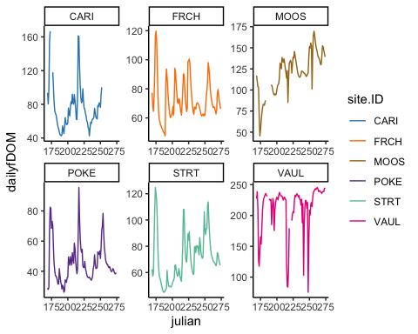

ggplot(mean_daily_2020, aes(x = site.ID, y = dailyfDOM, fill = site.ID)) +  
 geom_boxplot() +  
 scale_fill_manual(values=c("#3288BD","#FF7F00", "#A6761D", "#6A3D9A", "#66C2A5", "#E7298A"))

## Warning: Removed 37 rows containing non-finite values (stat_boxplot).

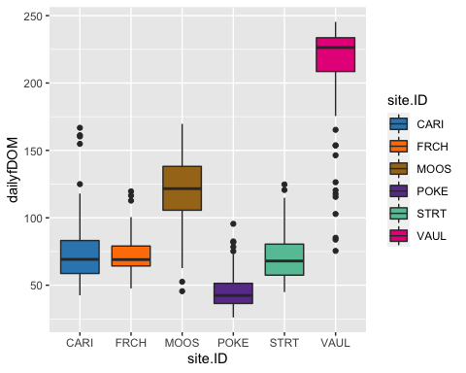

# corAR1 structure

fDOM.mod.ar1 <- gls(dailyfDOM ~ site.ID,   
 na.action = na.omit,   
 data = mean_daily_2020,   
 correlation = corAR1(form = ~ julian|site.ID))

# diagnostic plots

plot(fDOM.mod.ar1, resid(., type = "p") ~ fitted(.), abline = 0)

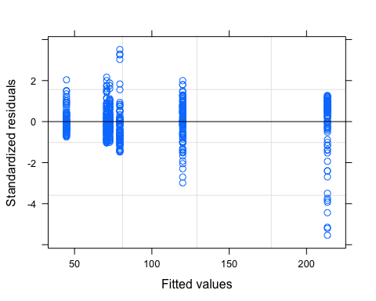

plot(fDOM.mod.ar1, dailyfDOM ~ fitted(.) | site.ID, abline = c(0,1))

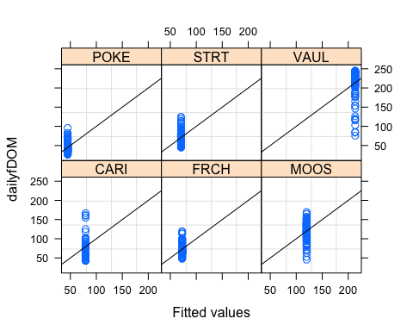

qqnorm(fDOM.mod.ar1, abline = c(0,1))

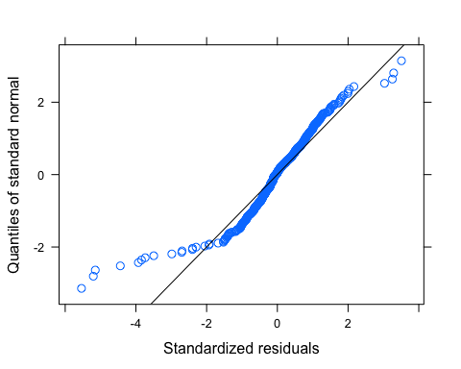 Let me log transform to see if its better

# log transformed

mean_daily_2020$logDailyfDOM <- log(mean_daily_2020$dailyfDOM)  
  
fDOM.mod.ar1.log <- gls(logDailyfDOM ~ site.ID,   
 na.action = na.omit,   
 data = mean_daily_2020,   
 correlation = corAR1(form = ~ julian|site.ID))

# diagnostic plots

plot(fDOM.mod.ar1.log, resid(., type = "p") ~ fitted(.), abline = 0)

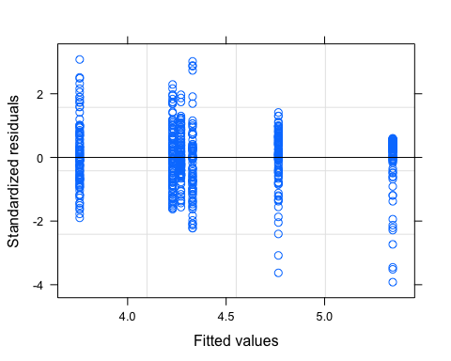

plot(fDOM.mod.ar1.log, logDailyfDOM ~ fitted(.) | site.ID, abline = c(0,1))

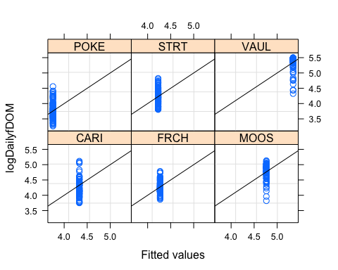

qqnorm(fDOM.mod.ar1.log, abline = c(0,1))

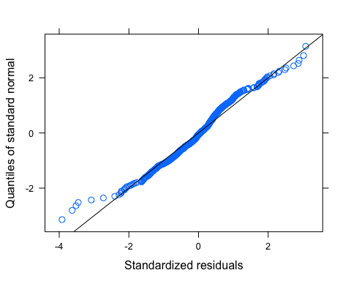 Looks much better

# ACF plot

Ear1<-residuals(fDOM.mod.ar1.log, type="normalized")  
I1<-!is.na(mean_daily_2020$logDailyfDOM)  
Efulla<-vector(length = length(mean_daily_2020$logDailyfDOM))  
Efulla<-NA  
Efulla[I1]<-Ear1  
acf(Efulla, na.action=na.pass)

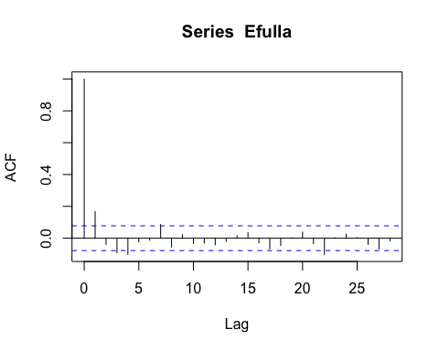

pacf(Efulla, na.action=na.pass)

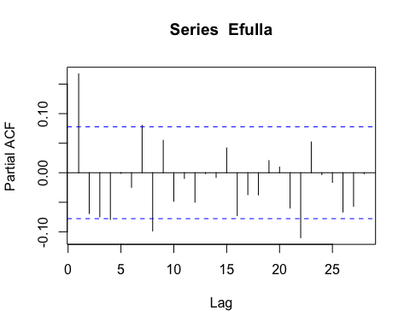 AR1 is not adequately handling the temporal autocorrelation

# corARMA structure

fDOM.mod.arma.1.1 <- gls(logDailyfDOM ~ site.ID,   
 na.action = na.omit,   
 data = mean_daily_2020,   
 correlation = corARMA(form = ~ julian|site.ID, p = 1, q = 1))

# ACF plot

Ear1<-residuals(fDOM.mod.arma.1.1, type="normalized")  
I1<-!is.na(mean_daily_2020$logDailyfDOM)  
Efulla<-vector(length = length(mean_daily_2020$logDailyfDOM))  
Efulla<-NA  
Efulla[I1]<-Ear1  
acf(Efulla, na.action=na.pass)

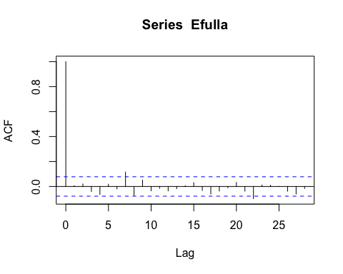

pacf(Efulla, na.action=na.pass)

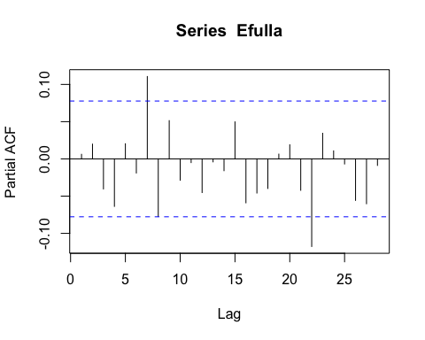 Still autocorrelation on the later lags but we are close

# corARMA structure

fDOM.mod.arma.2.1 <- gls(logDailyfDOM ~ site.ID,   
 na.action = na.omit,   
 data = mean_daily_2020,   
 correlation = corARMA(form = ~ julian|site.ID, p = 2, q = 1))

# ACF plot

Ear1<-residuals(fDOM.mod.arma.2.1, type="normalized")  
I1<-!is.na(mean_daily_2020$logDailyfDOM)  
Efulla<-vector(length = length(mean_daily_2020$logDailyfDOM))  
Efulla<-NA  
Efulla[I1]<-Ear1  
acf(Efulla, na.action=na.pass)

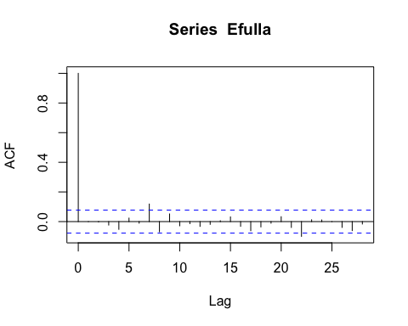

pacf(Efulla, na.action=na.pass)

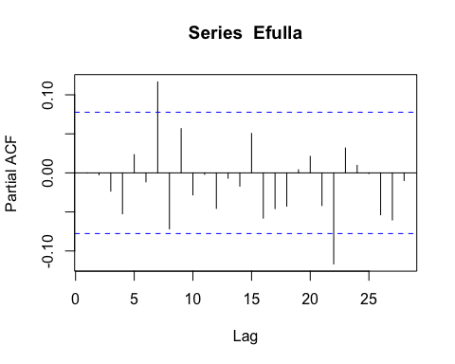 same as above

# corARMA structure

fDOM.mod.arma.1.2 <- gls(logDailyfDOM ~ site.ID,   
 na.action = na.omit,   
 data = mean_daily_2020,   
 correlation = corARMA(form = ~ julian|site.ID, p = 1, q = 2))

# ACF plot

Ear1<-residuals(fDOM.mod.arma.1.2, type="normalized")  
I1<-!is.na(mean_daily_2020$logDailyfDOM)  
Efulla<-vector(length = length(mean_daily_2020$logDailyfDOM))  
Efulla<-NA  
Efulla[I1]<-Ear1  
acf(Efulla, na.action=na.pass)

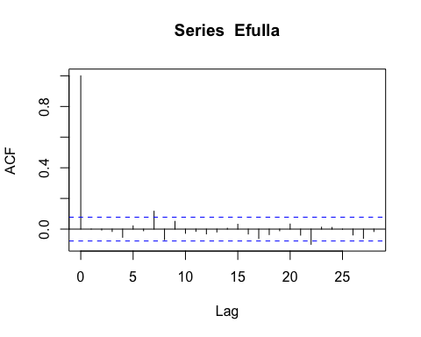

pacf(Efulla, na.action=na.pass)

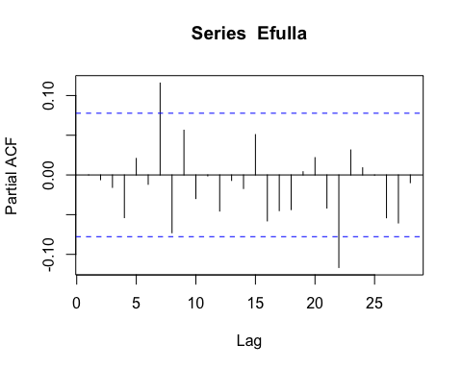 Still autocorrelation in the later lags

# corARMA structure

fDOM.mod.arma.2.2 <- gls(logDailyfDOM ~ site.ID,   
 na.action = na.omit,   
 data = mean_daily_2020,   
 correlation = corARMA(form = ~ julian|site.ID, p = 2, q = 2))

# ACF plot

Ear1<-residuals(fDOM.mod.arma.2.2, type="normalized")  
I1<-!is.na(mean_daily_2020$logDailyfDOM)  
Efulla<-vector(length = length(mean_daily_2020$logDailyfDOM))  
Efulla<-NA  
Efulla[I1]<-Ear1  
acf(Efulla, na.action=na.pass)

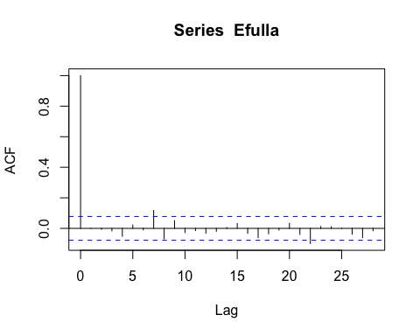

pacf(Efulla, na.action=na.pass)

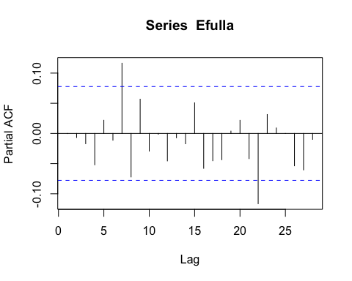 Still autocorrelation but this is the best one yet so lets interpret this model

# generalized linear hypotheses

site.ID.comp <- glht(fDOM.mod.arma.2.2, linfct = mcp(site.ID = "Tukey"))  
summary(site.ID.comp)

##   
## Simultaneous Tests for General Linear Hypotheses  
##   
## Multiple Comparisons of Means: Tukey Contrasts  
##   
##   
## Fit: gls(model = logDailyfDOM ~ site.ID, data = mean_daily_2020, correlation = corARMA(form = ~julian |   
## site.ID, p = 2, q = 2), na.action = na.omit)  
##   
## Linear Hypotheses:  
## Estimate Std. Error z value Pr(>|z|)   
## FRCH - CARI == 0 -0.04869 0.10564 -0.461 0.997404   
## MOOS - CARI == 0 0.44323 0.10599 4.182 0.000398 ***  
## POKE - CARI == 0 -0.55272 0.10564 -5.232 < 1e-04 ***  
## STRT - CARI == 0 -0.08840 0.10564 -0.837 0.960635   
## VAUL - CARI == 0 1.02127 0.10569 9.663 < 1e-04 ***  
## MOOS - FRCH == 0 0.49193 0.10010 4.914 < 1e-04 ***  
## POKE - FRCH == 0 -0.50402 0.09973 -5.054 < 1e-04 ***  
## STRT - FRCH == 0 -0.03971 0.09973 -0.398 0.998715   
## VAUL - FRCH == 0 1.06997 0.09979 10.722 < 1e-04 ***  
## POKE - MOOS == 0 -0.99595 0.10010 -9.949 < 1e-04 ***  
## STRT - MOOS == 0 -0.53163 0.10010 -5.311 < 1e-04 ***  
## VAUL - MOOS == 0 0.57804 0.10016 5.771 < 1e-04 ***  
## STRT - POKE == 0 0.46432 0.09973 4.656 < 1e-04 ***  
## VAUL - POKE == 0 1.57399 0.09979 15.772 < 1e-04 ***  
## VAUL - STRT == 0 1.10967 0.09979 11.120 < 1e-04 ***  
## ---  
## Signif. codes: 0 '***' 0.001 '**' 0.01 '*' 0.05 '.' 0.1 ' ' 1  
## (Adjusted p values reported -- single-step method)

summary(fDOM.mod.arma.2.2)

## Generalized least squares fit by REML  
## Model: logDailyfDOM ~ site.ID   
## Data: mean_daily_2020   
## AIC BIC logLik  
## -682.876 -634.6389 352.438  
##   
## Correlation Structure: ARMA(2,2)  
## Formula: ~julian | site.ID   
## Parameter estimate(s):  
## Phi1 Phi2 Theta1 Theta2   
## 0.85424595 -0.06489215 0.16848932 0.03580862   
##   
## Coefficients:  
## Value Std.Error t-value p-value  
## (Intercept) 4.320346 0.07864864 54.93224 0.000  
## site.IDFRCH -0.048693 0.10563626 -0.46095 0.645  
## site.IDMOOS 0.443234 0.10598617 4.18200 0.000  
## site.IDPOKE -0.552715 0.10563626 -5.23225 0.000  
## site.IDSTRT -0.088400 0.10563626 -0.83684 0.403  
## site.IDVAUL 1.021274 0.10569254 9.66269 0.000  
##   
## Correlation:   
## (Intr) s.IDFR s.IDMO s.IDPO s.IDST  
## site.IDFRCH -0.745   
## site.IDMOOS -0.742 0.552   
## site.IDPOKE -0.745 0.554 0.552   
## site.IDSTRT -0.745 0.554 0.552 0.554   
## site.IDVAUL -0.744 0.554 0.552 0.554 0.554  
##   
## Standardized residuals:  
## Min Q1 Med Q3 Max   
## -3.97094376 -0.57122089 0.06091714 0.51487604 3.10562528   
##   
## Residual standard error: 0.2564105   
## Degrees of freedom: 599 total; 593 residual

intervals(fDOM.mod.arma.2.2)

## Approximate 95% confidence intervals  
##   
## Coefficients:  
## lower est. upper  
## (Intercept) 4.1658818 4.32034558 4.4748093  
## site.IDFRCH -0.2561593 -0.04869255 0.1587742  
## site.IDMOOS 0.2350802 0.44323413 0.6513880  
## site.IDPOKE -0.7601820 -0.55271532 -0.3452486  
## site.IDSTRT -0.2958670 -0.08840028 0.1190664  
## site.IDVAUL 0.8136965 1.02127375 1.2288510  
## attr(,"label")  
## [1] "Coefficients:"  
##   
## Correlation structure:  
## lower est. upper  
## Phi1 0.85252389 0.85424595 0.7435565  
## Phi2 -0.28565173 -0.06489215 0.1624074  
## Theta1 -0.10922843 0.16848932 0.4808197  
## Theta2 -0.07569305 0.03580862 0.1464258  
## attr(,"label")  
## [1] "Correlation structure:"  
##   
## Residual standard error:  
## lower est. upper   
## 0.2255270 0.2564105 0.2915231

plot(print(confint(site.ID.comp)))

##   
## Simultaneous Confidence Intervals  
##   
## Multiple Comparisons of Means: Tukey Contrasts  
##   
##   
## Fit: gls(model = logDailyfDOM ~ site.ID, data = mean_daily_2020, correlation = corARMA(form = ~julian |   
## site.ID, p = 2, q = 2), na.action = na.omit)  
##   
## Quantile = 2.8484  
## 95% family-wise confidence level  
##   
##   
## Linear Hypotheses:  
## Estimate lwr upr   
## FRCH - CARI == 0 -0.04869 -0.34958 0.25220  
## MOOS - CARI == 0 0.44323 0.14135 0.74512  
## POKE - CARI == 0 -0.55272 -0.85361 -0.25182  
## STRT - CARI == 0 -0.08840 -0.38929 0.21249  
## VAUL - CARI == 0 1.02127 0.72022 1.32233  
## MOOS - FRCH == 0 0.49193 0.20679 0.77706  
## POKE - FRCH == 0 -0.50402 -0.78810 -0.21994  
## STRT - FRCH == 0 -0.03971 -0.32379 0.24437  
## VAUL - FRCH == 0 1.06997 0.78572 1.35421  
## POKE - MOOS == 0 -0.99595 -1.28108 -0.71082  
## STRT - MOOS == 0 -0.53163 -0.81677 -0.24650  
## VAUL - MOOS == 0 0.57804 0.29274 0.86334  
## STRT - POKE == 0 0.46432 0.18024 0.74839  
## VAUL - POKE == 0 1.57399 1.28974 1.85824  
## VAUL - STRT == 0 1.10967 0.82543 1.39392

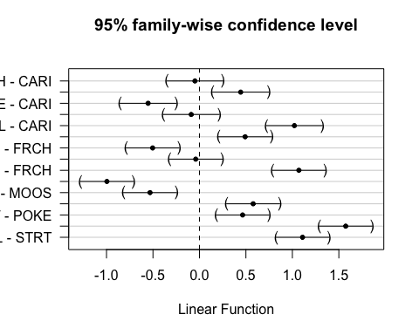 This shows that CARI is different than MOOS, POKE, VAUL FRCH to MOOS and POKE and VAUL MOOS to POKE, STRT, VAUL POKE to STRT VAUL VAUL - STRT

### SPC

ggplot(mean_daily_2020, aes(x = julian, y = dailySPC, color = site.ID)) +  
 geom_line() +  
 scale_color_manual(values=c("#3288BD","#FF7F00", "#A6761D", "#6A3D9A", "#66C2A5", "#E7298A")) +  
 facet_wrap(~site.ID, scales = "free") +  
 theme_classic()

## Warning: Removed 22 row(s) containing missing values (geom_path).

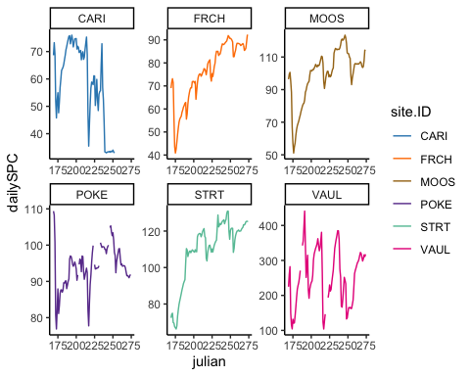

ggplot(mean_daily_2020, aes(x = site.ID, y = dailySPC, fill = site.ID)) +  
 geom_boxplot() +  
 scale_fill_manual(values=c("#3288BD","#FF7F00", "#A6761D", "#6A3D9A", "#66C2A5", "#E7298A"))

## Warning: Removed 31 rows containing non-finite values (stat_boxplot).

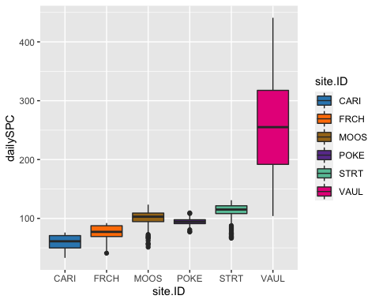

# corAR1 structure

SPC.mod.ar1 <- gls(dailySPC ~ site.ID,   
 na.action = na.omit,   
 data = mean_daily_2020,   
 correlation = corAR1(form = ~ julian|site.ID))

# diagnostic plots

plot(SPC.mod.ar1, resid(., type = "p") ~ fitted(.), abline = 0)

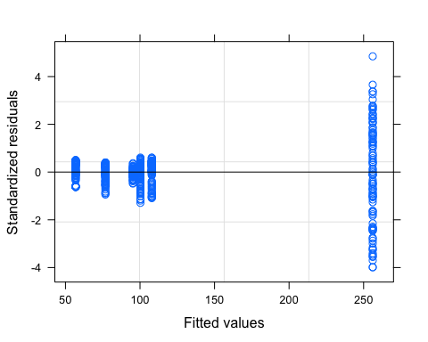

plot(SPC.mod.ar1, dailySPC ~ fitted(.) | site.ID, abline = c(0,1))

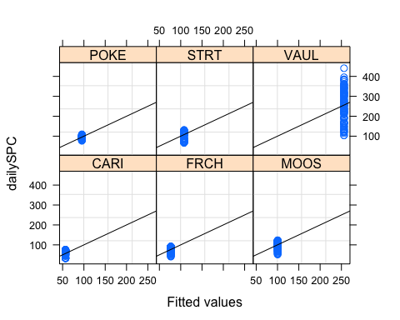

qqnorm(SPC.mod.ar1, abline = c(0,1))

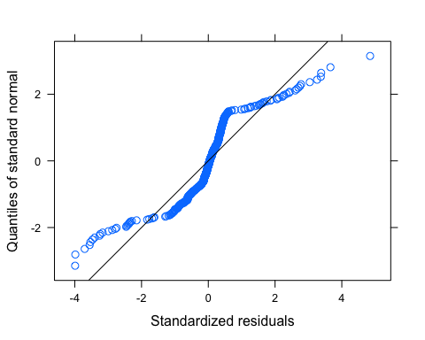 VAUL has way more heterogeneity that needs to be dealt with

mean_daily_2020$logDailySPC <- log(mean_daily_2020$dailySPC)  
  
SPC.mod.ar1.log <- gls(logDailySPC ~ site.ID,   
 na.action = na.omit,   
 data = mean_daily_2020,  
 weights = varfixed,  
 correlation = corAR1(form = ~ julian|site.ID))

# diagnostic plots

plot(SPC.mod.ar1.log, resid(., type = "p") ~ fitted(.), abline = 0)

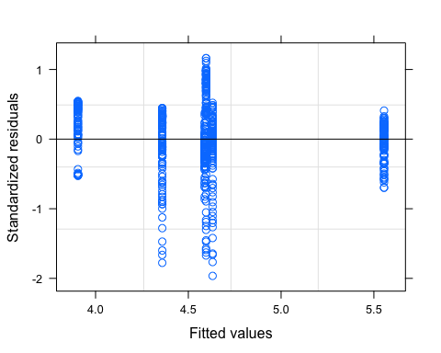

plot(SPC.mod.ar1.log, dailySPC ~ fitted(.) | site.ID, abline = c(0,1))

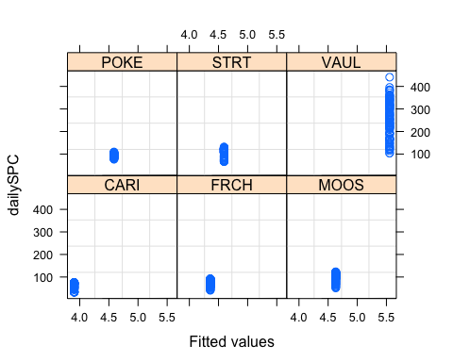

qqnorm(SPC.mod.ar1.log, abline = c(0,1))

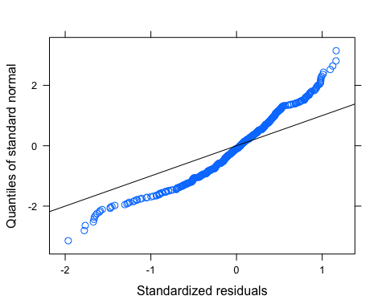 may need further transformation

# ACF plot

Ear1<-residuals(SPC.mod.ar1, type="normalized")  
I1<-!is.na(mean_daily_2019$dailySPC)  
Efulla<-vector(length = length(mean_daily_2019$dailySPC))  
Efulla<-NA  
Efulla[I1]<-Ear1

## Warning in Efulla[I1] <- Ear1: number of items to replace is not a multiple of  
## replacement length

acf(Efulla, na.action=na.pass)

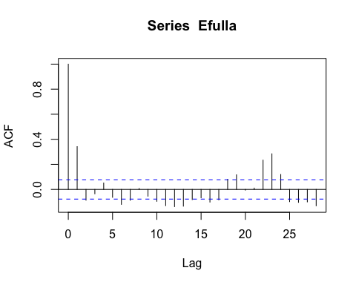

pacf(Efulla, na.action=na.pass)

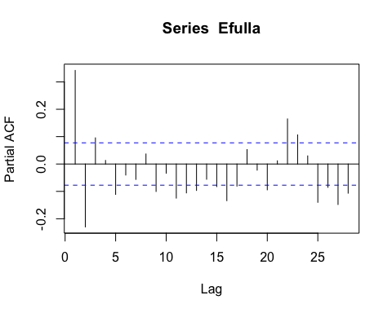 AR1 is not adequately handling the temporal autocorrelation

# corARMA structure

SPC.mod.arma.1.1 <- gls(dailySPC ~ site.ID,   
 na.action = na.omit,   
 data = mean_daily_2019,   
 weights = varfixed,  
 correlation = corARMA(form = ~ julian|site.ID, p = 1, q = 1))

# ACF plot

Ear1<-residuals(SPC.mod.arma.1.1, type="normalized")  
I1<-!is.na(mean_daily_2019$dailySPC)  
Efulla<-vector(length = length(mean_daily_2019$dailySPC))  
Efulla<-NA  
Efulla[I1]<-Ear1  
acf(Efulla, na.action=na.pass)

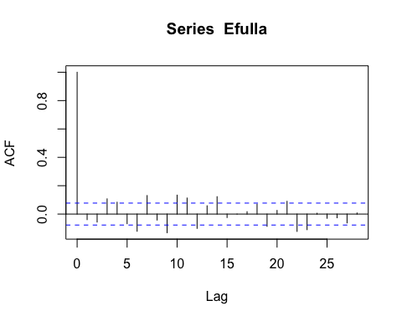

pacf(Efulla, na.action=na.pass)

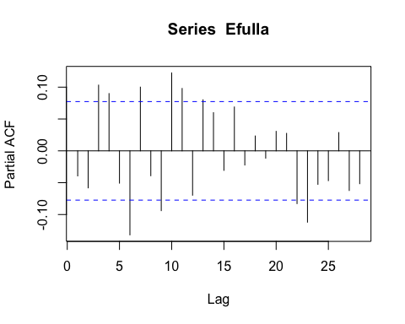 Still autocorrelation at the 9th lag but that is it

# corARMA structure

SPC.mod.arma.2.1 <- gls(dailySPC ~ site.ID,   
 na.action = na.omit,   
 data = mean_daily_2019,  
 weights = varfixed,  
 correlation = corARMA(form = ~ julian|site.ID, p = 2, q = 1))

# ACF plot

Ear1<-residuals(SPC.mod.arma.2.1, type="normalized")  
I1<-!is.na(mean_daily_2019$dailySPC)  
Efulla<-vector(length = length(mean_daily_2019$dailySPC))  
Efulla<-NA  
Efulla[I1]<-Ear1  
acf(Efulla, na.action=na.pass)

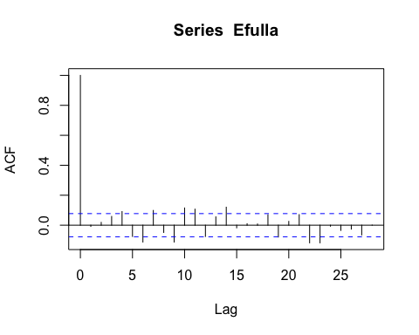

pacf(Efulla, na.action=na.pass)

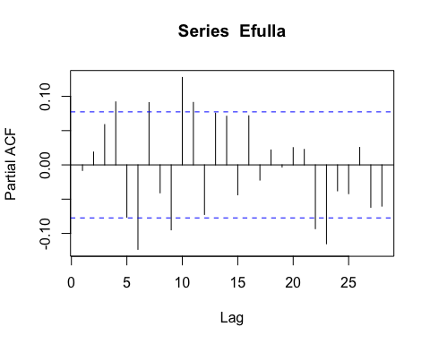 Still correlation

# corARMA structure

SPC.mod.arma.1.2 <- gls(dailySPC ~ site.ID,   
 na.action = na.omit,   
 data = mean_daily_2019,   
 weights = varfixed,  
 correlation = corARMA(form = ~ julian|site.ID, p = 1, q = 2))

# ACF plot

Ear1<-residuals(SPC.mod.arma.1.2, type="normalized")  
I1<-!is.na(mean_daily_2019$dailySPC)  
Efulla<-vector(length = length(mean_daily_2019$dailySPC))  
Efulla<-NA  
Efulla[I1]<-Ear1  
acf(Efulla, na.action=na.pass)

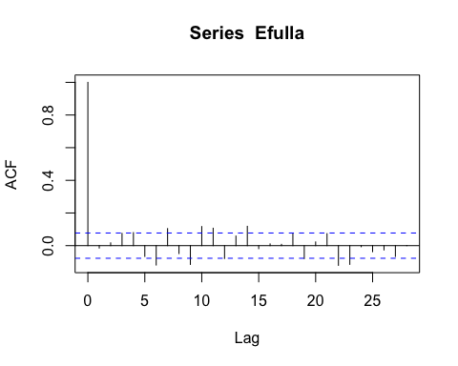

pacf(Efulla, na.action=na.pass)

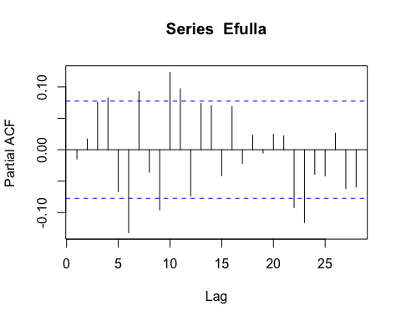 Still autocorrelation in the later lags

# corARMA structure

SPC.mod.arma.2.2 <- gls(dailySPC ~ site.ID,   
 na.action = na.omit,   
 data = mean_daily_2019,   
 weights = varfixed,  
 correlation = corARMA(form = ~ julian|site.ID, p = 2, q = 2))

# ACF plot

Ear1<-residuals(SPC.mod.arma.2.2, type="normalized")  
I1<-!is.na(mean_daily_2019$dailySPC)  
Efulla<-vector(length = length(mean_daily_2019$dailySPC))  
Efulla<-NA  
Efulla[I1]<-Ear1  
acf(Efulla, na.action=na.pass)

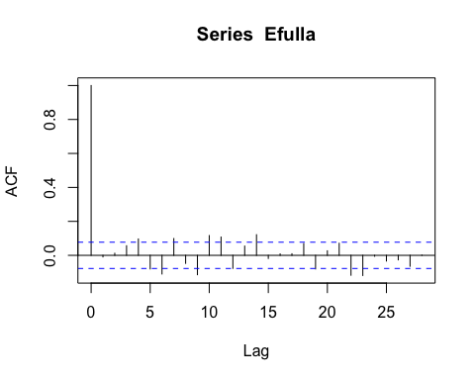

pacf(Efulla, na.action=na.pass)

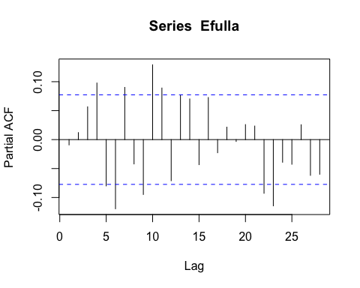 Still autocorrelation but this is the best one yet so lets interpret this model

# generalized linear hypotheses

site.ID.comp <- glht(SPC.mod.arma.1.1, linfct = mcp(site.ID = "Tukey"))  
summary(site.ID.comp)

##   
## Simultaneous Tests for General Linear Hypotheses  
##   
## Multiple Comparisons of Means: Tukey Contrasts  
##   
##   
## Fit: gls(model = dailySPC ~ site.ID, data = mean_daily_2019, correlation = corARMA(form = ~julian |   
## site.ID, p = 1, q = 1), weights = varfixed, na.action = na.omit)  
##   
## Linear Hypotheses:  
## Estimate Std. Error z value Pr(>|z|)   
## FRCH - CARI == 0 3.017 19.401 0.156 1.0000   
## MOOS - CARI == 0 28.382 20.199 1.405 0.6949   
## POKE - CARI == 0 31.083 21.937 1.417 0.6874   
## STRT - CARI == 0 32.113 23.376 1.374 0.7151   
## VAUL - CARI == 0 293.553 88.211 3.328 0.0092 **  
## MOOS - FRCH == 0 25.364 17.045 1.488 0.6403   
## POKE - FRCH == 0 28.066 19.073 1.471 0.6513   
## STRT - FRCH == 0 29.095 20.712 1.405 0.6952   
## VAUL - FRCH == 0 290.535 87.543 3.319 0.0095 **  
## POKE - MOOS == 0 2.701 19.884 0.136 1.0000   
## STRT - MOOS == 0 3.731 21.461 0.174 1.0000   
## VAUL - MOOS == 0 265.171 87.723 3.023 0.0248 *   
## STRT - POKE == 0 1.030 23.104 0.045 1.0000   
## VAUL - POKE == 0 262.470 88.140 2.978 0.0287 *   
## VAUL - STRT == 0 261.440 88.509 2.954 0.0309 *   
## ---  
## Signif. codes: 0 '***' 0.001 '**' 0.01 '*' 0.05 '.' 0.1 ' ' 1  
## (Adjusted p values reported -- single-step method)

summary(SPC.mod.arma.1.1)

## Generalized least squares fit by REML  
## Model: dailySPC ~ site.ID   
## Data: mean_daily_2019   
## AIC BIC logLik  
## 4065.529 4127.294 -2018.764  
##   
## Correlation Structure: ARMA(1,1)  
## Formula: ~julian | site.ID   
## Parameter estimate(s):  
## Phi1 Theta1   
## 0.9613828 0.4264419   
## Variance function:  
## Structure: Different standard deviations per stratum  
## Formula: ~1 | site.ID   
## Parameter estimates:  
## CARI FRCH MOOS POKE STRT VAUL   
## 1.0000000 0.7406415 0.8260112 0.9963464 1.1256232 5.6498342   
##   
## Coefficients:  
## Value Std.Error t-value p-value  
## (Intercept) 87.41780 15.71427 5.562958 0.0000  
## site.IDFRCH 3.01740 19.40128 0.155526 0.8765  
## site.IDMOOS 28.38154 20.19919 1.405083 0.1605  
## site.IDPOKE 31.08298 21.93721 1.416906 0.1570  
## site.IDSTRT 32.11260 23.37607 1.373738 0.1700  
## site.IDVAUL 293.55272 88.21133 3.327835 0.0009  
##   
## Correlation:   
## (Intr) s.IDFR s.IDMO s.IDPO s.IDST  
## site.IDFRCH -0.810   
## site.IDMOOS -0.778 0.630   
## site.IDPOKE -0.716 0.580 0.557   
## site.IDSTRT -0.672 0.544 0.523 0.482   
## site.IDVAUL -0.178 0.144 0.139 0.128 0.120  
##   
## Standardized residuals:  
## Min Q1 Med Q3 Max   
## -2.52209964 -0.40894559 0.01620886 0.65819274 1.84750415   
##   
## Residual standard error: 26.90951   
## Degrees of freedom: 615 total; 609 residual

intervals(SPC.mod.arma.1.1)

## Approximate 95% confidence intervals  
##   
## Coefficients:  
## lower est. upper  
## (Intercept) 56.55707 87.417800 118.27853  
## site.IDFRCH -35.08413 3.017397 41.11892  
## site.IDMOOS -11.28698 28.381538 68.05006  
## site.IDPOKE -11.99879 31.082979 74.16475  
## site.IDSTRT -13.79489 32.112597 78.02008  
## site.IDVAUL 120.31742 293.552725 466.78803  
## attr(,"label")  
## [1] "Coefficients:"  
##   
## Correlation structure:  
## lower est. upper  
## Phi1 0.9236644 0.9613828 0.9806515  
## Theta1 0.3350782 0.4264419 0.5098606  
## attr(,"label")  
## [1] "Correlation structure:"  
##   
## Variance function:  
## lower est. upper  
## FRCH 0.6096618 0.7406415 0.8997609  
## MOOS 0.6748860 0.8260112 1.0109774  
## POKE 0.8256480 0.9963464 1.2023358  
## STRT 0.9224473 1.1256232 1.3735501  
## VAUL 4.6342201 5.6498342 6.8880256  
## attr(,"label")  
## [1] "Variance function:"  
##   
## Residual standard error:  
## lower est. upper   
## 18.60336 26.90951 38.92424

plot(print(confint(site.ID.comp)))

##   
## Simultaneous Confidence Intervals  
##   
## Multiple Comparisons of Means: Tukey Contrasts  
##   
##   
## Fit: gls(model = dailySPC ~ site.ID, data = mean_daily_2019, correlation = corARMA(form = ~julian |   
## site.ID, p = 1, q = 1), weights = varfixed, na.action = na.omit)  
##   
## Quantile = 2.7861  
## 95% family-wise confidence level  
##   
##   
## Linear Hypotheses:  
## Estimate lwr upr   
## FRCH - CARI == 0 3.0174 -51.0366 57.0714  
## MOOS - CARI == 0 28.3815 -27.8955 84.6586  
## POKE - CARI == 0 31.0830 -30.0364 92.2023  
## STRT - CARI == 0 32.1126 -33.0155 97.2407  
## VAUL - CARI == 0 293.5527 47.7868 539.3186  
## MOOS - FRCH == 0 25.3641 -22.1257 72.8540  
## POKE - FRCH == 0 28.0656 -25.0734 81.2046  
## STRT - FRCH == 0 29.0952 -28.6097 86.8001  
## VAUL - FRCH == 0 290.5353 46.6315 534.4391  
## POKE - MOOS == 0 2.7014 -52.6974 58.1002  
## STRT - MOOS == 0 3.7311 -56.0613 63.5234  
## VAUL - MOOS == 0 265.1712 20.7651 509.5773  
## STRT - POKE == 0 1.0296 -63.3412 65.4004  
## VAUL - POKE == 0 262.4697 16.9035 508.0360  
## VAUL - STRT == 0 261.4401 14.8455 508.0347

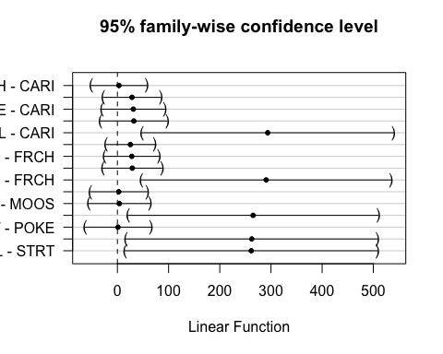 This shows that MOOS is significantly different than CARI and FRCH

### Turb

ggplot(mean_daily_2020, aes(x = julian, y = dailyTurb, color = site.ID)) +  
 geom_line() +  
 scale_color_manual(values=c("#3288BD","#FF7F00", "#A6761D", "#6A3D9A", "#66C2A5", "#E7298A")) +  
 facet_wrap(~site.ID, scales = "free") +  
 theme_classic()

## Warning: Removed 22 row(s) containing missing values (geom_path).

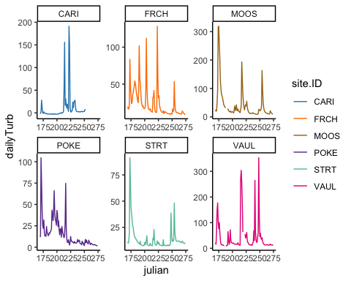

ggplot(mean_daily_2020, aes(x = site.ID, y = dailyTurb, fill = site.ID)) +  
 geom_boxplot() +  
 scale_fill_manual(values=c("#3288BD","#FF7F00", "#A6761D", "#6A3D9A", "#66C2A5", "#E7298A"))

## Warning: Removed 30 rows containing non-finite values (stat_boxplot).

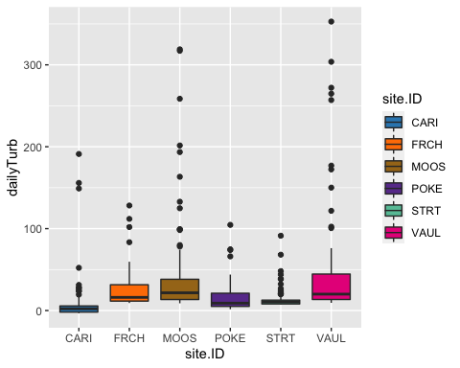

# corAR1 structure

turb.mod.ar1 <- gls(dailyTurb ~ site.ID,   
 na.action = na.omit,   
 data = mean_daily_2020,   
 correlation = corAR1(form = ~ julian|site.ID))

# diagnostic plots

plot(turb.mod.ar1, resid(., type = "p") ~ fitted(.), abline = 0)

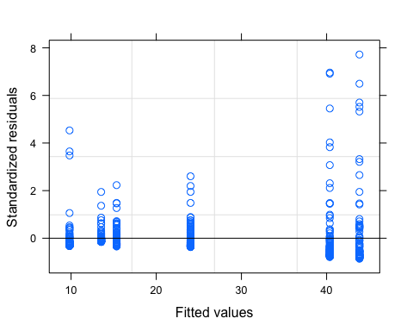

plot(turb.mod.ar1, dailyTurb ~ fitted(.) | site.ID, abline = c(0,1))

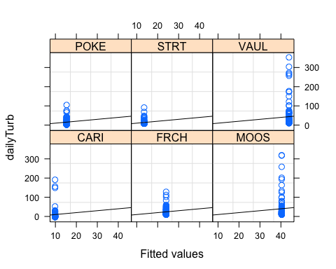

qqnorm(turb.mod.ar1, abline = c(0,1))

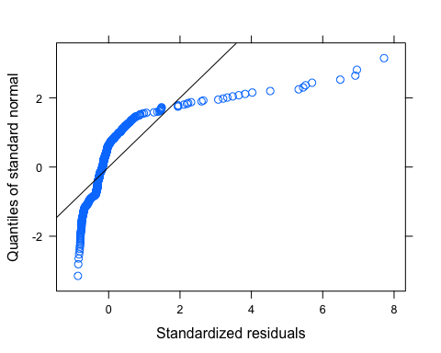 Looks like we have lots of outliers here but our normality isnt good either so lets log transform first and then investigate outliers

# corAR1 structure

mean_daily_2020$logDailyTurb <- log(mean_daily_2020$dailyTurb)

## Warning in log(mean_daily_2020$dailyTurb): NaNs produced

turb.mod.ar1.log <- gls(logDailyTurb ~ site.ID,   
 na.action = na.omit,   
 data = mean_daily_2020,   
 correlation = corAR1(form = ~ julian|site.ID))

# diagnostic plots

plot(turb.mod.ar1.log, resid(., type = "p") ~ fitted(.), abline = 0)

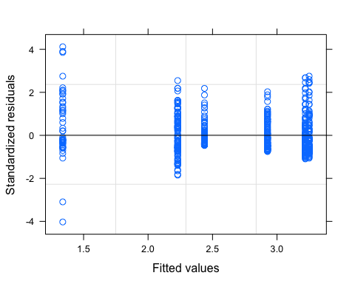

plot(turb.mod.ar1.log, logDailyTurb ~ fitted(.) | site.ID, abline = c(0,1))

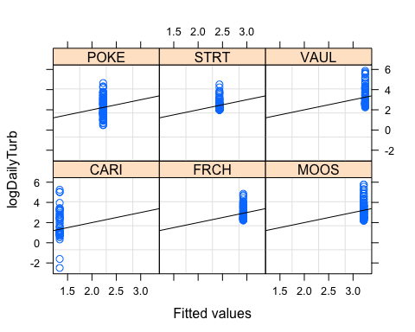

qqnorm(turb.mod.ar1.log, abline = c(0,1))

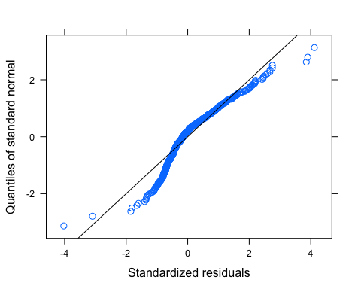 This may need further transformation but it looks a lot better

# ACF plot

Ear1<-residuals(turb.mod.ar1.log, type="normalized")  
I1<-!is.na(mean_daily_2020$logDailyTurb)  
Efulla<-vector(length = length(mean_daily_2020$logDailyTurb))  
Efulla<-NA  
Efulla[I1]<-Ear1  
acf(Efulla, na.action=na.pass)

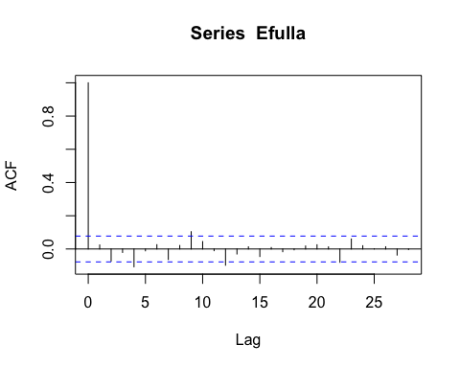

pacf(Efulla, na.action=na.pass)

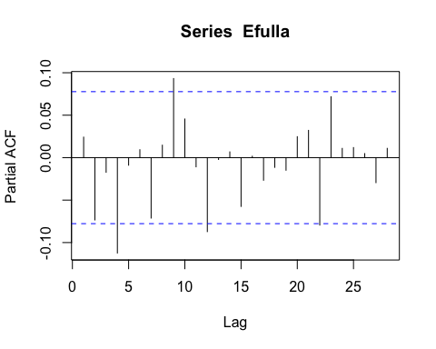 AR1 is not adequately handling the temporal autocorrelation

# corARMA structure

turb.mod.arma.1.1 <- gls(logDailyTurb ~ site.ID,   
 na.action = na.omit,   
 data = mean_daily_2020,   
 correlation = corARMA(form = ~ julian|site.ID, p = 1, q = 1))

# ACF plot

Ear1<-residuals(turb.mod.arma.1.1, type="normalized")  
I1<-!is.na(mean_daily_2020$logDailyTurb)  
Efulla<-vector(length = length(mean_daily_2020$logDailyTurb))  
Efulla<-NA  
Efulla[I1]<-Ear1  
acf(Efulla, na.action=na.pass)

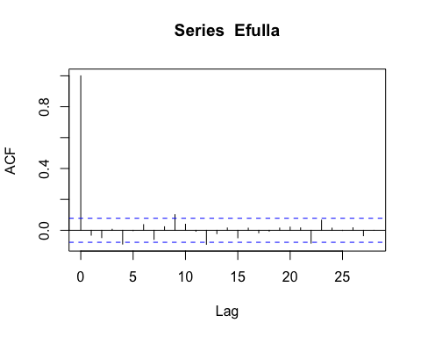

pacf(Efulla, na.action=na.pass)

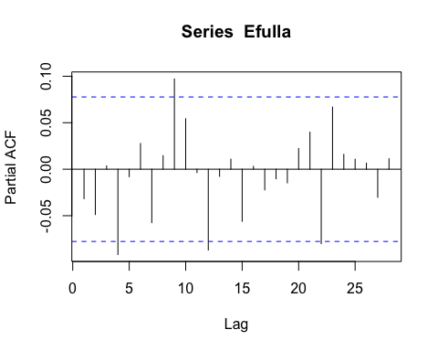 Still autocorrelation

# corARMA structure

turb.mod.arma.1.2 <- gls(logDailyTurb ~ site.ID,   
 na.action = na.omit,   
 data = mean_daily_2020,   
 correlation = corARMA(form = ~ julian|site.ID, p = 1, q = 2))

# ACF plot

Ear1<-residuals(turb.mod.arma.1.2, type="normalized")  
I1<-!is.na(mean_daily_2020$logDailyTurb)  
Efulla<-vector(length = length(mean_daily_2020$logDailyTurb))  
Efulla<-NA  
Efulla[I1]<-Ear1  
acf(Efulla, na.action=na.pass)

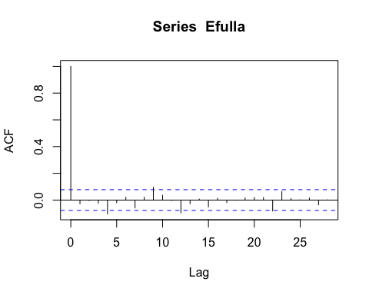

pacf(Efulla, na.action=na.pass)

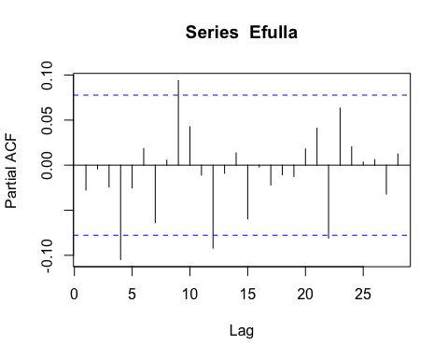 Still autocorrelation at the 9th lag but that is it

# corARMA structure

turb.mod.arma.2.1 <- gls(logDailyTurb ~ site.ID,   
 na.action = na.omit,   
 data = mean_daily_2020,   
 correlation = corARMA(form = ~ julian|site.ID, p = 2, q = 1))

# ACF plot

Ear1<-residuals(turb.mod.arma.2.1, type="normalized")  
I1<-!is.na(mean_daily_2020$logDailyTurb)  
Efulla<-vector(length = length(mean_daily_2020$logDailyTurb))  
Efulla<-NA  
Efulla[I1]<-Ear1  
acf(Efulla, na.action=na.pass)

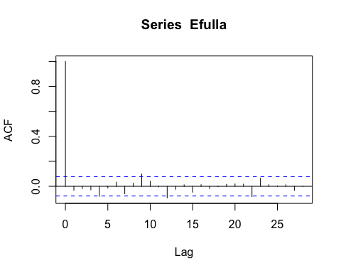

pacf(Efulla, na.action=na.pass)

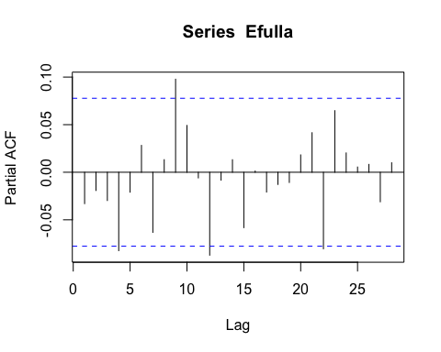 Still autocorrelation at the 9th lag but that is itation in the later lags

# corARMA structure

turb.mod.arma.2.2 <- gls(logDailyTurb ~ site.ID,   
 na.action = na.omit,   
 data = mean_daily_2020,   
 correlation = corARMA(form = ~ julian|site.ID, p = 2, q = 2))

# ACF plot

Ear1<-residuals(turb.mod.arma.2.2, type="normalized")  
I1<-!is.na(mean_daily_2020$logDailyTurb)  
Efulla<-vector(length = length(mean_daily_2020$logDailyTurb))  
Efulla<-NA  
Efulla[I1]<-Ear1  
acf(Efulla, na.action=na.pass)

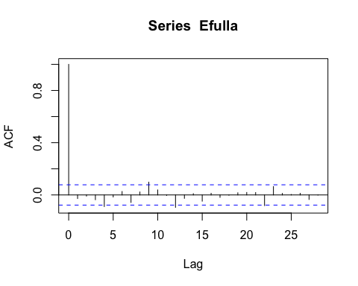

pacf(Efulla, na.action=na.pass)

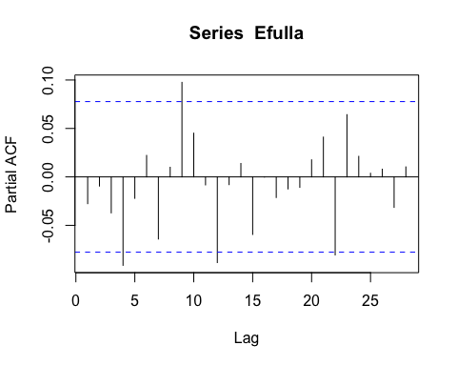 Still autocorrelation at the 9th lag but that is it # generalized linear hypotheses

site.ID.comp <- glht(turb.mod.arma.2.2, linfct = mcp(site.ID = "Tukey"))  
summary(site.ID.comp)

##   
## Simultaneous Tests for General Linear Hypotheses  
##   
## Multiple Comparisons of Means: Tukey Contrasts  
##   
##   
## Fit: gls(model = logDailyTurb ~ site.ID, data = mean_daily_2020, correlation = corARMA(form = ~julian |   
## site.ID, p = 2, q = 2), na.action = na.omit)  
##   
## Linear Hypotheses:  
## Estimate Std. Error z value Pr(>|z|)   
## FRCH - CARI == 0 1.58572 0.46127 3.438 0.00778 **   
## MOOS - CARI == 0 1.87821 0.46140 4.071 < 0.001 ***  
## POKE - CARI == 0 0.89440 0.46127 1.939 0.37684   
## STRT - CARI == 0 1.09565 0.46127 2.375 0.16392   
## VAUL - CARI == 0 1.91119 0.46146 4.142 < 0.001 ***  
## MOOS - FRCH == 0 0.29250 0.40222 0.727 0.97851   
## POKE - FRCH == 0 -0.69132 0.40207 -1.719 0.51726   
## STRT - FRCH == 0 -0.49007 0.40207 -1.219 0.82691   
## VAUL - FRCH == 0 0.32547 0.40228 0.809 0.96576   
## POKE - MOOS == 0 -0.98381 0.40222 -2.446 0.13989   
## STRT - MOOS == 0 -0.78256 0.40222 -1.946 0.37282   
## VAUL - MOOS == 0 0.03298 0.40244 0.082 1.00000   
## STRT - POKE == 0 0.20125 0.40207 0.501 0.99614   
## VAUL - POKE == 0 1.01679 0.40228 2.528 0.11526   
## VAUL - STRT == 0 0.81554 0.40228 2.027 0.32534   
## ---  
## Signif. codes: 0 '***' 0.001 '**' 0.01 '*' 0.05 '.' 0.1 ' ' 1  
## (Adjusted p values reported -- single-step method)

summary(turb.mod.arma.2.2)

## Generalized least squares fit by REML  
## Model: logDailyTurb ~ site.ID   
## Data: mean_daily_2020   
## AIC BIC logLik  
## 913.8143 961.4999 -445.9071  
##   
## Correlation Structure: ARMA(2,2)  
## Formula: ~julian | site.ID   
## Parameter estimate(s):  
## Phi1 Phi2 Theta1 Theta2   
## 0.4888638 0.2779794 0.4007288 -0.0419719   
##   
## Coefficients:  
## Value Std.Error t-value p-value  
## (Intercept) 1.3432338 0.3632315 3.698010 0.0002  
## site.IDFRCH 1.5857172 0.4612656 3.437753 0.0006  
## site.IDMOOS 1.8782131 0.4613997 4.070686 0.0001  
## site.IDPOKE 0.8944003 0.4612656 1.939014 0.0530  
## site.IDSTRT 1.0956486 0.4612656 2.375309 0.0179  
## site.IDVAUL 1.9111917 0.4614555 4.141660 0.0000  
##   
## Correlation:   
## (Intr) s.IDFR s.IDMO s.IDPO s.IDST  
## site.IDFRCH -0.787   
## site.IDMOOS -0.787 0.620   
## site.IDPOKE -0.787 0.620 0.620   
## site.IDSTRT -0.787 0.620 0.620 0.620   
## site.IDVAUL -0.787 0.620 0.620 0.620 0.620  
##   
## Standardized residuals:  
## Min Q1 Med Q3 Max   
## -4.0485861 -0.5241604 -0.1462653 0.5717021 4.1288455   
##   
## Residual standard error: 0.9469433   
## Degrees of freedom: 570 total; 564 residual

intervals(turb.mod.arma.2.2)

## Approximate 95% confidence intervals  
##   
## Coefficients:  
## lower est. upper  
## (Intercept) 0.62978212 1.3432338 2.056686  
## site.IDFRCH 0.67970892 1.5857172 2.491725  
## site.IDMOOS 0.97194151 1.8782131 2.784485  
## site.IDPOKE -0.01160797 0.8944003 1.800409  
## site.IDSTRT 0.18964034 1.0956486 2.001657  
## site.IDVAUL 1.00481047 1.9111917 2.817573  
## attr(,"label")  
## [1] "Coefficients:"  
##   
## Correlation structure:  
## lower est. upper  
## Phi1 -1.1586452 0.4888638 0.1113075  
## Phi2 -0.6844432 0.2779794 0.8871555  
## Theta1 -0.5824384 0.4007288 1.1700689  
## Theta2 -0.2886734 -0.0419719 0.2099561  
## attr(,"label")  
## [1] "Correlation structure:"  
##   
## Residual standard error:  
## lower est. upper   
## 0.8154371 0.9469433 1.0996576

plot(print(confint(site.ID.comp)))

##   
## Simultaneous Confidence Intervals  
##   
## Multiple Comparisons of Means: Tukey Contrasts  
##   
##   
## Fit: gls(model = logDailyTurb ~ site.ID, data = mean_daily_2020, correlation = corARMA(form = ~julian |   
## site.ID, p = 2, q = 2), na.action = na.omit)  
##   
## Quantile = 2.8476  
## 95% family-wise confidence level  
##   
##   
## Linear Hypotheses:  
## Estimate lwr upr   
## FRCH - CARI == 0 1.58572 0.27221 2.89922  
## MOOS - CARI == 0 1.87821 0.56433 3.19210  
## POKE - CARI == 0 0.89440 -0.41910 2.20790  
## STRT - CARI == 0 1.09565 -0.21786 2.40915  
## VAUL - CARI == 0 1.91119 0.59715 3.22524  
## MOOS - FRCH == 0 0.29250 -0.85287 1.43786  
## POKE - FRCH == 0 -0.69132 -1.83625 0.45361  
## STRT - FRCH == 0 -0.49007 -1.63500 0.65486  
## VAUL - FRCH == 0 0.32547 -0.82007 1.47102  
## POKE - MOOS == 0 -0.98381 -2.12918 0.16155  
## STRT - MOOS == 0 -0.78256 -1.92793 0.36280  
## VAUL - MOOS == 0 0.03298 -1.11301 1.17897  
## STRT - POKE == 0 0.20125 -0.94368 1.34618  
## VAUL - POKE == 0 1.01679 -0.12876 2.16234  
## VAUL - STRT == 0 0.81554 -0.33001 1.96109

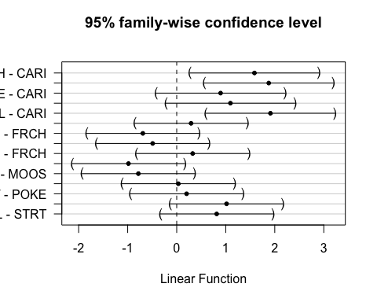 CARI is different to FRCH,MOOS,VAUL

# 2021

mean_daily_2021 <- subset(mean_daily, year == "2021")  
mean_daily_2021$site.ID <- as.factor(mean_daily_2021$site.ID)  
  
ggplot(mean_daily_2021, aes(x = julian, y = dailyNO3, color = site.ID)) +  
 geom_line() +  
 scale_color_manual(values=c("#3288BD","#FF7F00", "#A6761D", "#6A3D9A", "#66C2A5", "#E7298A")) +  
 facet_wrap(~site.ID, scales = "free") +  
 theme_classic()

## Warning: Removed 13 row(s) containing missing values (geom_path).

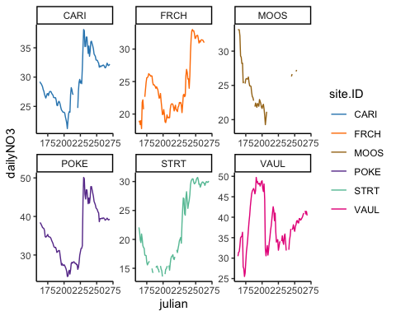

ggplot(mean_daily_2021, aes(x = site.ID, y = dailyNO3, fill = site.ID)) +  
 geom_boxplot() +  
 scale_fill_manual(values=c("#3288BD","#FF7F00", "#A6761D", "#6A3D9A", "#66C2A5", "#E7298A"))

## Warning: Removed 84 rows containing non-finite values (stat_boxplot).

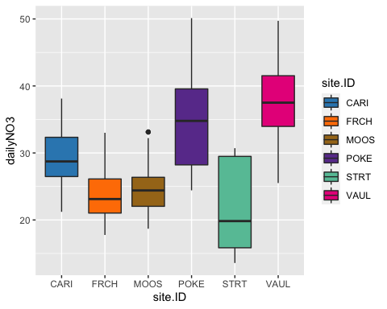 # CorAR1 structure #

no3.mod.gls <- gls(dailyNO3 ~ site.ID,   
 na.action = na.omit,   
 data = mean_daily_2021,   
 correlation = corAR1(form = ~ julian|site.ID))

# diagnostic plots

plot(no3.mod.gls, resid(., type = "p") ~ fitted(.), abline = 0)

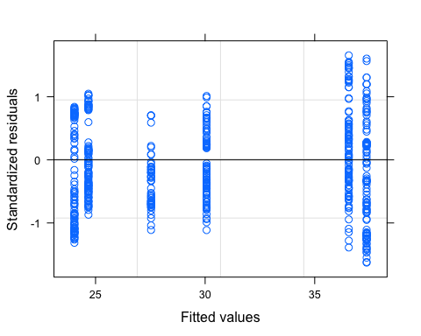

plot(no3.mod.gls, dailyNO3 ~ fitted(.) | site.ID, abline = c(0,1))

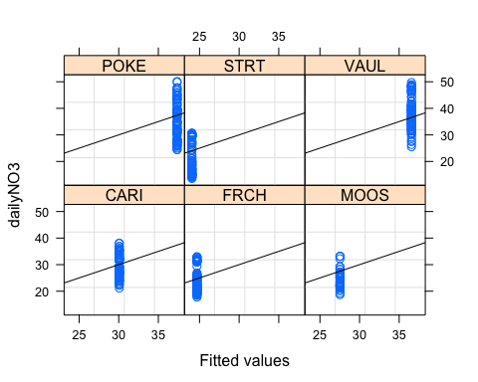

qqnorm(no3.mod.gls, abline = c(0,1))

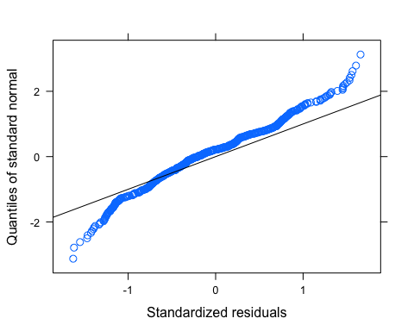 Lets log transform

# CorAR1 structure

mean_daily_2021$logDailyNO3 <- log(mean_daily_2021$dailyNO3)  
  
no3.mod.gls.log <- gls(logDailyNO3 ~ site.ID,   
 na.action = na.omit,   
 data = mean_daily_2021,   
 correlation = corAR1(form = ~ julian|site.ID))

# diagnostic plots

plot(no3.mod.gls.log, resid(., type = "p") ~ fitted(.), abline = 0)

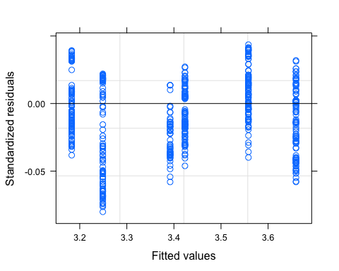

plot(no3.mod.gls.log, dailyNO3 ~ fitted(.) | site.ID, abline = c(0,1))

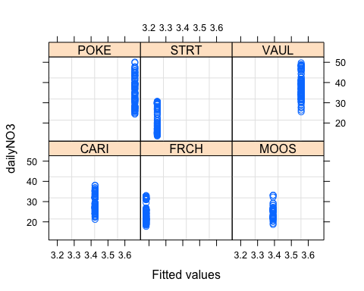

qqnorm(no3.mod.gls.log, abline = c(0,1))

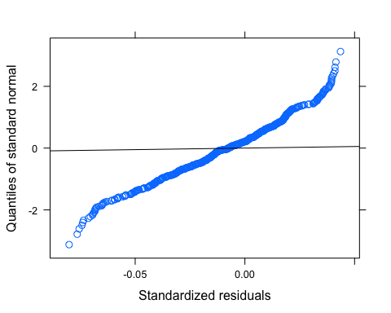 makes the tail a little worse….does this to be transformed further

# ACF plot

Ear1<-residuals(no3.mod.gls, type="normalized")  
I1<-!is.na(mean_daily_2021$dailyNO3)  
Efulla<-vector(length = length(mean_daily_2021$dailyNO3))  
Efulla<-NA  
Efulla[I1]<-Ear1  
acf(Efulla, na.action=na.pass)

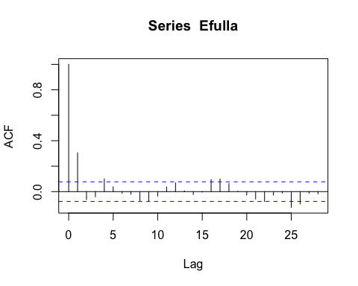

pacf(Efulla, na.action=na.pass)

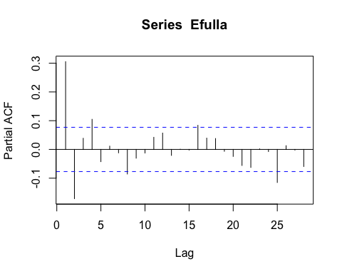 AR1 is does a pretty good job

# corARMA structure

NO3.mod.arma.1.1 <- gls(dailyNO3 ~ site.ID,   
 na.action = na.omit,   
 data = mean_daily_2021,   
 correlation = corARMA(form = ~ julian|site.ID, p = 1, q = 1))

# ACF plot

Ear1<-residuals(NO3.mod.arma.1.1, type="normalized")  
I1<-!is.na(mean_daily_2021$dailyNO3)  
Efulla<-vector(length = length(mean_daily_2021$dailyNO3))  
Efulla<-NA  
Efulla[I1]<-Ear1  
acf(Efulla, na.action=na.pass)

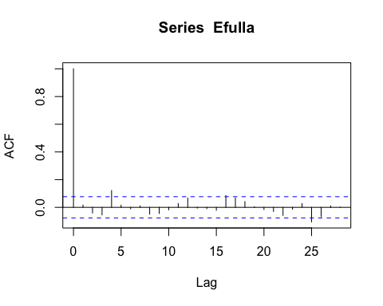

pacf(Efulla, na.action=na.pass)

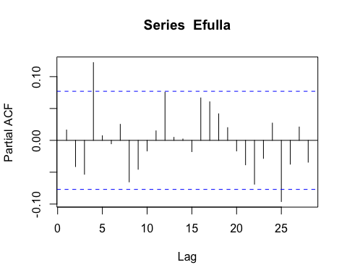 lag at 4

# corARMA structure

NO3.mod.arma.1.2 <- gls(dailyNO3 ~ site.ID,   
 na.action = na.omit,   
 data = mean_daily_2021,   
 correlation = corARMA(form = ~ julian|site.ID, p = 1, q = 2))

# ACF plot

Ear1<-residuals(NO3.mod.arma.1.2, type="normalized")  
I1<-!is.na(mean_daily_2021$dailyNO3)  
Efulla<-vector(length = length(mean_daily_2021$dailyNO3))  
Efulla<-NA  
Efulla[I1]<-Ear1  
acf(Efulla, na.action=na.pass)

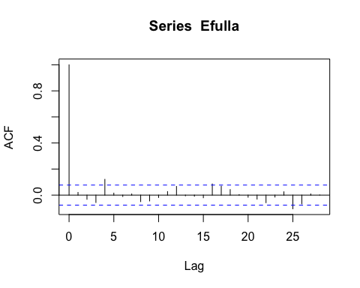

pacf(Efulla, na.action=na.pass)

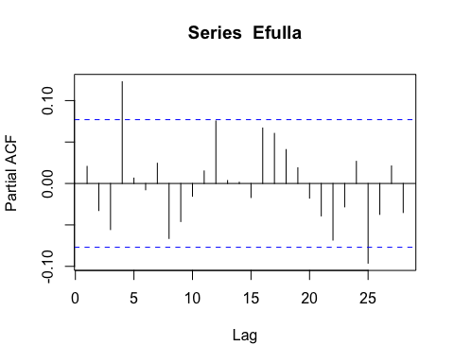 # corARMA structure

NO3.mod.arma.2.1 <- gls(dailyNO3 ~ site.ID,   
 na.action = na.omit,   
 data = mean_daily_2021,   
 correlation = corARMA(form = ~ julian|site.ID, p = 2, q = 1))

# ACF plot

Ear1<-residuals(NO3.mod.arma.1.2, type="normalized")  
I1<-!is.na(mean_daily_2021$dailyNO3)  
Efulla<-vector(length = length(mean_daily_2021$dailyNO3))  
Efulla<-NA  
Efulla[I1]<-Ear1  
acf(Efulla, na.action=na.pass)



pacf(Efulla, na.action=na.pass)

 # corARMA structure

NO3.mod.arma.2.2 <- gls(dailyNO3 ~ site.ID,   
 na.action = na.omit,   
 data = mean_daily_2021,   
 correlation = corARMA(form = ~ julian|site.ID, p = 2, q = 2))

# ACF plot

Ear1<-residuals(NO3.mod.arma.2.2, type="normalized")  
I1<-!is.na(mean_daily_2021$dailyNO3)  
Efulla<-vector(length = length(mean_daily_2021$dailyNO3))  
Efulla<-NA  
Efulla[I1]<-Ear1  
acf(Efulla, na.action=na.pass)

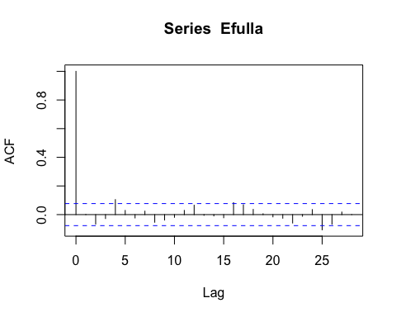

pacf(Efulla, na.action=na.pass)

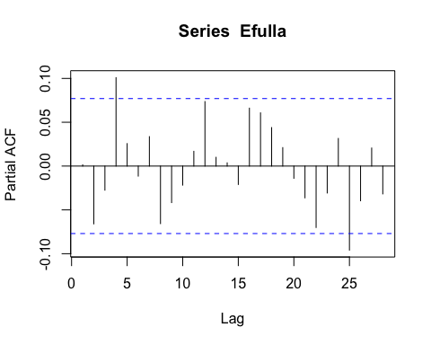

# generalized linear hypotheses

site.ID.comp <- glht(NO3.mod.arma.2.2, linfct = mcp(site.ID = "Tukey"))  
summary(site.ID.comp)

##   
## Simultaneous Tests for General Linear Hypotheses  
##   
## Multiple Comparisons of Means: Tukey Contrasts  
##   
##   
## Fit: gls(model = dailyNO3 ~ site.ID, data = mean_daily_2021, correlation = corARMA(form = ~julian |   
## site.ID, p = 2, q = 2), na.action = na.omit)  
##   
## Linear Hypotheses:  
## Estimate Std. Error z value Pr(>|z|)  
## FRCH - CARI == 0 -5.1969 5.7414 -0.905 0.945  
## MOOS - CARI == 0 -3.4358 5.7264 -0.600 0.991  
## POKE - CARI == 0 6.8842 5.6801 1.212 0.831  
## STRT - CARI == 0 -6.7087 5.6802 -1.181 0.846  
## VAUL - CARI == 0 7.2306 5.6886 1.271 0.801  
## MOOS - FRCH == 0 1.7611 5.7870 0.304 1.000  
## POKE - FRCH == 0 12.0811 5.7412 2.104 0.285  
## STRT - FRCH == 0 -1.5118 5.7413 -0.263 1.000  
## VAUL - FRCH == 0 12.4276 5.7496 2.161 0.256  
## POKE - MOOS == 0 10.3199 5.7262 1.802 0.464  
## STRT - MOOS == 0 -3.2730 5.7262 -0.572 0.993  
## VAUL - MOOS == 0 10.6664 5.7346 1.860 0.427  
## STRT - POKE == 0 -13.5929 5.6800 -2.393 0.158  
## VAUL - POKE == 0 0.3465 5.6884 0.061 1.000  
## VAUL - STRT == 0 13.9394 5.6885 2.450 0.139  
## (Adjusted p values reported -- single-step method)

summary(NO3.mod.arma.1.1)

## Generalized least squares fit by REML  
## Model: dailyNO3 ~ site.ID   
## Data: mean_daily_2021   
## AIC BIC logLik  
## 1870.411 1909.33 -926.2055  
##   
## Correlation Structure: ARMA(1,1)  
## Formula: ~julian | site.ID   
## Parameter estimate(s):  
## Phi1 Theta1   
## 0.9702145 0.3437274   
##   
## Coefficients:  
## Value Std.Error t-value p-value  
## (Intercept) 29.776834 4.183421 7.117819 0.0000  
## site.IDFRCH -5.245368 5.977875 -0.877464 0.3806  
## site.IDMOOS -3.372682 5.962320 -0.565666 0.5718  
## site.IDPOKE 6.917527 5.916078 1.169276 0.2428  
## site.IDSTRT -6.642259 5.916096 -1.122743 0.2620  
## site.IDVAUL 7.139450 5.924647 1.205042 0.2287  
##   
## Correlation:   
## (Intr) s.IDFR s.IDMO s.IDPO s.IDST  
## site.IDFRCH -0.700   
## site.IDMOOS -0.702 0.491   
## site.IDPOKE -0.707 0.495 0.496   
## site.IDSTRT -0.707 0.495 0.496 0.500   
## site.IDVAUL -0.706 0.494 0.495 0.499 0.499  
##   
## Standardized residuals:  
## Min Q1 Med Q3 Max   
## -1.8210724 -0.6858523 -0.2138269 0.4851320 1.9925341   
##   
## Residual standard error: 6.739431   
## Degrees of freedom: 564 total; 558 residual

intervals(NO3.mod.arma.1.1)

## Approximate 95% confidence intervals  
##   
## Coefficients:  
## lower est. upper  
## (Intercept) 21.559656 29.776834 37.994012  
## site.IDFRCH -16.987257 -5.245368 6.496521  
## site.IDMOOS -15.084016 -3.372682 8.338652  
## site.IDPOKE -4.702978 6.917527 18.538033  
## site.IDSTRT -18.262800 -6.642259 4.978283  
## site.IDVAUL -4.497885 7.139450 18.776786  
## attr(,"label")  
## [1] "Coefficients:"  
##   
## Correlation structure:  
## lower est. upper  
## Phi1 0.9272941 0.9702145 0.9879561  
## Theta1 0.2627897 0.3437274 0.4198614  
## attr(,"label")  
## [1] "Correlation structure:"  
##   
## Residual standard error:  
## lower est. upper   
## 4.310722 6.739431 10.536500

plot(print(confint(site.ID.comp)))

##   
## Simultaneous Confidence Intervals  
##   
## Multiple Comparisons of Means: Tukey Contrasts  
##   
##   
## Fit: gls(model = dailyNO3 ~ site.ID, data = mean_daily_2021, correlation = corARMA(form = ~julian |   
## site.ID, p = 2, q = 2), na.action = na.omit)  
##   
## Quantile = 2.8495  
## 95% family-wise confidence level  
##   
##   
## Linear Hypotheses:  
## Estimate lwr upr   
## FRCH - CARI == 0 -5.1969 -21.5569 11.1631  
## MOOS - CARI == 0 -3.4358 -19.7529 12.8813  
## POKE - CARI == 0 6.8842 -9.3012 23.0695  
## STRT - CARI == 0 -6.7087 -22.8941 9.4766  
## VAUL - CARI == 0 7.2306 -8.9789 23.4401  
## MOOS - FRCH == 0 1.7611 -14.7287 18.2510  
## POKE - FRCH == 0 12.0811 -4.2783 28.4405  
## STRT - FRCH == 0 -1.5118 -17.8713 14.8477  
## VAUL - FRCH == 0 12.4276 -3.9558 28.8109  
## POKE - MOOS == 0 10.3199 -5.9966 26.6365  
## STRT - MOOS == 0 -3.2730 -19.5896 13.0437  
## VAUL - MOOS == 0 10.6664 -5.6741 27.0070  
## STRT - POKE == 0 -13.5929 -29.7777 2.5919  
## VAUL - POKE == 0 0.3465 -15.8625 16.5554  
## VAUL - STRT == 0 13.9394 -2.2696 30.1484

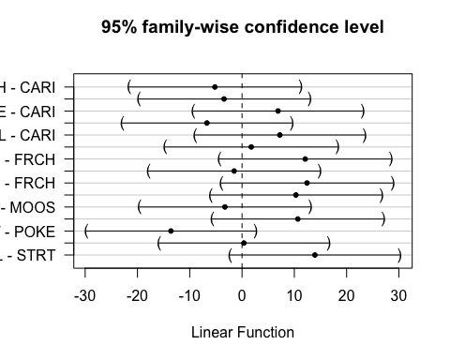 This shows significance for STRT and CARI FRCH and MOOS, VAUL MOOS and POKE,STRT, VAUL VAUL and POKE,STRT

### fDOM

mean_daily_2021 <- mean_daily_2021 %>%  
 mutate(across(c(dailyfDOM),   
 ~ifelse(dailyfDOM < 0, NA, .)))  
  
mean_daily_2021 <- mean_daily_2021 %>%  
 mutate(across(c(dailyfDOM),   
 ~ifelse(site.ID == "VAUL" & dailyfDOM < 90, NA, .)))  
  
mean_daily_2021 <- mean_daily_2021 %>%  
 mutate(across(c(dailyfDOM),   
 ~ifelse(site.ID == "FRCH" & dailyfDOM < 20, NA, .)))  
  
ggplot(mean_daily_2021, aes(x = julian, y = dailyfDOM, color = site.ID)) +  
 geom_line() +  
 scale_color_manual(values=c("#3288BD","#FF7F00", "#A6761D", "#6A3D9A", "#66C2A5", "#E7298A")) +  
 facet_wrap(~site.ID, scales = "free") +  
 theme_classic()

## Warning: Removed 55 row(s) containing missing values (geom_path).

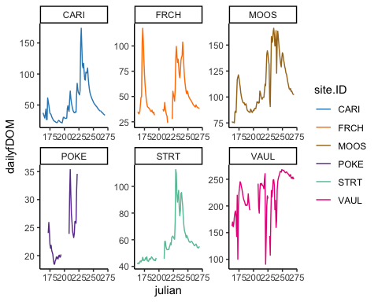

ggplot(mean_daily_2021, aes(x = site.ID, y = dailyfDOM, fill = site.ID)) +  
 geom_boxplot() +  
 scale_fill_manual(values=c("#3288BD","#FF7F00", "#A6761D", "#6A3D9A", "#66C2A5", "#E7298A"))

## Warning: Removed 117 rows containing non-finite values (stat_boxplot).

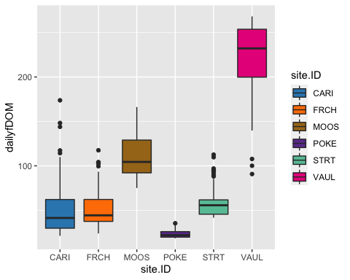

# corAR1 structure

fDOM.mod.ar1 <- gls(dailyfDOM ~ site.ID,   
 na.action = na.omit,   
 data = mean_daily_2021,   
 correlation = corAR1(form = ~ julian|site.ID))

# diagnostic plots

plot(fDOM.mod.ar1, resid(., type = "p") ~ fitted(.), abline = 0)

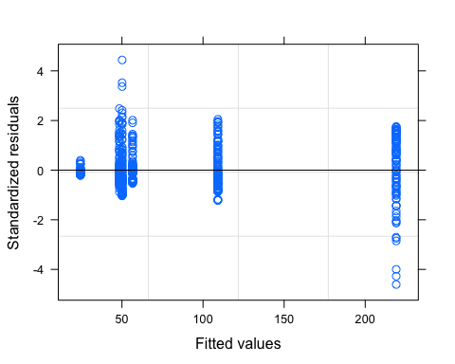

plot(fDOM.mod.ar1, dailyfDOM ~ fitted(.) | site.ID, abline = c(0,1))

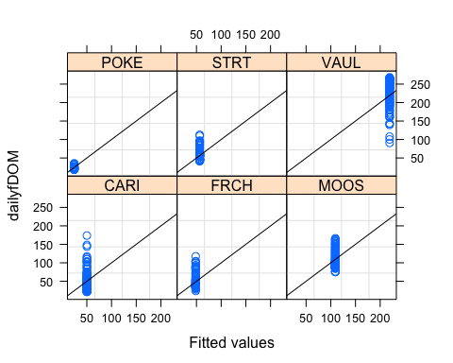

qqnorm(fDOM.mod.ar1, abline = c(0,1))

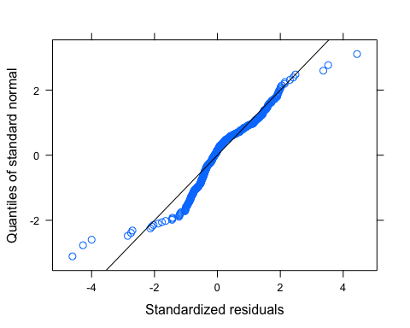 Let me log transform to see if its better

# log transformed

mean_daily_2021$logDailyfDOM <- log(mean_daily_2021$dailyfDOM)  
  
fDOM.mod.ar1.log <- gls(logDailyfDOM ~ site.ID,   
 na.action = na.omit,   
 data = mean_daily_2021,   
 weights = varfixed,  
 correlation = corAR1(form = ~ julian|site.ID))

# diagnostic plots

plot(fDOM.mod.ar1.log, resid(., type = "p") ~ fitted(.), abline = 0)

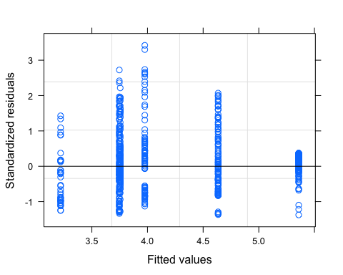

plot(fDOM.mod.ar1.log, logDailyfDOM ~ fitted(.) | site.ID, abline = c(0,1))

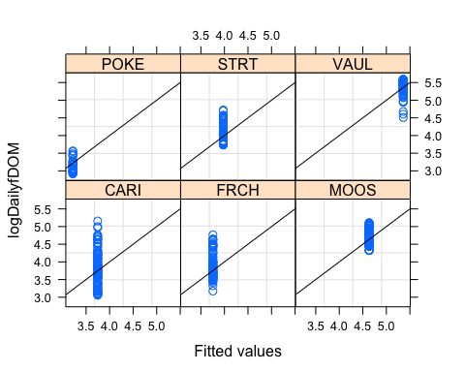

qqnorm(fDOM.mod.ar1.log, abline = c(0,1))

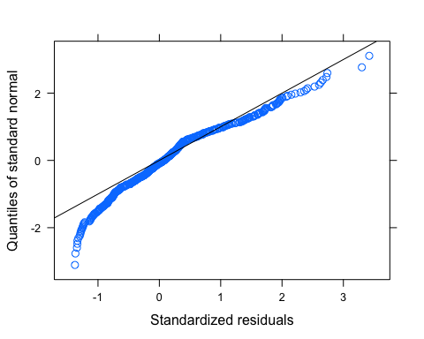 Looks much better

# ACF plot

Ear1<-residuals(fDOM.mod.ar1.log, type="normalized")  
I1<-!is.na(mean_daily_2021$logDailyfDOM)  
Efulla<-vector(length = length(mean_daily_2021$logDailyfDOM))  
Efulla<-NA  
Efulla[I1]<-Ear1  
acf(Efulla, na.action=na.pass)

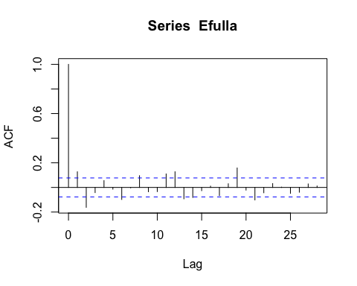

pacf(Efulla, na.action=na.pass)

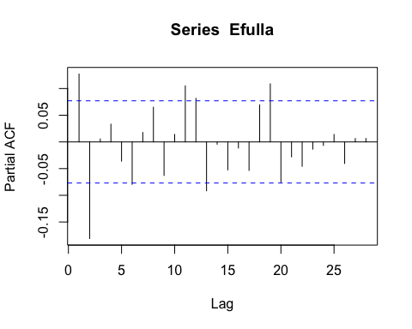 AR1 is not adequately handling the temporal autocorrelation

# corARMA structure

fDOM.mod.arma.1.1 <- gls(logDailyfDOM ~ site.ID,   
 na.action = na.omit,   
 data = mean_daily_2021,   
 weights = varfixed,  
 correlation = corARMA(form = ~ julian|site.ID, p = 1, q = 1))

# ACF plot

Ear1<-residuals(fDOM.mod.arma.1.1, type="normalized")  
I1<-!is.na(mean_daily_2021$logDailyfDOM)  
Efulla<-vector(length = length(mean_daily_2021$logDailyfDOM))  
Efulla<-NA  
Efulla[I1]<-Ear1  
acf(Efulla, na.action=na.pass)

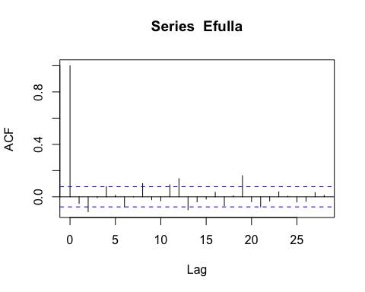

pacf(Efulla, na.action=na.pass)

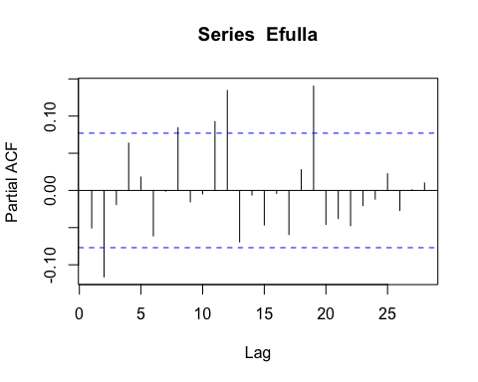 Still autocorrelation on the later lags but we are close

# corARMA structure

fDOM.mod.arma.2.1 <- gls(logDailyfDOM ~ site.ID,   
 na.action = na.omit,   
 data = mean_daily_2021,   
 weights = varfixed,  
 correlation = corARMA(form = ~ julian|site.ID, p = 2, q = 1))

# ACF plot

Ear1<-residuals(fDOM.mod.arma.2.1, type="normalized")  
I1<-!is.na(mean_daily_2021$logDailyfDOM)  
Efulla<-vector(length = length(mean_daily_2021$logDailyfDOM))  
Efulla<-NA  
Efulla[I1]<-Ear1  
acf(Efulla, na.action=na.pass)

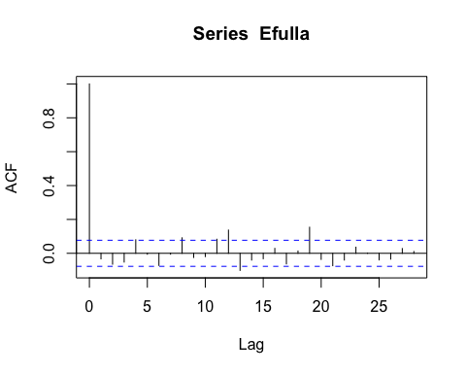

pacf(Efulla, na.action=na.pass)

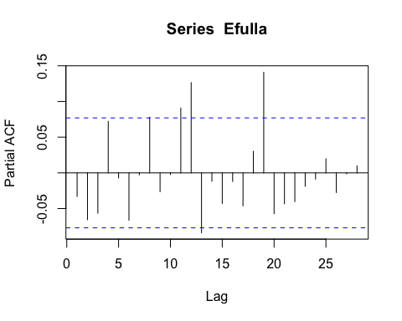 same as above

# corARMA structure

fDOM.mod.arma.1.2 <- gls(logDailyfDOM ~ site.ID,   
 na.action = na.omit,   
 data = mean_daily_2021,   
 weights = varfixed,  
 correlation = corARMA(form = ~ julian|site.ID, p = 1, q = 2))

# ACF plot

Ear1<-residuals(fDOM.mod.arma.1.2, type="normalized")  
I1<-!is.na(mean_daily_2021$logDailyfDOM)  
Efulla<-vector(length = length(mean_daily_2021$logDailyfDOM))  
Efulla<-NA  
Efulla[I1]<-Ear1  
acf(Efulla, na.action=na.pass)

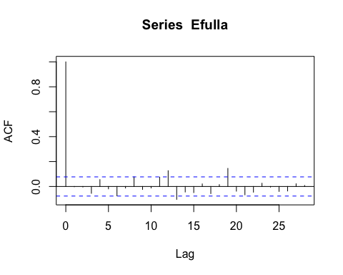

pacf(Efulla, na.action=na.pass)

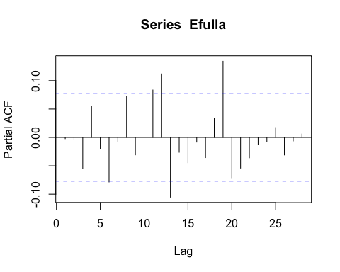 Still autocorrelation in the later lags

# corARMA structure

fDOM.mod.arma.2.2 <- gls(logDailyfDOM ~ site.ID,   
 na.action = na.omit,   
 data = mean_daily_2021,   
 weights = varfixed,  
 correlation = corARMA(form = ~ julian|site.ID, p = 2, q = 2))

# ACF plot

Ear1<-residuals(fDOM.mod.arma.2.2, type="normalized")  
I1<-!is.na(mean_daily_2021$logDailyfDOM)  
Efulla<-vector(length = length(mean_daily_2021$logDailyfDOM))  
Efulla<-NA  
Efulla[I1]<-Ear1  
acf(Efulla, na.action=na.pass)

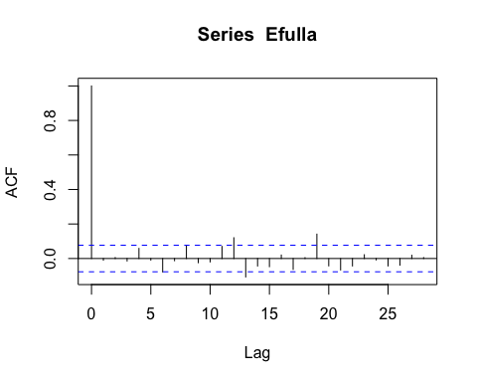

pacf(Efulla, na.action=na.pass)

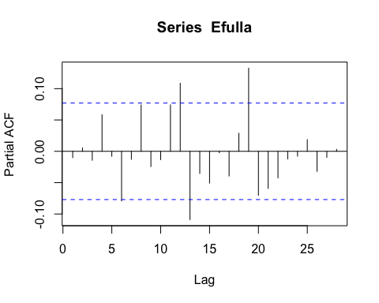 Still autocorrelation but this is the best one yet so lets interpret this model

# generalized linear hypotheses

site.ID.comp <- glht(fDOM.mod.arma.2.2, linfct = mcp(site.ID = "Tukey"))  
summary(site.ID.comp)

##   
## Simultaneous Tests for General Linear Hypotheses  
##   
## Multiple Comparisons of Means: Tukey Contrasts  
##   
##   
## Fit: gls(model = logDailyfDOM ~ site.ID, data = mean_daily_2021, correlation = corARMA(form = ~julian |   
## site.ID, p = 2, q = 2), weights = varfixed, na.action = na.omit)  
##   
## Linear Hypotheses:  
## Estimate Std. Error z value Pr(>|z|)   
## FRCH - CARI == 0 0.01106 0.40698 0.027 1.00000   
## MOOS - CARI == 0 0.89168 0.32886 2.711 0.06495 .   
## POKE - CARI == 0 -0.50341 0.34286 -1.468 0.66166   
## STRT - CARI == 0 0.23511 0.32344 0.727 0.97602   
## VAUL - CARI == 0 1.62422 0.51344 3.163 0.01723 *   
## MOOS - FRCH == 0 0.88062 0.30987 2.842 0.04524 *   
## POKE - FRCH == 0 -0.51446 0.32469 -1.584 0.58372   
## STRT - FRCH == 0 0.22406 0.30411 0.737 0.97456   
## VAUL - FRCH == 0 1.61316 0.50149 3.217 0.01432 *   
## POKE - MOOS == 0 -1.39508 0.21895 -6.372 < 0.001 ***  
## STRT - MOOS == 0 -0.65656 0.18708 -3.509 0.00517 **   
## VAUL - MOOS == 0 0.73254 0.44047 1.663 0.53041   
## STRT - POKE == 0 0.73852 0.21072 3.505 0.00537 **   
## VAUL - POKE == 0 2.12762 0.45102 4.717 < 0.001 ***  
## VAUL - STRT == 0 1.38910 0.43643 3.183 0.01607 *   
## ---  
## Signif. codes: 0 '***' 0.001 '**' 0.01 '*' 0.05 '.' 0.1 ' ' 1  
## (Adjusted p values reported -- single-step method)

summary(fDOM.mod.arma.2.2)

## Generalized least squares fit by REML  
## Model: logDailyfDOM ~ site.ID   
## Data: mean_daily_2021   
## AIC BIC logLik  
## -783.0285 -714.8141 407.5143  
##   
## Correlation Structure: ARMA(2,2)  
## Formula: ~julian | site.ID   
## Parameter estimate(s):  
## Phi1 Phi2 Theta1 Theta2   
## 1.2716837 -0.2974025 -0.1264542 -0.2318784   
## Variance function:  
## Structure: Different standard deviations per stratum  
## Formula: ~1 | site.ID   
## Parameter estimates:  
## CARI FRCH MOOS POKE STRT VAUL   
## 1.0000000 0.9279053 0.4656178 0.4583175 0.4201812 1.4004411   
##   
## Coefficients:  
## Value Std.Error t-value p-value  
## (Intercept) 3.731415 0.2981309 12.516031 0.0000  
## site.IDFRCH 0.011057 0.4069813 0.027167 0.9783  
## site.IDMOOS 0.891676 0.3288641 2.711382 0.0069  
## site.IDPOKE -0.503407 0.3428603 -1.468256 0.1426  
## site.IDSTRT 0.235114 0.3234381 0.726921 0.4676  
## site.IDVAUL 1.624216 0.5134449 3.163369 0.0016  
##   
## Correlation:   
## (Intr) s.IDFR s.IDMO s.IDPO s.IDST  
## site.IDFRCH -0.733   
## site.IDMOOS -0.907 0.664   
## site.IDPOKE -0.870 0.637 0.788   
## site.IDSTRT -0.922 0.675 0.836 0.802   
## site.IDVAUL -0.581 0.425 0.526 0.505 0.535  
##   
## Standardized residuals:  
## Min Q1 Med Q3 Max   
## -1.29174066 -0.40041541 0.09120624 0.55757740 3.41650881   
##   
## Residual standard error: 0.5275613   
## Degrees of freedom: 531 total; 525 residual

intervals(fDOM.mod.arma.2.2)

## Approximate 95% confidence intervals  
##   
## Coefficients:  
## lower est. upper  
## (Intercept) 3.1457391 3.7314150 4.3170910  
## site.IDFRCH -0.7884554 0.0110565 0.8105684  
## site.IDMOOS 0.2456251 0.8916764 1.5377277  
## site.IDPOKE -1.1769533 -0.5034068 0.1701398  
## site.IDSTRT -0.4002780 0.2351138 0.8705057  
## site.IDVAUL 0.6155567 1.6242155 2.6328743  
## attr(,"label")  
## [1] "Coefficients:"  
##   
## Correlation structure:  
## lower est. upper  
## Phi1 1.4953365 1.2716837 0.7940116  
## Phi2 -0.6747286 -0.2974025 0.2031711  
## Theta1 -0.4457422 -0.1264542 0.4111186  
## Theta2 -0.3462505 -0.2318784 -0.1107144  
## attr(,"label")  
## [1] "Correlation structure:"  
##   
## Variance function:  
## lower est. upper  
## FRCH 0.7577815 0.9279053 1.1362225  
## MOOS 0.3845651 0.4656178 0.5637535  
## POKE 0.3518699 0.4583175 0.5969677  
## STRT 0.3447633 0.4201812 0.5120969  
## VAUL 1.1349501 1.4004411 1.7280367  
## attr(,"label")  
## [1] "Variance function:"  
##   
## Residual standard error:  
## lower est. upper   
## 0.3524759 0.5275613 0.7896169

plot(print(confint(site.ID.comp)))

##   
## Simultaneous Confidence Intervals  
##   
## Multiple Comparisons of Means: Tukey Contrasts  
##   
##   
## Fit: gls(model = logDailyfDOM ~ site.ID, data = mean_daily_2021, correlation = corARMA(form = ~julian |   
## site.ID, p = 2, q = 2), weights = varfixed, na.action = na.omit)  
##   
## Quantile = 2.8052  
## 95% family-wise confidence level  
##   
##   
## Linear Hypotheses:  
## Estimate lwr upr   
## FRCH - CARI == 0 0.01106 -1.13062 1.15273  
## MOOS - CARI == 0 0.89168 -0.03086 1.81422  
## POKE - CARI == 0 -0.50341 -1.46521 0.45839  
## STRT - CARI == 0 0.23511 -0.67220 1.14243  
## VAUL - CARI == 0 1.62422 0.18389 3.06455  
## MOOS - FRCH == 0 0.88062 0.01136 1.74988  
## POKE - FRCH == 0 -0.51446 -1.42529 0.39636  
## STRT - FRCH == 0 0.22406 -0.62904 1.07715  
## VAUL - FRCH == 0 1.61316 0.20636 3.01996  
## POKE - MOOS == 0 -1.39508 -2.00930 -0.78087  
## STRT - MOOS == 0 -0.65656 -1.18137 -0.13175  
## VAUL - MOOS == 0 0.73254 -0.50308 1.96816  
## STRT - POKE == 0 0.73852 0.14741 1.32963  
## VAUL - POKE == 0 2.12762 0.86242 3.39282  
## VAUL - STRT == 0 1.38910 0.16481 2.61340

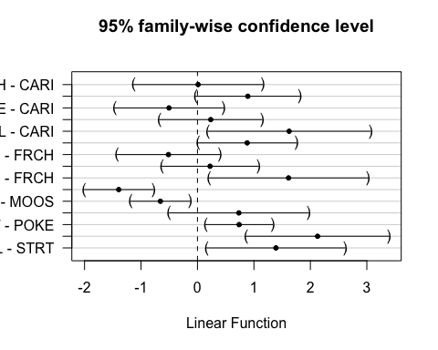 This shows that CARI is different than MOOS, POKE, VAUL FRCH to MOOS and POKE and VAUL MOOS to POKE, STRT, VAUL POKE to STRT VAUL VAUL - STRT

### SPC

ggplot(mean_daily_2021, aes(x = julian, y = dailySPC, color = site.ID)) +  
 geom_line() +  
 scale_color_manual(values=c("#3288BD","#FF7F00", "#A6761D", "#6A3D9A", "#66C2A5", "#E7298A")) +  
 facet_wrap(~site.ID, scales = "free") +  
 theme_classic()

## Warning: Removed 55 row(s) containing missing values (geom_path).

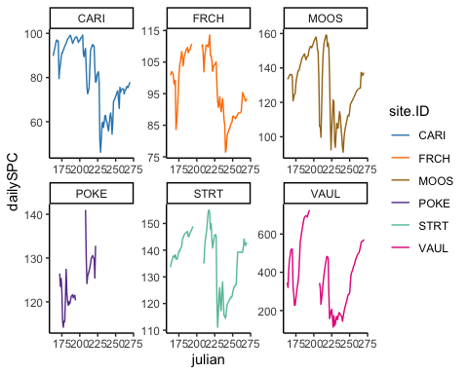

ggplot(mean_daily_2021, aes(x = site.ID, y = dailySPC, fill = site.ID)) +  
 geom_boxplot() +  
 scale_fill_manual(values=c("#3288BD","#FF7F00", "#A6761D", "#6A3D9A", "#66C2A5", "#E7298A"))

## Warning: Removed 108 rows containing non-finite values (stat_boxplot).

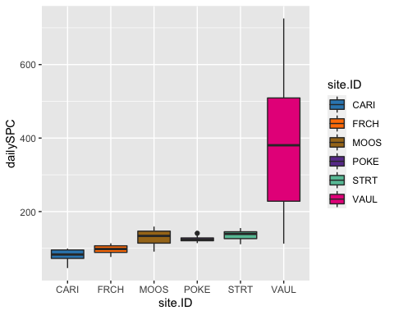

# corAR1 structure

SPC.mod.ar1 <- gls(dailySPC ~ site.ID,   
 na.action = na.omit,   
 data = mean_daily_2021,   
 correlation = corAR1(form = ~ julian|site.ID))

# diagnostic plots

plot(SPC.mod.ar1, resid(., type = "p") ~ fitted(.), abline = 0)

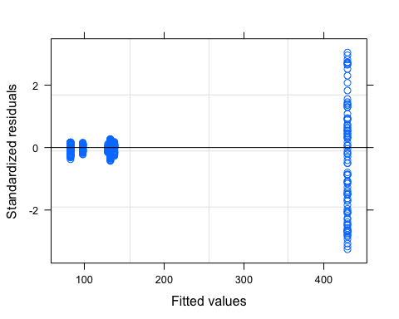

plot(SPC.mod.ar1, dailySPC ~ fitted(.) | site.ID, abline = c(0,1))

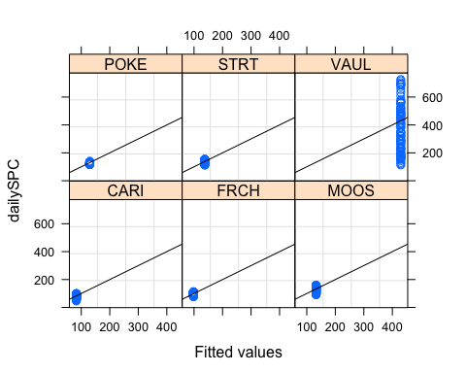

qqnorm(SPC.mod.ar1, abline = c(0,1))

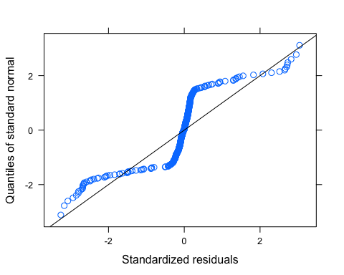 VAUL has way more heterogeneity that needs to be dealt with

mean_daily_2021$logDailySPC <- log(mean_daily_2021$dailySPC)  
  
SPC.mod.ar1.log <- gls(logDailySPC ~ site.ID,   
 na.action = na.omit,   
 data = mean_daily_2021,   
 weights = varfixed,  
 correlation = corAR1(form = ~ julian|site.ID))

# diagnostic plots

plot(SPC.mod.ar1.log, resid(., type = "p") ~ fitted(.), abline = 0)

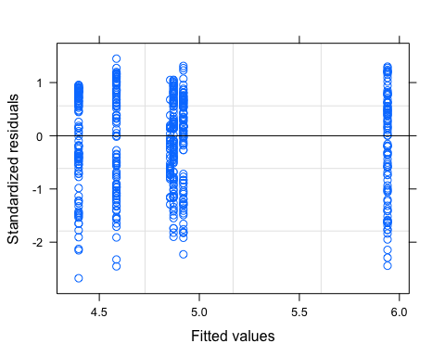

plot(SPC.mod.ar1.log, dailySPC ~ fitted(.) | site.ID, abline = c(0,1))

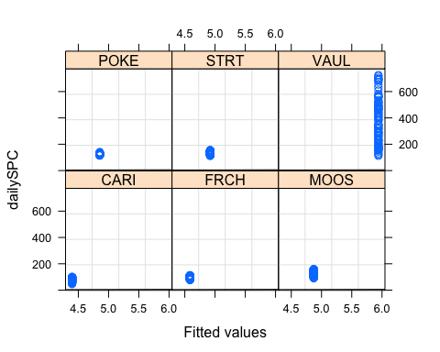

qqnorm(SPC.mod.ar1.log, abline = c(0,1))

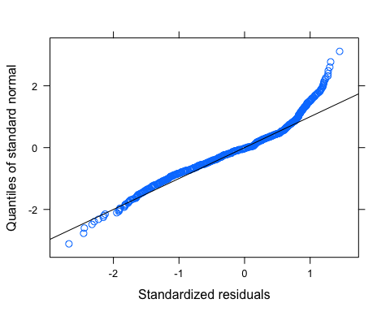 upper tail is meh

# ACF plot

Ear1<-residuals(SPC.mod.ar1, type="normalized")  
I1<-!is.na(mean_daily_2021$dailySPC)  
Efulla<-vector(length = length(mean_daily_2021$dailySPC))  
Efulla<-NA  
Efulla[I1]<-Ear1  
acf(Efulla, na.action=na.pass)

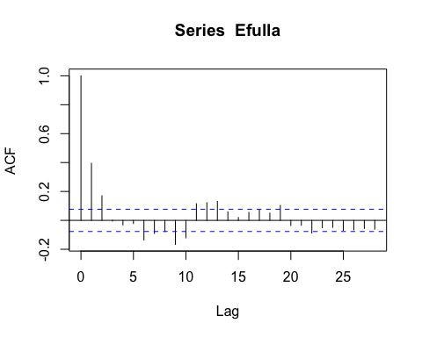

pacf(Efulla, na.action=na.pass)

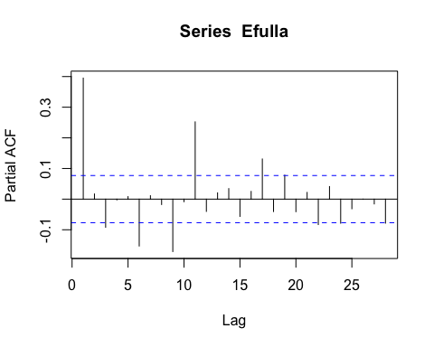 AR1 is not adequately handling the temporal autocorrelation

# corARMA structure

SPC.mod.arma.1.1 <- gls(dailySPC ~ site.ID,   
 na.action = na.omit,   
 data = mean_daily_2021,   
 weights = varfixed,  
 correlation = corARMA(form = ~ julian|site.ID, p = 1, q = 1))

# ACF plot

Ear1<-residuals(SPC.mod.arma.1.1, type="normalized")  
I1<-!is.na(mean_daily_2021$dailySPC)  
Efulla<-vector(length = length(mean_daily_2021$dailySPC))  
Efulla<-NA  
Efulla[I1]<-Ear1  
acf(Efulla, na.action=na.pass)

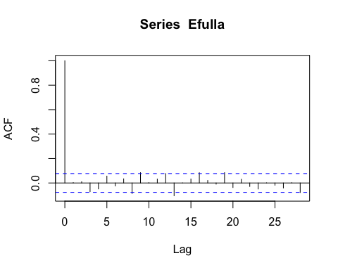

pacf(Efulla, na.action=na.pass)

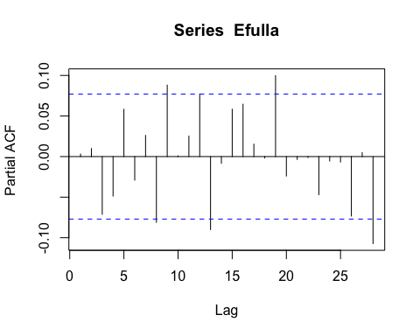 Still autocorrelation at the 9th lag but that is it

# corARMA structure

SPC.mod.arma.2.1 <- gls(dailySPC ~ site.ID,   
 na.action = na.omit,   
 data = mean_daily_2021,   
 weights = varfixed,  
 correlation = corARMA(form = ~ julian|site.ID, p = 2, q = 1))

# ACF plot

Ear1<-residuals(SPC.mod.arma.2.1, type="normalized")  
I1<-!is.na(mean_daily_2021$dailySPC)  
Efulla<-vector(length = length(mean_daily_2021$dailySPC))  
Efulla<-NA  
Efulla[I1]<-Ear1  
acf(Efulla, na.action=na.pass)

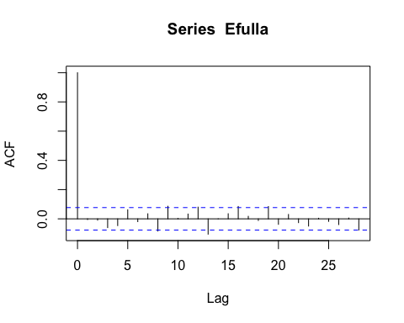

pacf(Efulla, na.action=na.pass)

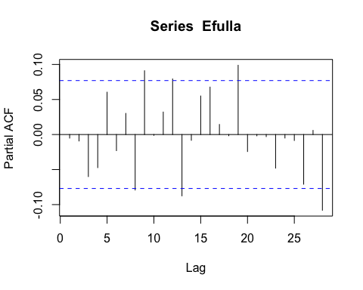 Still that 9th lag

# corARMA structure

SPC.mod.arma.1.2 <- gls(dailySPC ~ site.ID,   
 na.action = na.omit,   
 data = mean_daily_2021,   
 weights = varfixed,  
 correlation = corARMA(form = ~ julian|site.ID, p = 1, q = 2))

# ACF plot

Ear1<-residuals(SPC.mod.arma.1.2, type="normalized")  
I1<-!is.na(mean_daily_2021$dailySPC)  
Efulla<-vector(length = length(mean_daily_2021$dailySPC))  
Efulla<-NA  
Efulla[I1]<-Ear1  
acf(Efulla, na.action=na.pass)

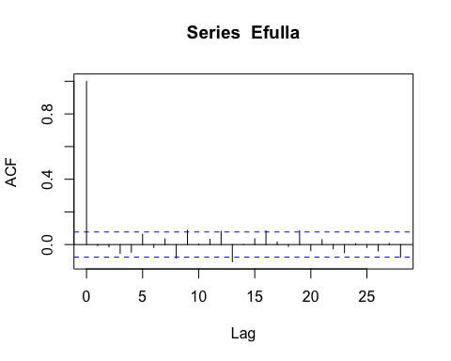

pacf(Efulla, na.action=na.pass)

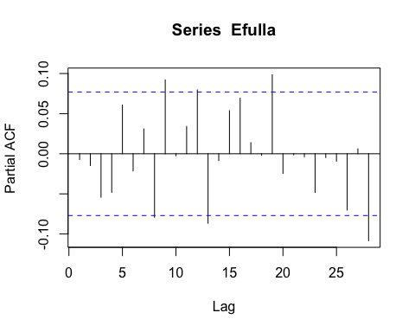 Still autocorrelation in the later lags

# corARMA structure

SPC.mod.arma.2.2 <- gls(dailySPC ~ site.ID,   
 na.action = na.omit,   
 data = mean_daily_2021,   
 weights = varfixed,  
 correlation = corARMA(form = ~ julian|site.ID, p = 2, q = 2))

# ACF plot

Ear1<-residuals(SPC.mod.arma.2.2, type="normalized")  
I1<-!is.na(mean_daily_2021$dailySPC)  
Efulla<-vector(length = length(mean_daily_2021$dailySPC))  
Efulla<-NA  
Efulla[I1]<-Ear1  
acf(Efulla, na.action=na.pass)

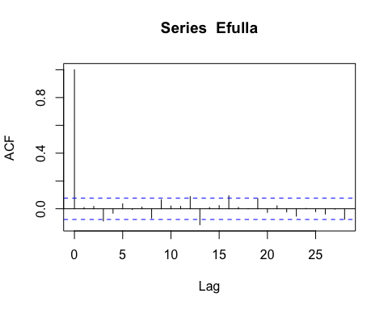

pacf(Efulla, na.action=na.pass)

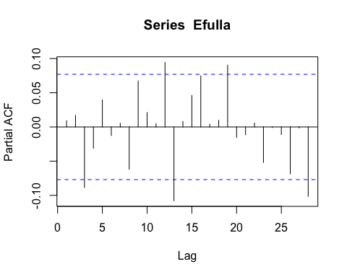 Still autocorrelation but this is the best one yet so lets interpret this model

# generalized linear hypotheses

site.ID.comp <- glht(SPC.mod.arma.2.2, linfct = mcp(site.ID = "Tukey"))  
summary(site.ID.comp)

##   
## Simultaneous Tests for General Linear Hypotheses  
##   
## Multiple Comparisons of Means: Tukey Contrasts  
##   
##   
## Fit: gls(model = dailySPC ~ site.ID, data = mean_daily_2021, correlation = corARMA(form = ~julian |   
## site.ID, p = 2, q = 2), weights = varfixed, na.action = na.omit)  
##   
## Linear Hypotheses:  
## Estimate Std. Error z value Pr(>|z|)   
## FRCH - CARI == 0 16.491 9.048 1.823 0.40561   
## MOOS - CARI == 0 49.122 12.814 3.833 0.00126 **   
## POKE - CARI == 0 46.439 10.579 4.390 < 0.001 ***  
## STRT - CARI == 0 55.249 9.487 5.824 < 0.001 ***  
## VAUL - CARI == 0 333.223 72.341 4.606 < 0.001 ***  
## MOOS - FRCH == 0 32.630 11.570 2.820 0.04348 *   
## POKE - FRCH == 0 29.947 9.033 3.315 0.00919 **   
## STRT - FRCH == 0 38.757 7.725 5.017 < 0.001 ***  
## VAUL - FRCH == 0 316.732 72.131 4.391 < 0.001 ***  
## POKE - MOOS == 0 -2.683 12.804 -0.210 0.99993   
## STRT - MOOS == 0 6.127 11.917 0.514 0.99457   
## VAUL - MOOS == 0 284.101 72.699 3.908 < 0.001 ***  
## STRT - POKE == 0 8.810 9.473 0.930 0.92652   
## VAUL - POKE == 0 286.784 72.339 3.964 < 0.001 ***  
## VAUL - STRT == 0 277.974 72.187 3.851 0.00123 **   
## ---  
## Signif. codes: 0 '***' 0.001 '**' 0.01 '*' 0.05 '.' 0.1 ' ' 1  
## (Adjusted p values reported -- single-step method)

summary(SPC.mod.arma.2.2)

## Generalized least squares fit by REML  
## Model: dailySPC ~ site.ID   
## Data: mean_daily_2021   
## AIC BIC logLik  
## 3456.825 3525.312 -1712.413  
##   
## Correlation Structure: ARMA(2,2)  
## Formula: ~julian | site.ID   
## Parameter estimate(s):  
## Phi1 Phi2 Theta1 Theta2   
## -0.007738018 0.879887736 1.322717719 0.341368387   
## Variance function:  
## Structure: Different standard deviations per stratum  
## Formula: ~1 | site.ID   
## Parameter estimates:  
## CARI FRCH MOOS POKE STRT VAUL   
## 1.0000000 0.6755950 1.3881868 0.7674008 0.7750188 9.5762083   
##   
## Coefficients:  
## Value Std.Error t-value p-value  
## (Intercept) 82.0148 7.48981 10.950190 0.0000  
## site.IDFRCH 16.4914 9.04786 1.822684 0.0689  
## site.IDMOOS 49.1217 12.81405 3.833427 0.0001  
## site.IDPOKE 46.4387 10.57944 4.389527 0.0000  
## site.IDSTRT 55.2488 9.48714 5.823549 0.0000  
## site.IDVAUL 333.2229 72.34061 4.606305 0.0000  
##   
## Correlation:   
## (Intr) s.IDFR s.IDMO s.IDPO s.IDST  
## site.IDFRCH -0.828   
## site.IDMOOS -0.584 0.484   
## site.IDPOKE -0.708 0.586 0.414   
## site.IDSTRT -0.789 0.654 0.461 0.559   
## site.IDVAUL -0.104 0.086 0.061 0.073 0.082  
##   
## Standardized residuals:  
## Min Q1 Med Q3 Max   
## -2.24262070 -0.84899972 -0.02351287 0.69413369 2.02952139   
##   
## Residual standard error: 15.96124   
## Degrees of freedom: 540 total; 534 residual

plot(print(confint(site.ID.comp)))

##   
## Simultaneous Confidence Intervals  
##   
## Multiple Comparisons of Means: Tukey Contrasts  
##   
##   
## Fit: gls(model = dailySPC ~ site.ID, data = mean_daily_2021, correlation = corARMA(form = ~julian |   
## site.ID, p = 2, q = 2), weights = varfixed, na.action = na.omit)  
##   
## Quantile = 2.7708  
## 95% family-wise confidence level  
##   
##   
## Linear Hypotheses:  
## Estimate lwr upr   
## FRCH - CARI == 0 16.4914 -8.5784 41.5612  
## MOOS - CARI == 0 49.1217 13.6165 84.6269  
## POKE - CARI == 0 46.4387 17.1252 75.7523  
## STRT - CARI == 0 55.2488 28.9618 81.5358  
## VAUL - CARI == 0 333.2229 132.7815 533.6643  
## MOOS - FRCH == 0 32.6303 0.5716 64.6890  
## POKE - FRCH == 0 29.9473 4.9189 54.9758  
## STRT - FRCH == 0 38.7574 17.3531 60.1618  
## VAUL - FRCH == 0 316.7315 116.8718 516.5912  
## POKE - MOOS == 0 -2.6830 -38.1590 32.7930  
## STRT - MOOS == 0 6.1271 -26.8921 39.1463  
## VAUL - MOOS == 0 284.1012 82.6663 485.5361  
## STRT - POKE == 0 8.8101 -17.4375 35.0576  
## VAUL - POKE == 0 286.7842 86.3479 487.2204  
## VAUL - STRT == 0 277.9741 77.9581 477.9901

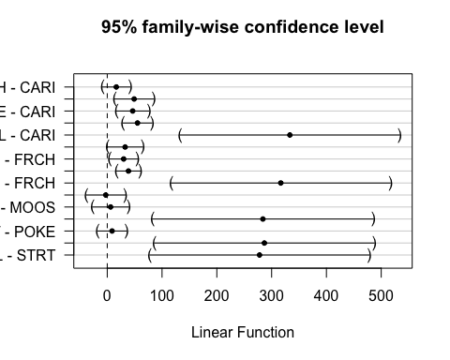 This shows that MOOS is significantly different than CARI and FRCH

### Turb

ggplot(mean_daily_2021, aes(x = julian, y = dailyTurb, color = site.ID)) +  
 geom_line() +  
 scale_color_manual(values=c("#3288BD","#FF7F00", "#A6761D", "#6A3D9A", "#66C2A5", "#E7298A")) +  
 facet_wrap(~site.ID, scales = "free") +  
 theme_classic()

## Warning: Removed 55 row(s) containing missing values (geom_path).

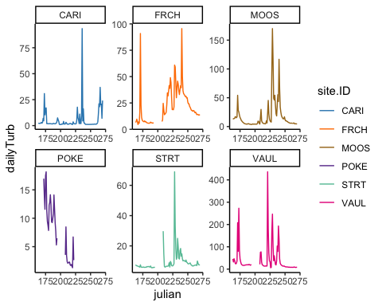

ggplot(mean_daily_2021, aes(x = site.ID, y = dailyTurb, fill = site.ID)) +  
 geom_boxplot() +  
 scale_fill_manual(values=c("#3288BD","#FF7F00", "#A6761D", "#6A3D9A", "#66C2A5", "#E7298A"))

## Warning: Removed 108 rows containing non-finite values (stat_boxplot).

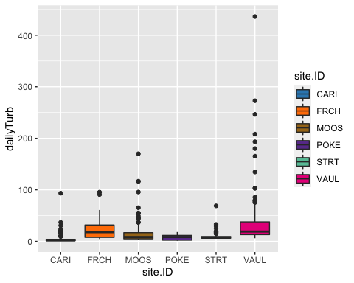

# corAR1 structure

turb.mod.ar1 <- gls(dailyTurb ~ site.ID,   
 na.action = na.omit,   
 data = mean_daily_2021,   
 correlation = corAR1(form = ~ julian|site.ID))

# diagnostic plots

plot(turb.mod.ar1, resid(., type = "p") ~ fitted(.), abline = 0)

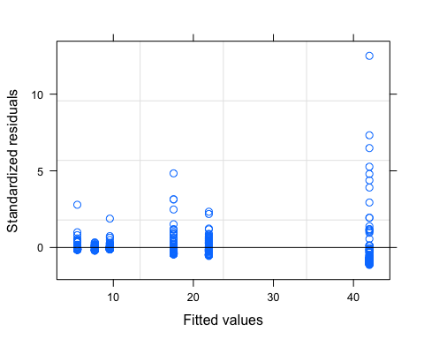

plot(turb.mod.ar1, dailyTurb ~ fitted(.) | site.ID, abline = c(0,1))

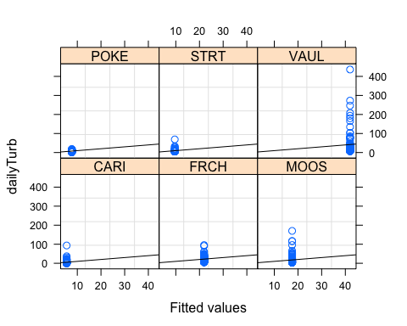

qqnorm(turb.mod.ar1, abline = c(0,1))

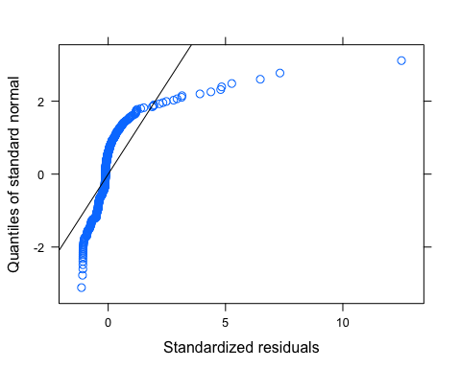 Looks like we have lots of outliers here but our normality isnt good either so lets log transform first and then investigate outliers

# corAR1 structure

mean_daily_2021$logDailyTurb <- log(mean_daily_2021$dailyTurb)  
  
turb.mod.ar1.log <- gls(logDailyTurb ~ site.ID,   
 na.action = na.omit,   
 data = mean_daily_2021,   
 correlation = corAR1(form = ~ julian|site.ID))

# diagnostic plots

plot(turb.mod.ar1.log, resid(., type = "p") ~ fitted(.), abline = 0)

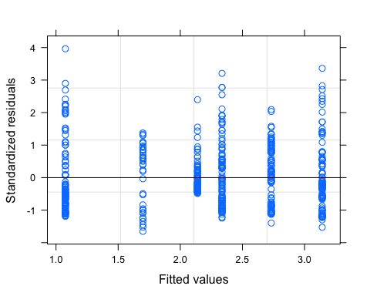

plot(turb.mod.ar1.log, logDailyTurb ~ fitted(.) | site.ID, abline = c(0,1))

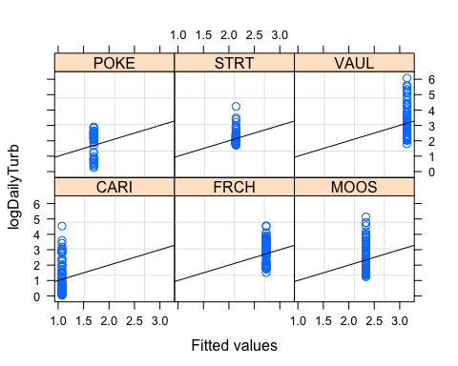

qqnorm(turb.mod.ar1.log, abline = c(0,1))

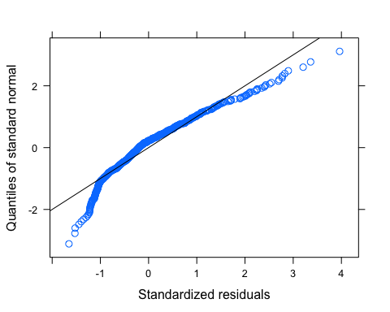 This may need further transformation but it looks a lot better

# ACF plot

Ear1<-residuals(turb.mod.ar1.log, type="normalized")  
I1<-!is.na(mean_daily_2021$logDailyTurb)  
Efulla<-vector(length = length(mean_daily_2021$logDailyTurb))  
Efulla<-NA  
Efulla[I1]<-Ear1  
acf(Efulla, na.action=na.pass)

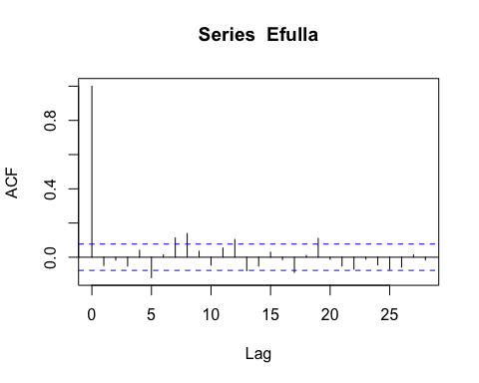

pacf(Efulla, na.action=na.pass)

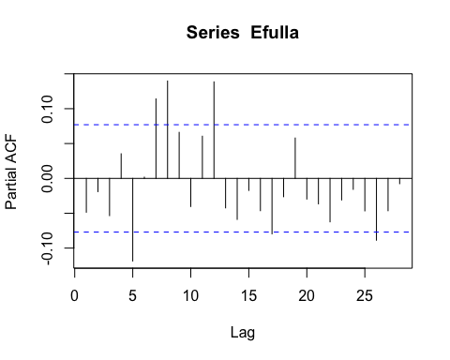 AR1 is not adequately handling the temporal autocorrelation

# corARMA structure

turb.mod.arma.1.1 <- gls(logDailyTurb ~ site.ID,   
 na.action = na.omit,   
 data = mean_daily_2021,   
 correlation = corARMA(form = ~ julian|site.ID, p = 1, q = 1))

# ACF plot

Ear1<-residuals(turb.mod.arma.1.1, type="normalized")  
I1<-!is.na(mean_daily_2021$logDailyTurb)  
Efulla<-vector(length = length(mean_daily_2021$logDailyTurb))  
Efulla<-NA  
Efulla[I1]<-Ear1  
acf(Efulla, na.action=na.pass)

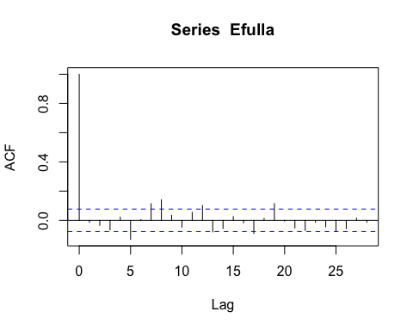

pacf(Efulla, na.action=na.pass)

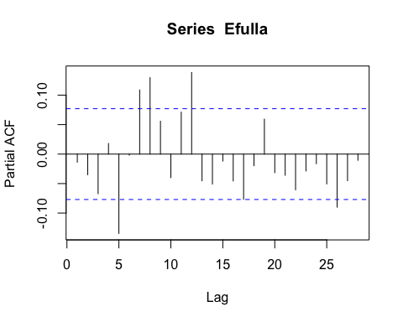 Still autocorrelation

# corARMA structure

turb.mod.arma.1.2 <- gls(logDailyTurb ~ site.ID,   
 na.action = na.omit,   
 data = mean_daily_2021,   
 correlation = corARMA(form = ~ julian|site.ID, p = 1, q = 2))

# ACF plot

Ear1<-residuals(turb.mod.arma.1.2, type="normalized")  
I1<-!is.na(mean_daily_2021$logDailyTurb)  
Efulla<-vector(length = length(mean_daily_2021$logDailyTurb))  
Efulla<-NA  
Efulla[I1]<-Ear1  
acf(Efulla, na.action=na.pass)

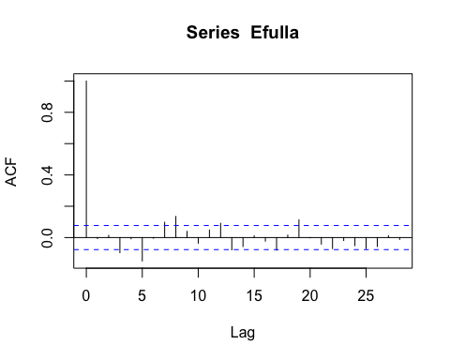

pacf(Efulla, na.action=na.pass)

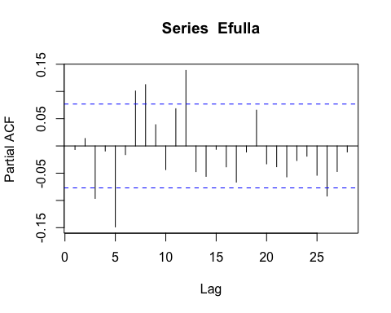 Still autocorrelation at the 9th lag but that is it

# corARMA structure

turb.mod.arma.2.1 <- gls(logDailyTurb ~ site.ID,   
 na.action = na.omit,   
 data = mean_daily_2021,   
 correlation = corARMA(form = ~ julian|site.ID, p = 2, q = 1))

# ACF plot

Ear1<-residuals(turb.mod.arma.2.1, type="normalized")  
I1<-!is.na(mean_daily_2021$logDailyTurb)  
Efulla<-vector(length = length(mean_daily_2021$logDailyTurb))  
Efulla<-NA  
Efulla[I1]<-Ear1  
acf(Efulla, na.action=na.pass)

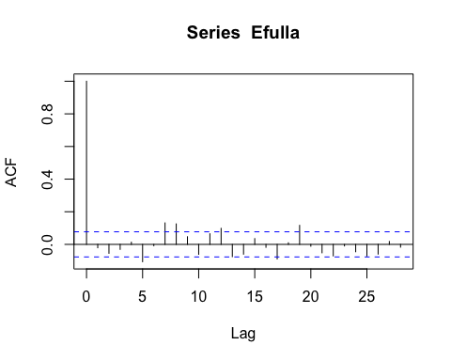

pacf(Efulla, na.action=na.pass)

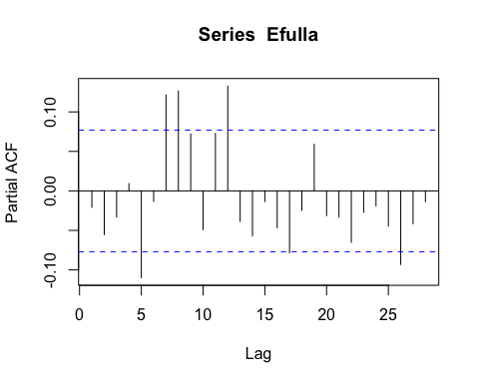 Still autocorrelation at the 9th lag but that is itation in the later lags

# corARMA structure

turb.mod.arma.2.2 <- gls(logDailyTurb ~ site.ID,   
 na.action = na.omit,   
 data = mean_daily_2021,   
 correlation = corARMA(form = ~ julian|site.ID, p = 2, q = 2))

# ACF plot

Ear1<-residuals(turb.mod.arma.2.2, type="normalized")  
I1<-!is.na(mean_daily_2021$logDailyTurb)  
Efulla<-vector(length = length(mean_daily_2021$logDailyTurb))  
Efulla<-NA  
Efulla[I1]<-Ear1  
acf(Efulla, na.action=na.pass)

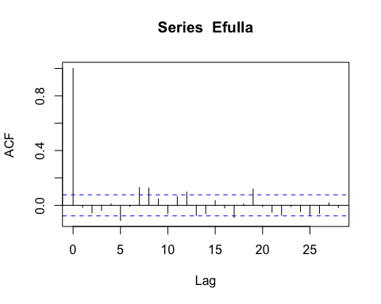

pacf(Efulla, na.action=na.pass)

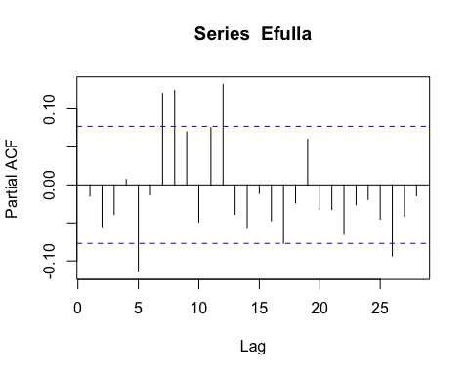 Still autocorrelation at the 9th lag but that is it # generalized linear hypotheses

site.ID.comp <- glht(turb.mod.ar1.log, linfct = mcp(site.ID = "Tukey"))  
summary(site.ID.comp)

##   
## Simultaneous Tests for General Linear Hypotheses  
##   
## Multiple Comparisons of Means: Tukey Contrasts  
##   
##   
## Fit: gls(model = logDailyTurb ~ site.ID, data = mean_daily_2021, correlation = corAR1(form = ~julian |   
## site.ID), na.action = na.omit)  
##   
## Linear Hypotheses:  
## Estimate Std. Error z value Pr(>|z|)   
## FRCH - CARI == 0 1.6566 0.3617 4.580 < 0.001 ***  
## MOOS - CARI == 0 1.2602 0.3575 3.525 0.00559 **   
## POKE - CARI == 0 0.6236 0.4428 1.408 0.71961   
## STRT - CARI == 0 1.0632 0.3617 2.939 0.03806 *   
## VAUL - CARI == 0 2.0664 0.3617 5.712 < 0.001 ***  
## MOOS - FRCH == 0 -0.3964 0.3617 -1.096 0.88199   
## POKE - FRCH == 0 -1.0330 0.4462 -2.315 0.18536   
## STRT - FRCH == 0 -0.5934 0.3659 -1.622 0.58113   
## VAUL - FRCH == 0 0.4098 0.3659 1.120 0.87194   
## POKE - MOOS == 0 -0.6366 0.4428 -1.438 0.70135   
## STRT - MOOS == 0 -0.1970 0.3617 -0.545 0.99422   
## VAUL - MOOS == 0 0.8062 0.3617 2.229 0.22227   
## STRT - POKE == 0 0.4396 0.4462 0.985 0.92190   
## VAUL - POKE == 0 1.4428 0.4462 3.234 0.01523 *   
## VAUL - STRT == 0 1.0032 0.3659 2.742 0.06637 .   
## ---  
## Signif. codes: 0 '***' 0.001 '**' 0.01 '*' 0.05 '.' 0.1 ' ' 1  
## (Adjusted p values reported -- single-step method)

summary(turb.mod.ar1.log)

## Generalized least squares fit by REML  
## Model: logDailyTurb ~ site.ID   
## Data: mean_daily_2021   
## AIC BIC logLik  
## 824.3236 858.5668 -404.1618  
##   
## Correlation Structure: ARMA(1,0)  
## Formula: ~julian | site.ID   
## Parameter estimate(s):  
## Phi1   
## 0.8145249   
##   
## Coefficients:  
## Value Std.Error t-value p-value  
## (Intercept) 1.0754833 0.2528218 4.253919 0.0000  
## site.IDFRCH 1.6566251 0.3617392 4.579612 0.0000  
## site.IDMOOS 1.2602233 0.3575440 3.524666 0.0005  
## site.IDPOKE 0.6236271 0.4427659 1.408480 0.1596  
## site.IDSTRT 1.0632118 0.3617392 2.939167 0.0034  
## site.IDVAUL 2.0663972 0.3617392 5.712395 0.0000  
##   
## Correlation:   
## (Intr) s.IDFR s.IDMO s.IDPO s.IDST  
## site.IDFRCH -0.699   
## site.IDMOOS -0.707 0.494   
## site.IDPOKE -0.571 0.399 0.404   
## site.IDSTRT -0.699 0.488 0.494 0.399   
## site.IDVAUL -0.699 0.488 0.494 0.399 0.488  
##   
## Standardized residuals:  
## Min Q1 Med Q3 Max   
## -1.6525941 -0.6733958 -0.2013578 0.5562107 3.9629701   
##   
## Residual standard error: 0.8735061   
## Degrees of freedom: 540 total; 534 residual

intervals(turb.mod.ar1.log)

## Approximate 95% confidence intervals  
##   
## Coefficients:  
## lower est. upper  
## (Intercept) 0.5788361 1.0754833 1.572131  
## site.IDFRCH 0.9460187 1.6566251 2.367231  
## site.IDMOOS 0.5578580 1.2602233 1.962589  
## site.IDPOKE -0.2461495 0.6236271 1.493404  
## site.IDSTRT 0.3526055 1.0632118 1.773818  
## site.IDVAUL 1.3557908 2.0663972 2.777004  
## attr(,"label")  
## [1] "Coefficients:"  
##   
## Correlation structure:  
## lower est. upper  
## Phi1 0.7546139 0.8145249 0.8609676  
## attr(,"label")  
## [1] "Correlation structure:"  
##   
## Residual standard error:  
## lower est. upper   
## 0.7582233 0.8735061 1.0063168

plot(print(confint(site.ID.comp)))

##   
## Simultaneous Confidence Intervals  
##   
## Multiple Comparisons of Means: Tukey Contrasts  
##   
##   
## Fit: gls(model = logDailyTurb ~ site.ID, data = mean_daily_2021, correlation = corAR1(form = ~julian |   
## site.ID), na.action = na.omit)  
##   
## Quantile = 2.8456  
## 95% family-wise confidence level  
##   
##   
## Linear Hypotheses:  
## Estimate lwr upr   
## FRCH - CARI == 0 1.65663 0.62726 2.68599  
## MOOS - CARI == 0 1.26022 0.24280 2.27765  
## POKE - CARI == 0 0.62363 -0.63630 1.88356  
## STRT - CARI == 0 1.06321 0.03385 2.09257  
## VAUL - CARI == 0 2.06640 1.03704 3.09576  
## MOOS - FRCH == 0 -0.39640 -1.42576 0.63296  
## POKE - FRCH == 0 -1.03300 -2.30259 0.23659  
## STRT - FRCH == 0 -0.59341 -1.63457 0.44775  
## VAUL - FRCH == 0 0.40977 -0.63139 1.45093  
## POKE - MOOS == 0 -0.63660 -1.89652 0.62333  
## STRT - MOOS == 0 -0.19701 -1.22637 0.83235  
## VAUL - MOOS == 0 0.80617 -0.22319 1.83553  
## STRT - POKE == 0 0.43958 -0.83000 1.70917  
## VAUL - POKE == 0 1.44277 0.17318 2.71236  
## VAUL - STRT == 0 1.00319 -0.03798 2.04435

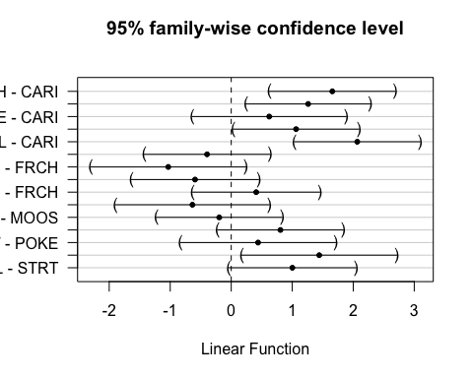 CARI is different to FRCH,MOOS,VAUL VAUL and POKE

real as of 9/22